

**DISSERTATION**

**ON**

***Tracing more than a century of migration to major cities of India from the Census records***

Submitted by

**MEKHALA KUMAR**

Carried out in partial fulfilment of the requirements of the FLAME Scholars Program (FSP) of FLAME University, Pune.

**April 2022**



**CERTIFICATE**

I certify that this dissertation titled “Tracing more than a century of migration to major cities of India from the Census records” was carried out by the following scholar under my guidance between October 2021 and April 2022.

Mekhala Kumar

This was carried out in partial fulfilment of the requirements of the FLAME Scholars Program (FSP) of FLAME University, Pune.

Signatures:

**Supervisor Dean - FSLE**

Date: 16th April 2022

Place: Pune

**Acknowledgement**

I would like to express my sincere gratitude to Professor Shivakumar Jolad for serving as my dissertation mentor and providing assistance throughout the dissertation process in various aspects such as the direction of the topic, data preparation, and solving any queries I had and analysis of results. I would also like to thank Professor Kaushik Gopalan for providing valuable insights and suggestions for the dissertation. Moreover, I would like to express my deep gratitude to Professor Chinmay Tumbe, Professor S. Irudaya Rajan, and the team of professors at The International Institute of Migration and Development for providing specific knowledge about migration research in India and taking the time to solve queries I had regarding the same.

Additionally, this research project would not have been possible without the support of my parents, sister and friends. I would like to thank Prachi Agarwal for helping me narrow down my research interests for the dissertation. Moreover, I would like to express my sincere gratitude to Smriti Jalihal for taking out her precious time to help me utilise QGIS for my research and provide guidance for the written content of the dissertation. I would also like to thank Muskan Agarwal for administering suggestions for the visualisations in my study. Finally, I would like to express my deep gratitude to Yash Gupta and my mother, Vaishali Kumar for proofreading the dissertation and providing valuable suggestions.

**Abstract**

This paper studies migration in**economically dominant million-plus cities of India,**namelyMumbai, Surat, Kolkata, Delhi, Bangalore, Chennai, Ahmedabad and Pune. The migrants in the study are defined as those residing in a district that is different from their place of birth. This is a quantitative research project that utilises the Indian Census data to observe historical patterns of migration occurring between 1881 to 2011. The objective of conducting such a study is to corroborate trends in population and migration to major political and economic events that have taken place during the 19th, 20th and 21st centuries. The migrants and natives were calculated as percentages of the city’s entire population, and these percentages were plotted for multiple decades to observe the changes occurring. It was found that Mumbai, Kolkata and Delhi used to be dominated by migrant populations during the late 19th and early 20th centuries. The cities of Surat and Bangalore were found to have the opposite trend as they have only had dominant migration populations after the mid-20th century.

Moreover, the growth of industries in these major cities, such as textile, jute, diamond and information technology, have played a role in attracting migrants. Finally, there were specific events that caused either an increase or decrease in migration. An event that resulted in a decline in almost all of the cities’ growth was the Influenza epidemic of 1918-1919. In contrast, events that resulted in an increase in migrants and population, in general, included the Partition of India in 1947 and the liberalisation of the Indian economy in the 1990s.

Keywords: Internal migration, urbanisation, industrialisation, Indian Census.

**Contents**

**Chapter 1: Introduction to Migration in India** 11

**Introduction** 11

**Research Statement** 12

**Overview of migration** 12

**Reasons for migration (Push and pull factors)** 12

**Migration Data and Estimates in India** 13

**2011 and 2001 Census Data Regarding Migration** 14

*Number of migrants (total, inter-state, intra-state and intra-district)* 14

*Migration based on movement to urban and rural areas* 15

**Tracing modern migration in India** 16

**Migration in Major cities of India** 18

*Mumbai* 18

*Pune* 18

*Ahmedabad* 19

*Surat* 20

*Chennai* 21

*Bangalore* 21

*Delhi* 22

*Kolkata* 23

**Migration and Urbanisation and Urban Growth** 24

*Characteristics of Urbanisation* 25

*Growth of major cities* 26

*Issues migrants face in urban areas* 27

**Rationale** 27

**Further Sections** 28

**Chapter 2: Methodology** 28

*Data* 29

*Cities in focus* 29

*Information regarding migration data used* 29

*Calculations* 30

*Changes in the districts and states* 31

*Issues faced* 36

**Chapter 3: Results and Analysis of Migration in 5 cities** 38

**Mumbai** 38

**Surat** 44

**Kolkata** 50

**Bangalore** 56

**Delhi** 62

**International migration in the four metropolitan cities** 69

**Chapter 4: Conclusion** 73

**Discussion** 73

**Limitations** 75

**Future Directions** 75

**Conclusion** 75

**References** 77

**Appendix** 87

**Ahmedabad** 87

**Chennai** 91

**Pune** 95

**Tables**

Table 1 *An overview of the issues faced in the data by decade*………………35

**Table of Figures**

Figure 1 Distribution (in%) of internal migrants by movement types 15

Figure 2 Determinants of Urbanisation in India 25

Figure 3 *Administrative boundaries in 1881* 31

*Figure 4 Administrative boundaries in 1951* 32

Figure 5 Administrative boundaries in 1961 33

Figure 6 Administrative boundaries in 2011 34

Figure 7 Population change for 8 cities 38

Figure 8 *a) Mumbai boundaries in 1991 b) Mumbai boundaries in 2001* 39

Figure 9 Population of Mumbai from 1881 to 2011 40

Figure 10 *Decadal Population Growth of Mumbai from 1881 to 2011* 41

Figure 11 Percentage of total migrants and natives in Mumbai from 1881 to 2011 42

Figure 12 Percentage of different types of migrants and natives in Mumbai from 1881 to 2011 43

Figure 13 a) Surat boundaries in 1941 b) Surat boundaries in 1951 45

Figure 14 a) Surat boundaries in 1961 b) Surat boundaries in 1971 45

Figure 15 a) Surat boundaries in 2001 b)Surat boundaries in 2011 46

Figure 16 Population of Surat from 1881 to 2011 46

Figure 17 Decadal Population Growth of Surat from 1881 to 2011 47

Figure 18 Percentage of total migrants and natives in Surat from 1881 to 2011 48

Figure 19 Percentage of different types of migrants and natives in Surat from 1881 to 2011 49

Figure 20 a)Kolkata boundaries in 1941 b)Kolkata boundaries in 1951 50

Figure 21 *Population of Kolkata from 1881 to 2011* 51

Figure 22 Decadal Population Growth of Kolkata from 1881 to 2011 52

Figure 23 Percentage of total migrants and natives in Kolkata from 1881 to 2011 53

Figure 24 Percentage of different types of migrants and natives in Kolkata from 1881 to 2011 55

Figure 25 Bangalore boundaries in 1981 Bangalore boundaries in 1991 56

Figure 26 Bangalore boundaries in 2001 Bangalore boundaries in 2011 57

Figure 27 Population of Bangalore from 1881 to 2011 58

Figure 28 Decadal Population Growth of Bangalore from 1881 to 2011 59

*Figure 29*  Percentage of total migrants and natives in Bangalore from 1881 to 2011 60

Figure 30 Percentage of different types of migrants and natives in Bangalore from 1881 to 2011 61

Figure 31 a) Delhi boundaries in 1891 b) Delhi boundaries in 1901 63

Figure 32 a)Delhi boundaries in 1911 b) Delhi boundaries in 1921 63

Figure 33 a) Delhi boundaries in 1941 b)Delhi boundaries in 1951 64

Figure 34 Population of Delhi from 1881 to 2011 65

Figure 35 Decadal Population Growth of Delhi from 1881 to 2011 66

Figure 36 Percentage of total migrants and natives in Delhi from 1881 to 2011 67

Figure 37 Percentage of different types of migrants and natives in Delhi from 1881 to 2011 68

Figure 38 International Migrants (except Asian migrants) as a percentage of total population 70

Figure 39 Asian Migrants as a percentage of total population 71

Figure 40 Major Asian migrant source countries (In Delhi 2011 Census) 73

Figure 41 Population of Ahmedabad from 1881 to 2011 87

Figure 42 Decadal Population Growth of Ahmedabad from 1881 to 2011 88

Figure 43 Percentage of total migrants and natives in Ahmedabad from 1881 to 2011 89

Figure 44 Percentage of different types of migrants and natives in Ahmedabad from 1881 to 2011 90

Figure 45 Population of Chennai from 1881 to 2011 91

Figure 46 *Decadal Population Growth of Chennai from 1881 to 2011* 92

Figure 47 Percentage of total migrants and natives in Chennai from 1881 to 2011 93

Figure 48 Percentage of different types of migrants and natives in Chennai from 1881 to 2011 94

*Figure 49* Population of Pune from 1881 to 2011 95

Figure 50 Decadal Population Growth of Pune from 1881 to 2011 96

Figure 51 Percentage of total migrants and natives in Pune from 1881 to 2011 97

Figure 52 Percentage of different types of migrants and natives in Pune from 1881 to 2011 98

# **Chapter 1: Introduction to Migration in India**

# **Introduction**

There has long been a trend of migration, running from early human migrations from Africa as means of expansion of residences to more recent movements that have formed the basis of modern systems of economy, community, oppression, and expression. According to Iyer (2020),migration is the movement of individuals from where they usually reside to regions within the country, referred to as internal migration or to other countries, referred to as international migration. In contemporary scenarios, migration can be regarded as a process that dis/connect cities, communities and geographies. Maxwald (2019) notes that modern-day migrations may re-create historical patterns of movement while simultaneously constructing new socio-political, economic, environmental, humanitarian, and cultural pathways. Thus, within this context, this dissertation adopts a historical lens, observing changing trends in migration in eight major cities in India, with the aim to comprehend migrations, both internal and international. Studying these trends may reflect our socio-economic needs, emphasise shared histories, and may reveal opportunities and obstacles present for both the host regions and the migrants.

Before delving into the field of migration, it is prudent to define the manner in which migrants are broadly defined and how migrants have been contextualised in this research. However, one must also keep in mind that the term migrant can have various meanings depending on the discipline where the phenomenon of migration is being studied. In simple terms, a migrant is one who moves to an area away from their “usual place of residence” (International Organization for Migration, 2021). This movement could be to a city or town within the country they reside in or to another country. Migrants are classified based on where they move to and their motives for the same. For instance, immigrants are those who move to another country, whereas immigrants who move due to a crisis in their home country are classified as refugees (Eldridge, n.d.). The individuals who move within a country are regarded as internal migrants. **This research** specifically deals with the **Indian Census definition of** **migrants as individuals residing in a district which is different from their place of birth**(Ministry of Housing and Urban Poverty Alleviation (Mo HUPA), 2017).

The COVID-19 pandemic that began in 2020 brought into picture the large population of internal migrants in India since many were forced to return to their homes in a rushed manner. As of 2020, it is estimated that India has about 600 million migrants. Many of the migrants who had to walk back to their homes were migrant labourers, a category often neglected in academic, bureaucratic and political discourse (Misra, 2021). However, this phenomenon of the mass exodus of migrants during moments of crisis is not new, as a similar wave of return migration occurred during the influenza epidemic of 1918-19 (Tumbe, 2022). The mass wave of return migration during the COVID-19 pandemic demonstrated how crucial it is to study historical trends of internal migration as well as keep an account of the number of migrants in India. By doing so, it can be anticipated when such a phenomenon (mass return migration) could occur again, and policies can be put in place for the benefit of the migrants.

## **Research Statement**

This paper looks into **“migration to economically dominant million-plus cities of India”** within the context mentioned above. It traces the inflow of migrants as well as the population growth in eight of the top ten cities (as of 2011, the cities with the highest population figures in India), from 1881 to 2011. The paper focuses more on the internal migrants and **correlates the population and migration trends observed to major economic and political events**. Additionally, the research gives insights into the growth of cities over time.

## **Overview of migration**

The academic literature on migration presented in the paper focuses on reasons for migration and contextualises migration in India. These themes are explored in detail in the following sections. The topics include: **Reasons for migration, Migration data and estimates in India, 2001 and 2011 Census Data regarding migration, Tracing modern migration in India, Migration in major cities of India and Migration and urbanisation and urban growth.**An overview of these topics is discussed in the following paragraphs.

Before delving into migration in India, it is important to understand why people migrate. This includes a variety of reasons such as in search of better jobs, to be closer to family members or due to changes in the environment that makes it difficult to continue to reside in that area.

Since this dissertation focuses on migrations in the Indian context, the data sources regarding migration that are available in India and the estimates of the Indian migrants are discussed in depth in the following sections. Moreover, the dissertation research centres on the Indian Census data as its source of statistical information. Thus, existing findings of the same for the past two decades (2001 and 2011) are highlighted in the sections mentioned.

Since the primary goal of this research is to trace migration from 1881 to 2011, the modern migration occurring within India has been reviewed. The review of modern migration includes information about the major source cities and states and the popular destinations within India, as well as outside India, which the migrants shifted to. Since there is a focus on eight cities in India, information regarding the migration trends observed in these cities is referenced. Finally, one major consequence of migration to cities is urbanisation. Hence, an overview of urbanisation and the occurrence of the same in the major cities are provided.

## **Reasons for migration (Push and pull factors)**

The reasons people migrate can be broadly categorised into push and pull factors. Push factors refer to the situations due to which individuals are forced to shift to new places. There is a deficit in their needs in the place of residence, and hence they move to new locations. **Push factors** include **unemployment, scarcity of land, famine and drought, insecurity and political instability**(Čirjak, 2022). On the other hand, pull factors refer to the situations or opportunities present in the destination location which attract migrants. **Pull factors** include **the availability of better job opportunities, fertile land, environmental safety, political freedom and religious freedom**. Often, migration happens due to a combination of push and pull factors (Čirjak, 2022; British Broadcasting Corporation (BBC), 2022).

One reason people migrate is for work. People tend to shift from regions with fewer employment opportunities, for instance, rural areas, to regions where more employment opportunities are present, usually urban areas (Čirjak, 2022). This is one of the primary reasons cities and towns have higher populations as individuals shift to find employment in greater industrialised regions (BBC, 2022).

One specific field of work for which people migrate is agriculture. If individuals involved in the agricultural sector require more land to cultivate crops and reside in the same area, then they have to migrate to a place that provides fertile land that has a large area. Hence, individuals involved in the agricultural sector may choose to move to an area with a lesser population (Čirjak, 2022).

Other than employment, people migrate due to environmental conditions. Some communities move from their homes during occurrences of severe drought and famine in order to find food and water. Consequently, regions that are not prone to environmental hazards such as tsunamis, earthquakes, hurricanes and flooding attract several people (Čirjak, 2022; BBC, 2022).

Finally, people may also migrate for safety reasons. If the place where the individuals are residing experiences violence, high rates of crime and terrorism, then individuals tend to migrate to an environment that is secure and peaceful. Due to political reasons, individuals are forced to migrate to other cities or even other countries; they tend to be attracted to places where governments follow democracy as opposed to dictatorship. Moreover, if individuals face religious persecution, they tend to shift to places where free worship can occur (Čirjak, 2022; BBC, 2022).

## **Migration Data and Estimates in India**

National-level Indian migration data is collected by the Census and the National Sample Survey (Ministry of Housing and Urban Poverty Alleviation (Mo HUPA), 2017). The**Census** defines a migrant as **one who changed their place of residence or is residing in a village or city different from their birthplace**. This does not consider temporary movements. In comparison, the **National Sample Survey** uses the **“usual place of residence”** as the basis for defining a migrant. Here, the usual place of residence is where one has resided in a village or city **for at least six months** **continuously** (Mo HUPA, 2017). Hence, both of these surveys capture long-term migration and do not capture short term migrants (Deshingkar & Akter, 2013). Another survey that collects large-scale migration data is the Kerala Migration Survey, which started in 1998, covering 10,000 households and increased to 15,000 in the latest survey in 2018 (Zachariah et al., 1999; Rajan & Zachariah, 2018). These focus on emigration and return migration.

However, large-scale surveys do not capture circular migration, that is, the migration that is undertaken for a few months or during particular seasons or information about particular regions. Studying circular migration is important since multiple studies found this to be the primary type of migration for work mobility. Moreover, this is common amongst the poor and historically disadvantaged groups such as the Scheduled Castes and Scheduled Tribes, whose information is not collected by the Census (Deshingkar & Akter, 2013). Finally, detailed information is required to make policies that suit a region. Hence, information regarding these aspects is collected through smaller-scale surveys by non-governmental organisations and researchers (Mo HUPA, 2017; Deshingkar & Akter, 2013). For example, a survey in Bundelkhand in 2017 looked into how many people migrate for work due to few economic activities and resources (Sharma, 2018).

Since national-level surveys are not conducted yearly, individuals have employed techniques to estimate migration numbers. A gravity model using data from the Ministry of Railways as a “proxy for work-related migrant flow” estimated labour migrant numbers between 2011 to 2016. First, they geocoded the stations to map them to states and districts. Then, the data was clustered to make the “Origin Destination Dyad Passenger Flow Matrix” for every financial year so that the data was not affected by seasonality (Government of India, 2017). Aggregated passenger flow data over calendar years was taken to check the robustness. It found that between 2011-2016, there was an average of 9 million labour migrants each year (Government of India, 2017). Moreover, Professor Amitabh Kundu of the Research and Information System for Developing countries used NSSO data, Census 2011 and the economic survey and estimated around 65 million interstate migrants in 2020 (Singh & Magazine, 2020).

As the dissertation research uses Census data to observe migration, existing migration information in the Census will be discussed further in the following section.

## **2011 and 2001 Census Data Regarding Migration**

### Number of migrants (total, inter-state, intra-state and intra-district)

According to the Census, in 2011, there were around 456 million migrants in India, which is approximately 38% of the population (Iyer, 2020). This was significantly higher than the number of migrants in 2001, which was 31.5 crore (31% of the population). Overall, the population of India grew by 18% from 2001 to 2011, while the number of migrants grew by 45% (Iyer, 2020).

Out of the 456 million, there were about 54.4 million inter-state migrants, 117.9 million inter-district migrants, and 281.2 million intra-district migrants (Rajan & Bhagat, 2021). Therefore, the internal migrants composed 99% of the migrant population, while the international migrants composed only 1% of the population (Iyer, 2020).

Figure 1  
Distribution (in%) of internal migrants by movement types

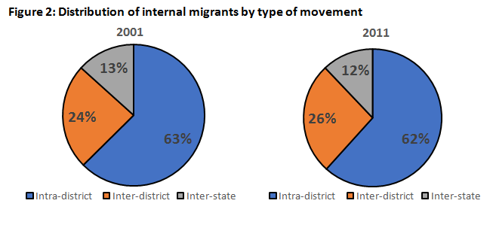

(De, 2019)

### Migration based on movement to urban and rural areas

The internal migrant flows based on the origin and destination of the migrants have also been calculated from the 2011 Census. One type of categorisation is based on migration to and from rural and urban areas; specifically, the four types are **Rural-rural, Rural-urban, Urban-rural and Urban-urban**. In the 2011 Census, there were 210 million rural to rural migrants, which was 54% of the internal migration that was classified (53 million migrants in the Census were not categorised as coming from either urban or rural places) (Iyer, 2020). Both rural to rural and urban to urban migrants were about 80 million (Iyer, 2020). Finally, 7% of the internal migrants, which were categorised, that is 30 million migrants, were urban to rural migrants (Iyer, 2020).

**Intra- and interstate migration in India and differences by Gender**

In the 2011 Census, the major portion of the intrastate migrants (70%) stated they moved due to marriage and family. This trend was observed in the previous decade, as well as migrations for marriage and other family-related reasons constituted 72.2% of all migrations between 1991-2001 (Mo HUPA, 2017). This percentage varied for male and female migrants. 83% of the females moved due to marriage and family, while only 39% of the males moved for the same reason. Contrarily, only 8% of the intrastate migrants moved for work, the corresponding figures for males being 21% and females being 2% (Iyer, 2020).

Among the interstate migrants, the percentage of those moving for work was higher in comparison to the percentage who moved for work within the state, the values being 50% of the male interstate migrants and 5% of the female interstate migrants. According to the 2011 Census, 45 million migrants moved for work. However, the Working Group Report on Migration pointed out that the Census often undercounts the migrant worker population. This is because the Census only records the primary reason for migration, in which many women’s primary reason is recorded as movement due to family. Many women who move due to family also work after migration, but this is not included in the records of women moving for work (Iyer, 2020).

Additionally, Devulapalli observed the changes in migrant inflows as well as the reasons for migration in the six biggest metropolitan cities, **Mumbai, Delhi, Kolkata, Chennai, Bangalore and Hyderabad-between 2001 to 2011 using Census data**(2019). It was found that the highest migrant inflow occurred in Hyderabad (39%), with Chennai (26%) and Bangalore (15%) having the next highest inflows (Devulapalli, 2019). The migrant flow was lower in Mumbai (11%) and Delhi (0.8%). Kolkata experienced a decrease in migrant inflow. Of the total migrants present in the cities, less than 50% had migrated in the decade of 2001 -2011. Majority came from urban areas and within the state. In contrast to the other cities, Mumbai and Bangalore had a higher diversity of migrants, from 9 and 12 states, respectively (Devulapalli, 2019). Finally, most moved due to household decisions or marriage, and only 12% of the migrants moved for work, which was in line with the trends found in the Census data for migration in India as a whole.

## **Tracing modern migration in India**

There has been no definite method to quantify migrations before the mid-19th century in India. Chinmay Tumbe has referred to the migration occurring mainly for work since the late 19th century as the “Great Indian Migration Wave” (2018). This affects areas with at least 20% of India’s population and is male-dominated, remittance-based and semi-permanent. This wave was also responsible for the rise of Indian cities: **Mumbai** and **Kolkata**, along with Dubai and Yangon abroad.

Through his study, Tumbe demonstrated male-dominated migration through correlations between migration (seasonal, non-remittance (migration where money is not sent back home) and remittance-based) and sex ratios (females per thousand males) across age groups (2015). He used the 2011 Census and 2007-08 National Sample Survey data. Higher and significant correlation coefficients were found for remittance-based migration and sex ratios between age groups 15-19 to 45-49, with the highest at 0.6 amongst 30–34-year-olds. Since remittance-based is the most significant form of out-migration for work, the correlation coefficients illustrate similar patterns to the migration statistic for out-migration for work (Tumbe, 2015). Moreover, various districts exhibited sex ratios with a higher number of females indicating mass migration. Both Ratnagiri, Maharashtra and Udupi, Karnataka have had sex ratios of at least 1100 females per 1000 males between 1872-2011 and above 1090 females per 1000 males between 1901-2011, respectively. The major destination for work has been **Mumbai**. Initially, Ratnagiri migrants shifted to Mumbai because of **Mumbai’s textile industry’s rise**. Many from Udupi ended up working in Udupi themed restaurants in Mumbai. Most returned to their districts during retirement. In general, the Western coast of India from Ratnagiri to Kerala has seen male labour migrants whose major destination was Mumbai in the late 19th century and later, places abroad, majorly the Gulf region (Tumbe, 2018).

 Analysis of the Kerala Migration survey data has provided extensive information about internal migration and emigration. There were two distinct periods - 1) the 1940s, when Kerala transitioned from a net in-migration to a net out-migration state, and 2) the 1970s, when many people started emigrating; with the population declining due to emigration becoming three times higher than the population declining due to internal migration (Zachariah et al., 1999).

This occurred partly due to stagnation in the agricultural field and the Government not generating opportunities in secondary and tertiary sectors. In 2018, the percentage of job seekers dropped to almost 0% after migration, showing that migration continues to occur mainly for employment.

(Rajan & Zachariah, 2019). Emigration results in large amounts of remittance being generated, with an estimated 85000 crores being received in 2018 (Rajan & Zachariah, 2019). This is also reflected by better household amenities and higher consumer durables found in emigrants’ or return migrants’ households.

An analysis of panel data from 1999-2004 revealed that the return migrants and the general population equally participated in economic activities. It also depicted that emigration contributed to rising unemployment rates. There were more unemployed people in households with emigrants. The analysis also found higher correlations of unemployment rates with education, suggesting that the emigration of household members allows others to continue education (Zachariah & Rajan, 2007).  Many eventually return since their contract expires or they are laid off. The panel data of 1999-2004 showed that higher in-migration occurs amongst the older-aged population. Furthermore, between 2013-2018, it was found that emigration rates declined, which could be attributed to the decrease in the working population and increase in the old-age population. Simultaneously, a growing number of internal migrants from West Bengal, Odisha, Assam, Uttar Pradesh and Bihar were observed (Rajan & Zachariah, 2019).

Moving to India’s Eastern regions, by 1901, Saran in Bihar had a sex ratio of 1200 females per 1000 males. Migrants mainly worked in Bengal, especially **Kolkata**, where the jute industry was rising. Later on, many worked in **Punjab and Delhi**. Additionally, cyclones and famines caused migration from the East coast. Migrants from Ganjam, Odisha, engaged in circular mass migration due to frequent cyclones. The sex ratio in Ganjam increased from 972 females per 1000 males in 1872 to higher than 1100 females per 1000 males in 1901. The migrants from Ganjam mainly worked in **Yangon, Myanmar, in the transport sector and rice industry till the mid-20th century.** Due to political turmoil in Myanmar, the migrants from Ganjam started working in **Surat**, in the gardening sector and later in the power loom sector. Similarly, males from cyclone-prone regions, like Vishakapatnam, Vizianagaram and Srikakulam, migrated to Yangon, but the migrant numbers fell with Visakhapatnam’s growth in the 20th century. Many from the districts on the East coast above Ganjam and coastal plains in Tamil Nadu migrated in the late 19th and early 20th because of famines. Those from Tamil Nadu migrated to South-East Asia, and those from districts above Ganjam went to Kolkata and Assam (Tumbe, 2018).

Five other major sources in the Great Indian Migration Wave include “the Bhojpuri speaking tracts of East Uttar Pradesh and West Bihar, Jharkhand, parts of Chhattisgarh, east Punjab and the Himalayan belt” (Tumbe, 2018). Some from the Bhojpuri-speaking region went abroad in the late 19th century, while others settled in Assam, Bengal, Burma and Maharashtra’s textile towns in the 20th century. Today several go to the Gulf region. Between 1880-1920, those from Jharkhand went to Assam’s tea gardens or Dhanbad’s coalfields. Now, they go to Jharkhand’s industrial towns. Migrants from Chhattisgarh went to Maharashtra’s cotton-growing belt in the late 19th century, whereas the migrants from Punjab shifted to the Gulf and Canada. In the 20th century, migration from Punjab and the Himalayan belt was associated with police, army and government services.

Other phenomena that contributed to the Great Indian Migration Wave included a “kithkin system of migration” (a modification of indentured labour) in the late 19th century and the construction of railways between 1853 and 1900 (Tumbe, 2018).

## **Migration in Major cities of India**

A few of the major cities based on the population include Mumbai, Pune, Surat, Ahmedabad, Chennai, Bangalore, Kolkata and Delhi. All of these cities have had a high percentage of migrant population corresponding to factors such as industrialisation during different decades between 1881 to 2011.

### Mumbai

           Mumbai is currently regarded as the financial capital of India (Singh, 2007). It has also been a centre of the textile industry since the British rule (Raghavan, n.d.). These two industries have led to many migrants shifting to the city. The growth of Mumbai, formerly Bombay, can be ascribed to the migrants who shifted during the first half of the 20th century (Singh, 2007). From 1901 to 1941, net migration was the sole reason for the population growth of the Greater Bombay region. However, a decline in net migration was observed in 1981, which may have been due to the under-enumeration of the population.

           The majority of the migrants in Mumbai come from other states (based on place of birth), with the figure being around 60% in most of the censuses. During the beginning of the 1950s, a high number of international migrants were observed because of the Partition in 1947 (Singh, 2007). Singh studied the migration trends of migrants based on those whose last place of residence was different or whose birthplace was different from 1961 to 2001. He found that there has been a change in migrants’ source from urban areas to rural areas for migrants from different residences.

Moreover, there has been an increase in migrants (defined as different birthplace) from North India, specifically Uttar Pradesh, Bihar, Rajasthan and Madhya Pradesh, as compared to the migrants from the southern states of Karnataka, Kerala, Andhra Pradesh and Tamil Nadu. Finally, within Maharashtra, most of the migrants (defined as different birthplace) come from Satara, Pune, Ratnagiri and Raigarh (previously called Kolaba district). The sex ratios have also improved since 1961, implying that a greater number of females are shifting as migrants or accompanying their husbands. Simultaneously, out-migration has also occurred, with almost half the migrants going to Ratnagiri and Thane between 1971 and 1981.

In 2001, a huge proportion of individuals migrated to Thane for residential reasons in the new areas of the district. Other than this, many migrated to Pune (Singh, 2007).

### Pune

           The city of Pune and the urban agglomeration has experienced rapid growth, most of which occurred post-1991. The diversification of industries and renowned educational institutions was responsible for an increase in migrants (Butsch et al., 2017). Pune has witnessed four stages of urbanisation. The first one was during the Peshwa rule in the 1700s, where ‘wada’, the housing form, was built. The second phase of urbanisation occurred at the beginning of the 1800s when the British defeated the Peshwas and established a military base. The third phase of urbanisation began in the 1960s when Pune’s urban growth was connected to Mumbai’s growth. Many of Mumbai’s industries were set up in areas surrounding Pune, and the township of Pimpri-Chinchwad was established. This was when migrants from across India started shifting to Pune. Moreover, the city performs the role of a counter-magnet to Mumbai (TOI, 2019). Finally, the fourth phase of urbanisation occurred during the 1990s with India’s economic liberalisation. Several biotechnology and information technology parks were set up, and Pune became an industrial city and information technology hub with a cosmopolitan population (Butsch et al., 2017).

           Similar to Mumbai, the growth of Pune is linked to a considerable proportion of in-migration. Due to economic development, a large number of migrants started to shift to Pune. The first industrial unit, an ammunition factory, was set up in 1869; other industries set up included the textile mill. However, it was in the 1940s that many migrants shifted due to more employment opportunities caused by the increase in armament production at the time of the Second World War. In 1946, industrial diversification occurred, and Kirloskar Oil Engines, automotive and chemical companies were set up. Moreover, in the 1960s, many pharmaceutical and automobile companies were found in the area around Pune and Pimpri and Chinchwad. Finally, in the 1990s, as discussed earlier, the information technology sector was established with the companies of Infosys, IBM and Accenture. Additionally, foreign automobile companies such as Volkswagen and Mercedes Benz set up in Pune. Many of these industries, which are partially labour and partially technology-intensive, were built in Pune due to the higher educational institutions present. As of 2011, 20% of the urban agglomeration population was migrants, two-thirds of which were intrastate migrants. The interstate migrants hailed from Andhra Pradesh and Karnataka (Butsch et al., 2017).

### Ahmedabad

           Ahmedabad’s and Surat’s textiles industries began to attract migrants in the 1960s. There were changes in the industry’s structure and labour relations after the liberalisation of the Indian economy. There are now micro-, small and medium units as opposed to the large textile mills that were present. Many female migrants work in the lowest end of the textile and garments industry and are often exploited in terms of the wages they receive for their work since they are not officially recognised as workers. In contrast, male migrants work in the micro-, small and medium units (Jayaram & Varma, 2020).

Another sector that attracts many migrants is the construction sector since there is an increasing demand for infrastructure such as office buildings and apartment buildings. In this sector, most of the workers are ST migrants from Gujarat, Madhya Pradesh and Rajasthan, who are employed for very low wages. It is estimated that these workers constitute 80% of the entire workforce (Prayas 2009 as cited in Jayaram & Varma, 2020). Therefore, they contribute to a huge portion of the migrant population in Ahmedabad.

Finally, several migrants work in labour-intensive jobs present in hotels and dhabas, where around half the migrant workforce in this industry belongs to the ST caste. One of the regions where these migrants hail from is Rajasthan (Jayaram & Varma, 2020).

Overall, as per the 2011 Census, the migrants (defined as those whose usual place of residence differed) in Ahmedabad constitute 46% of the population, of which only 12.4% of the migrants are from other states. The major source states of migrants are Rajasthan, Uttar Pradesh and Maharashtra and the main reasons for shifting were moving after marriage and moving for work (TOI, 2019).

### Surat

           Historically, Surat was a business centre and used to conduct trade with over 84 countries. With time, individuals from Saurashtra set up the diamond industry in Surat, which required semi-skilled and skilled labourers. However, the pull factor was not strong enough to attract migrants because the industry is trust-based (Chowdhury, 2020). When several institutional establishments such as government offices and Gujarat University were set up post-Independence, the city became a service hub. Finally, most of the interstate migrants worked in the textile mills (Chowdhury, 2020; Directorate of Census Operations Gujarat, 2011).

Today Surat is one of the largest destination regions for migrants. As per the 2011 Census, 64.6% of its population is composed of migrants, while 32.2% are interstate migrants (TOI,2019; UNESCO 2013 as cited in Jayaram & Varma, 2020). This is the highest migration inflow observed among all the Indian metropolis (Chowdhury, 2020). Within the migrant population, 70% are waged workers (Tumbe 2019, as cited in Jayaram & Varma, 2020). In spite of the high number of migrants, Surat does not face the issue of unemployment (Chowdhury, 2020). One of the reasons that there are so many migrants in Surat is due to the overcrowding and high cost of living in Mumbai. Hence, many individuals migrate to Surat for more work opportunities. Additionally, other migrants cited shifting for marriage as a reason of migration (TOI, 2019). Moreover, one characteristic of migration in Surat, which is dissimilar to migration in other major cities, is that the migrants come from a persistent pool. This means there is a factor other than push and pull factors that is present, which is networking (Tumbe 2012 as cited in Chowdhury, 2020).

 The two main industries where migrant workers are employed are synthetic textile and diamond cutting (Chowdhury, 2020). As previously mentioned, migration to the textile industry in Surat and Ahmedabad began in the 1960s. Post the liberalisation, the production of textiles moved to Surat’s handloom and artisanal sectors. The power loom industry is among the major employers of migrant workers in Surat (Jayaram & Varma, 2020). Majority of the migrants are from Odisha, around 70% of the workforce and more specifically, these workers come from Ganjam, Odisha (Jayaram & Varma, 2020; Subramaniam, 2018). The workforce is majorly composed of males who belong to OBC and SC categories. This nature of migration that is male-dominated migration has resulted in the sex ratio of Surat worsening (Chowdhury, 2020). Similar to Ahmedabad, Surat also has a prominent construction sector composed of ST migrants from Madhya Pradesh, Rajasthan and Gujarat. The diamond industry mainly employs migrants from within Gujarat (Chowdhury, 2020; Subramaniam, 2018).

           The persistent migrant pools include eastern Uttar Pradesh and Bihar, coastal Odisha, northern Maharashtra’s Khandesh and districts in Saurashtra, Gujarat. There are about 40% of the intrastate migrants employed in the diamond industry. In the textile industry, 50% of the migrants are from Maharashtra, 75% of the migrants are from Uttar Pradesh, 75% of the migrants are from Bihar, and 80% of the migrants are from Odisha. Moreover, migrants from Kerala, West Bengal, Jharkhand and Andhra Pradesh also work in the textile industry. Migrants from Rajasthan are involved in the trade services sector. Finally, migrants from Madhya Pradesh work in various industries (Chowdhury, 2020).

### Chennai

Imperial change started to occur in the city of Chennai due to the establishment of a trading centre in the 17th century. Although during the 18th and 19th centuries, several ports, factories, educational institutions and a naval base were set up, there was low population growth in the city overall (Directorate of Census Operations Tamil Nadu, 2014). In the 20th century, there were multiple kinds of establishments set up in Chennai that contributed to the city’s socio-economic development. The growth of the population occurred rapidly from 1921 to 2001, with some of the growth occurring due to the migration of people to the city.

           The most prominent industry that was set up in Chennai is the group of Buchingam and Carnatic Mills. Other significant industries that helped in the development of Chennai included tanneries, manufacturing units for products such as cars and colleges such as arts, medical and engineering colleges (Directorate of Census Operations Tamil Nadu, 2014).

           During the lockdown of 2020, Patel and Behera provided information about the migrant workers of Chennai, many of whom had returned to their homes (2020). The majority of the migrants were from within the state (74%), 24% were from other states, and the remaining were from other countries. The common regions where the interstate migrants hailed from were North and North-East India. Most of the migrant workers were engaged in the manufacturing sector, construction sector, service sector and textile industry (Patel & Behera, 2020).

### Bangalore

According to historians, Bangalore’s growth has occurred due to three waves of migrations. As of the 2011 Census, four people of every ten people are migrants. Here the definition of migrant has been taken as one who has shifted from their usual place of residence. The migrant population constitutes 42.12% of the total population in Bangalore (Dev, 2021). This is the second-highest population of migrants that a city in India has, the first being Mumbai.

           During the 16th century, when Kempegowda built a mud fort and during the reign of Tipu Sultan, several traders and craftsmen migrated to the city. However, the migration which led to demographic changes in Bangalore only began to occur during the colonial period. The cantonment area was set up, and several skilled labourers and traders from the Madras presidency were employed to develop the same. Hence, during the colonial period, the migration to Bangalore was mostly of the people from the Tamil-speaking region (Dev, 2021).

           The second wave of migration in Bangalore occurred in the 1950s and 60s. At this time, several strategic industries were set up due to Bangalore’s distance from international borders and proximity to major Indian cities. Thus, major public sector companies like Hindustan Aeronautics and Bharat Electronics were established, which attracted multiple migrants (Dev, 2021).

The 1980s was the peak of the industrial era of Bangalore, where 14% of the population was employed in the industrial work part of the public sector undertakings. The public sector undertakings brought forth the large-scale manufacturing economy (Dev, 2021). With the emergence of multiple industries, the regions where migrants came from also changed and other popular source states included Odisha, Andhra Pradesh and Kerala.

The globalisation of the Indian economy led to Bangalore becoming the Information Technology hub. This led to another wave of migration. During the late 1980s, the private sector manufacturing had begun, and remote software development resulted in the Information Technology sector’s growth.

This further changed the regions where migrants hailed from. For instance, the service industry is majorly composed of migrants from the North-East region of India (Dev, 2021). Thus, there are several periods where migration was a significant cause of economic development and growth in Bangalore.

### Delhi

           Delhi’s demographic evolution in the 20th century is linked to India’s history. After Delhi became the capital of British India in 1911, the population grew rapidly, increasing from 238,000 in 1911 to 696,000 in 1947. During the Partition of India (1947), Delhi experienced the highest growth in its history as the population increased from 700,000 in 1941 to 1.4 million in 1951. There was an inflow of 470,000 refugees from Sindh and western Punjab. At the same time, 320,000 Muslims migrated from Delhi to Pakistan (Dupont, 2000).

           Migration of individuals played a huge role in the population growth of Delhi. After Independence, internal migration impacted Delhi’s expansion until 1981, post which the role of migration has been declining (Devulapalli, 2019; Dupont, 2000). The proportion that the net migration contributed to the total population growth of the urban and rural areas in the Delhi National Capital Territory was 62%, 60% and 50% for the decades of 1961 to 1971, 1971 to 1981 and 1981 to 1991, respectively. The total migrants who were outside Delhi National Capital Territory was 50% in 1971, 47%, in 1981 and fell further to 40% in 1991 (Dupont, 2000). Five years prior to the 1991 Census, there were 883,500 in-migrants.

           In 1991, more than 66% of the migrants were from states neighbouring Delhi, namely Punjab, Haryana, Rajasthan and Uttar Pradesh. Around 46% of the total migrants were from Uttar Pradesh itself. Other than Bihar, migrants from the remaining states were very few. Moreover, most of these migrants came from rural areas (around 56%). Additionally, it was observed that the migration was male-dominated since many of the migrants came to Delhi to gain employment opportunities. The 1981 Census data also corroborated this as there were 51% of

male migrants who cited their reason for migrating was work, whereas there were only 5% of female migrants who cited the same. In general, Delhi attracts a diverse group of workers ranging from unskilled construction workers and casual labourers to highly-qualified professionals and civil servants (Dupont, 2000).

           Moreover, the 2011 census data of the migration occurring in Delhi also revealed some new patterns. Delhi had the second-largest population of interstate migrants, placing behind Maharashtra. In comparison to other states, the union territory had the highest percentage composition of interstate migrants in its total population. The major reasons for migration were marriage and work. The reasons for migrating also changed depending on the region the migrants hailed from. Individuals from Haryana migrated due to marriage, individuals from the North-East migrated for education and individuals from Kerala migrated for work or business. Overall, it was observed that the number of migrants who moved for work reduced in the decade 2001 to 2011. Similar to what was observed in 1991, more than half of Delhi’s migrants were from Uttar Pradesh. The migrants from Uttar Pradesh, Uttarakhand, Bihar and Jharkhand continuously increased between 1991 to 2011 and more than 60% of the migrants came from these four states (Kawoosa, 2019). It is to be noted that Uttar Pradesh was split into Uttarakhand and Uttar Pradesh between 1991 to 2001 (Chandramoulli, 2011).

### Kolkata

The city of Kolkata has had a rich history of migration. The city’s jute industry started attracting migrants in the 19th century (Tumbe, 2018). Moreover, it gained in-migrants because it was the capital of colonial India till 1911 (Roy & Samanta, 2020). The city has attracted not only internal but international migrants, the sources including the Indian states of Assam, Bihar, Odisha, Punjab, Tamil Nadu and Kerala and, post the Partition of 1947, migrants from Nepal, China and Bangladesh (United Nations Children’s Fund, 2014 as cited in Roy & Samanta, 2020). An additional reason for Kolkata being a migrant hub was the fact that it was the sole metropolitan city in the Eastern region of India, with several job opportunities provided by the industrial sector.

           Roy and Samanta studied the migration trends of “non-Bengali informal labours” from 1961 to 2011 using the Census D-series migration data and by conducting interviews in specific market places and manufacturing units (2020). They also looked into reasons for migration post-1981 onwards since this was the only data present since then. It was found that a majority of the informal workers were from Uttar Pradesh, Jharkhand and Bihar. Among the migrants, more than 75% of the workers who were interviewed were Hindus, and about 50% belonged to the Scheduled Caste category. Most of the workers were between the ages of 31 to 40, and the second-highest majority of workers were below 30 years old. A majority of workers migrated in the past ten years, and the next highest number of workers migrated 11 to 20 years ago, signifying that there are new entries in the informal work sector. About 70-93% of the workers were married but migrated alone, in line with the common trend of male-dominated migration for work in India. A challenge that the workers face is financially supporting their families as there are no policies to support the migrant workers. The only welfare scheme present for informal workers requires one to be a permanent resident of West Bengal (Roy & Samanta, 2020).

Since the colonial period, the common source states of migrants have remained Bihar and Uttar Pradesh. Using Census data, Roy and Samanta found that in 1971, Bihar, Kerala and West Bengal were the common source states. As of the 2011 Census data, the majority of the migrants are from Odisha, Jharkhand and Bihar. Another popular source state includes Rajasthan (Sen, 2019). Additionally, about one lakh of the migrants were from other Asian countries.

According to Singh, male migrants from Bihar, Kerala and West Bengal moved for work, whereas female migrants moved due to marriage (Singh, 1984 as cited in Roy & Samanta, 2020). Moreover, the Census states that the migrants from Bihar and Uttar Pradesh move primarily for work opportunities. In 2011 as well, the male migrants were 54.57% of the total migrants, and the same trend of most men migrating for work and most women migrating for marriage was observed (Sen, 2019).

However, the male migration declined during 1991 as well as 2011. The decline in 1991 was due to many migrants from Bihar and Uttar Pradesh going to Punjab to work in agriculture instead of going to Kolkata’s jute mills. This was partly because many of the mills had been changed to real estate businesses. Even though 2011 Census data depicted about 43% female interstate migrants, the surveys conducted showed that the informal workers continue to be mostly male. This was due to the employment opportunities and the high cost of living in Kolkata’s urban areas, restricting migration of the entire family (Rele, 1969, De Haan, 2002 and Das and Das, 2014, as cited in Roy & Samanta, 2014). Hence, it has been observed that the migration in Kolkata has been declining overall.

## **Migration and Urbanisation and Urban Growth**

           One phenomenon that migration may lead to is the urbanisation of cities. Before discussing urbanisation in India further, it is important to note the Indian Census definition of what is considered an urban area. According to the Indian Census, an urban area is one which has a population of at least 5000 people, a minimum of 75% of male main working population employed in non-agricultural fields and a population density that is minimum 400 persons per square kilometre. Additionally, the area should have a notified town area committee or cantonment board, municipality, corporation, etc. (Government of India, 2011). This definition is strict compared to other nations; for instance, prior to 2020, the US Census-defined an urban area as one which has a population of at least 2500 people and up to 10000 people (Census Bureau, 2022).

Figure 2   
Determinants of Urbanisation in India

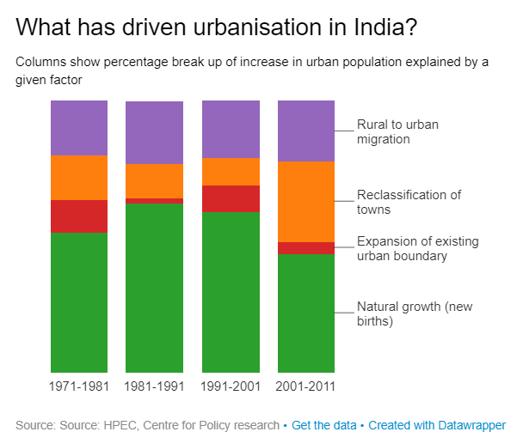

([Sreevatsan](https://www.livemint.com/Search/Link/Author/Ajai-Sreevatsan),2017)

The graph above depicts that a significant portion of urbanisation in India occurs due to rural to urban migrant inflows.

### Characteristics of Urbanisation

           According to Chinmay Tumbe, there are four important characteristics of urbanisation these are a) masculine urbanisation, b) service sector urbanisation, c) strong linkage between economic growth and urbanisation and finally, d) low level and slow pace of urbanisation in India in comparison to other countries (2016).

 Masculine urbanisation refers to the more pronounced deficit of females in urban areas as compared to rural areas. This phenomenon occurs because of the male-dominated migration to cities for job opportunities. It has been observed in the growth of some of India’s most populated cities today. For instance, at the beginning of the 20th century, **Mumbai and Kolkata**had **sex ratios of about 500 females per 1000 males**. This demonstrated that a possibility for the same would be the male-dominated migration for work. The **growth of Delhi and Surat** can be attributed to **masculine urbanisation**(Tumbe, 2016). However, masculine urbanisation also leads to slower urbanisation and slower urban growth overall because of return migration. The men who migrate for work return back eventually, resulting in the net rural-urban migration flows being lesser than the gross rural-urban migration flows (Tumbe, 2016).

Service-sector urbanisation refers to the phenomenon where a majority of people residing in cities earn a living by working in the services sector. In all Indian districts, there are more than 50% of the primary urban workforce in the services sector and the average going over 80%.

Although Mumbai and Kolkata used to have a considerable proportion of their workforce in the manufacturing sector at the beginning of the 20th century, by the beginning of the 21st century, the percentage of workers in the manufacturing sector reduced to less than 30%. It is to be noted that all the top ten cities by population in India, except for Surat, are characterised by the domination of the services sector (Tumbe, 2016).

In India, it has been observed that there is a strong relationship between the urbanisation rates and per capita income levels at the level of the states. For instance, comparatively richer states like Maharashtra, Gujarat, Tamil Nadu and Kerala have urbanisation rates greater than 40%, whereas poorer states like Odisha and Bihar have urbanisation rates lower than 20%. Moreover, at the sub-national level, urbanisation rates impact economic growth rates. This shows that the migration leading to urbanisation is also responsible for the economic growth of the cities (Tumbe, 2016).

Finally, India’s urbanisation rate, from 20% in 1971 to 31% in 2011, is relatively slower than other countries like Asian countries, for example, China, whose urbanisation rate increased by more than two times in the same time period. One reason for the same could be the strict definition of what constitutes as urban in the Indian Census. If the minimum population were to be taken as 5000, then the urbanisation rate may have been between 31% to 47%. However, even with the change in definition for urbanisation, it was found that the urbanisation rate was constant, thus showing that there is slow urbanisation (Tumbe, 2016).

An additional reason for slow urbanisation is the restrictions on migration. As already established, the rates of migration for non-marriage related reasons are low. Moreover, caste networks are present, which usually are a source of informal insurance in rural areas and act as a hurdle in migration. Other than this, the work-related migration statistics in the Census are significantly deficient, and the average male-out migration rate, in Indian districts, for work was calculated using the National Sample Surveys and found to be greater than 5% (Tumbe, 2016).

### Growth of major cities

Tumbe also studied the growth of major Indian cities using 1872-2011 Census data. The urban agglomerations observed for 1901 and 2011 depicted **Delhi’s** rapid growth in the 20th century. Higher urban agglomeration also occurred in **Bangalore, Chennai and Hyderabad**. Finally, the urban agglomerations illustrated the rise in **Surat**, **Ahmedabad, and Pune** compared to major cities in Uttar Pradesh (Tumbe, 2016).

Urban growth is the increase in population in cities. The immediate factors that affect urban growth are natural increase measured by fertility, migration measured by the "share of recent migrants in the total population", and area reclassification. A regression with the dependent variable as “Annual City Population Growth Rate in %, 2001-2011” and independent variables as the immediate factors and other political and geographical variables was carried out. This showed that the three factors account for 60% of the variation in cities’ growth rates. It also depicted that the cities further away from major cities had lower growth rates. The data also showed that the sectors responsible for variations in-migration rates in different cities were information and technology and public administration (Tumbe, 2016).

### Issues migrants face in urban areas

           With the increase in population in urban areas, there are certain issues that arise that affect migrants, specifically migrant workers. They usually face difficulty in availing health benefits, state-provided benefits such as food and basic necessities and housing. While the Inter-State Workmen Act 1979 was introduced to address the difficulties that the migrants may face, it has not been implemented properly. Specifically, regarding housing, it was found by the Ministry of Housing and Urban Affairs that migrants in urban locations constituted the largest population that required housing in cities (Iyer, 2020). Hence, it is important to trace migration and record migrant numbers in urban areas in order to address such types of problems.

## **Rationale**

The existing studies have captured general trends in migration over a few decades and looked into source states of migration. However, there is little information on the migrants in the destination cities which are often economic hubs; either the analysis has been limited to a decade or the number of migrants across various years. Moreover, no study covers the types of migrants, for instance, interstate or international migrants, residing in economically important cities over a more extended period.

It is important to understand migration to major economic cities over a long period of time because it reveals information about factors such as city growth and economic development. For instance, the decade when an industry began to expand, such as the diamond industry in Surat, can be tracked by the sudden increase in migrants (Directorate Of Census Operations Gujarat, 2011). By taking a longer time period into account, the initial situation and the changes after an event can be compared. In other words, in cases where the data was taken for a short time period, such as ten years, the abrupt changes in the composition of the population in terms of natives and migrants were not noticeable.

Moreover, the impact of major historical events such as the influenza epidemic of 1918, the Partition of India of 1947 and the liberalisation of India’s economy on the migration trends can be observed. It also indicates what one should expect if a similar event occurs in the future. As discussed earlier, a mass wave of return migration occurred due to the influenza epidemic, demonstrating that the same should have been anticipated during the COVID-19 pandemic. Moving to another example, the liberalisation of the Indian economy led to multinational companies setting up in major economic cities such as Pune and Bangalore and migration of the workforce to these areas (Butsch et al., 2017; Dey & Pendharkar, 2019). If some of the liberalisation policies were to be reversed or made stricter, then one would expect a decrease in migration.

There are also challenges that occur while studying migration patterns for over a century. The boundaries of districts, states and the country as a whole have changed during this time period. Some of the districts expanded in area, certain districts were split into two and some districts’ area was reduced. Certain states such as the Bombay state were bifurcated, and India was split into India and Pakistan in 1947 (Chari, 2016; Bowman, 1953a). Such changes would impact the population as well as migration records. If the area of a district expands, then the population would show an increase, not because of growth in population or increase in migrants but because a larger area is being considered. Moreover, the change in states and the country would cause one being considered an intrastate or internal migrant to be later on recorded as an interstate or international migrant, respectively. Thus, while studying the migration patterns, boundary changes also have to be taken into account to give accurate insights to changes in major cities.

Therefore, there is a need for a study that traces migration patterns and how certain events and factors impact the increase or decrease in migration.

## **Further Sections**

The remaining sections of the paper are divided as follows:

1. Methodology: This section describes the migrant definition used and the methods undertaken to plot migration patterns.
2. Analysis: This section provides explanations for the migration patterns observed in each of the cities.
3. Discussion: This section summarises the findings and explores the similarities and differences found in migration patterns across cities.
4. Limitations: This section discusses the aspects that were not covered in the research.
5. Conclusion and Future Directions: This section concludes by giving an overview of the research carried out and indicates future research that can be carried out in the field.

# **Chapter 2: Methodology**

The research looked into migration in India for eight of the top ten cities by population of India. The Census data present from the decade of 1881 till the decade of 2011 was used. The data of the population and migrant numbers was stored in Excel and the necessary calculations were also employed in Excel. To visualise the migration data, Tableau was utilised. Finally, the change in district boundaries were observed by extracting and visualising the district boundaries for every decade from 1881 to 2011 using QGIS. This was carried out since one of the factors that may cause drastic changes in population and migration numbers is the change of district boundaries.

### *Data*

Secondary data was used for the study. The Indian Census data, which is usually collected every ten years, was selected for the research since a historical study was being carried out. This is the only national level source of data in India regarding migration that has been present since the 19th century (Office of the Registrar General & Census Commissioner, n.d.). The National Sample Surveys have been conducted only since 1950 and hence would not fulfil the criteria for the nature of the research (Indian Statistical Institute, n.d.).

The reports which contain tables were used for the data present between 1881 to 1981. The data for the remaining decades, that is 1991, 2001 and 2011, was available in a digitised form of excel tables. The migrants considered in the study were the individuals defined as those whose birthplace is different from the city or village that they are currently residing in. That is, the D-1 Census data was utilised. The migrants who are defined as an individual residing in a different place than their last place of residence were not included in the study. This is because data regarding place of last residence was only included from the 1971 Census onwards, hence it would not be possible to carry out a comparison of migrants from 1881 to 2011 (Government of India, n.d.). It is important to note that the population value was taken as per the figure given in the report for that specific year. In subsequent years, the population figures for a previous year may have been changed to readjust for the area taken into account. For instance, the population figure noted for Surat in the report of 2001, may be noted as a different figure in the report of 2011 since the area of Surat changed.

### *Cities in focus*

Migration in eight of the top ten cities of India was observed. The classification is based on the population. In descending order of importance, the top ten cities are Mumbai, Delhi, Kolkata, Chennai, Bangalore, Hyderabad, Ahmedabad, Pune, Surat and Jaipur (Tumbe, 2016). Mumbai, Surat, Kolkata and Bangalore were studied in depth and the analysis of the trends observed in population and migration is provided in the following section. In depth analysis for Ahmedabad, Pune and Chennai was not carried out since changes in the migrant population were not as significant as observed for the five cities mentioned. The graphs for Ahmedabad, Pune and Chennai are included in the appendix. Finally, Hyderabad and Jaipur were not included due to inconsistencies present in the data, such as lack of data for certain years.

### *Information regarding migration data used*

Since the migration data was collected from 1881, until 1951, the data was that of colonial India. There were changes in the regions. For instance, during the colonial period, there were Presidencies and Princely states whereas after independence, there were states and union territories. Hence the data collected prior to independence was of natives, intraprovince, interprovince and international migrants whereas the data post-Independence included intrastate and interstate migrants instead of the intra/interprovince migrants.

### *Calculations*

To calculate the total migrants, the number of natives was subtracted from the total population. Moreover, to calculate the intra-province/interstate migrants, the number of natives was subtracted from the total number of individuals born in the province or state. For the remaining type of migrants, the values were already present in the report or dataset. This information was represented in the form of percentages. All of the natives and migrants were represented as percentages of the total population of the particular district being studied.

In order to calculate decadal population growth, the following formula was used:

Suppose there is decade 1 and decade 2, and the growth in decade 2 needs to be determined.

Population growth in Decade 2=

((Population growth in Decade 2- Population growth in Decade 1)/ Population growth in Decade 1)*100

### *Changes in the districts and states*

Figure 3   
*Administrative boundaries in 1881*

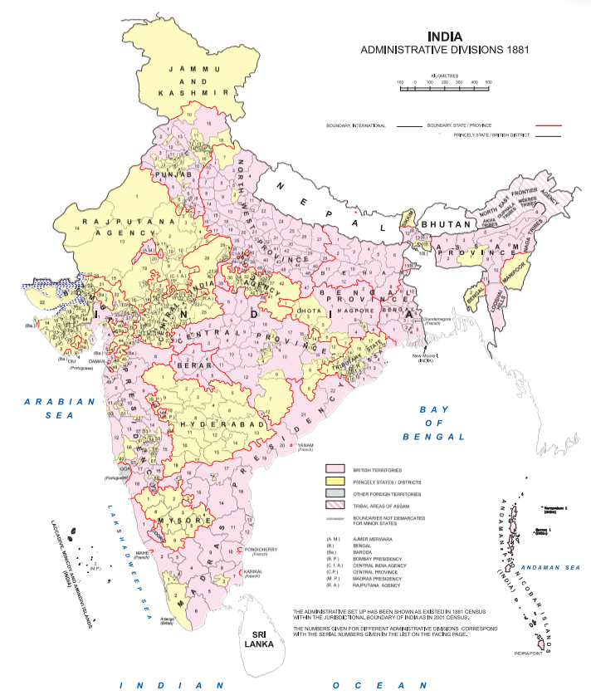

(Chandramoulli, 2011)

*Figure 4   
Administrative boundaries in 1951*

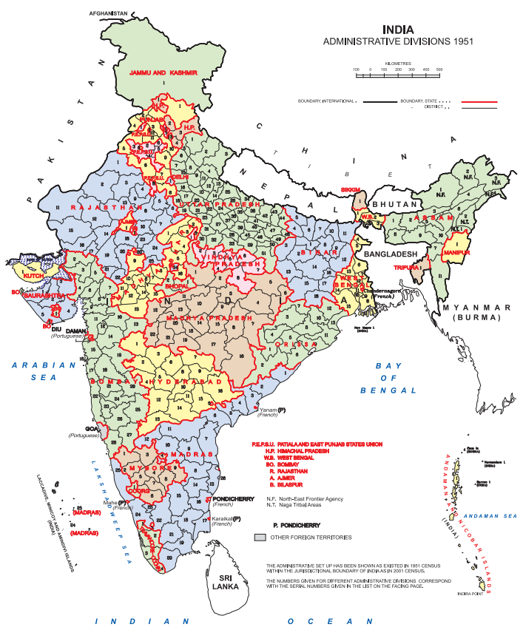

(Chandramoulli, 2011)

Figure 5   
Administrative boundaries in 1961

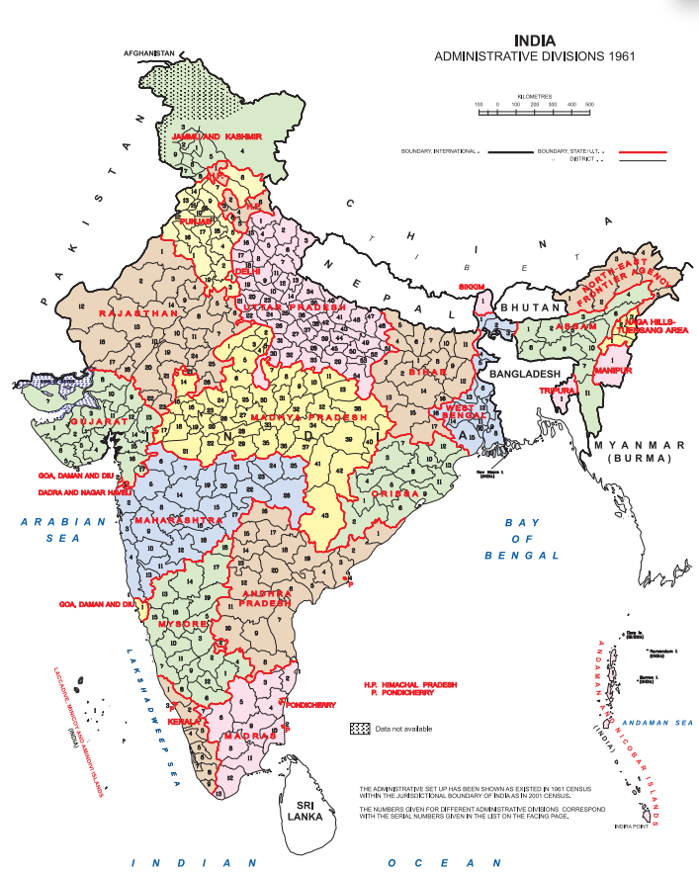

(Chandramoulli, 2011)

Figure 6   
Administrative boundaries in 2011

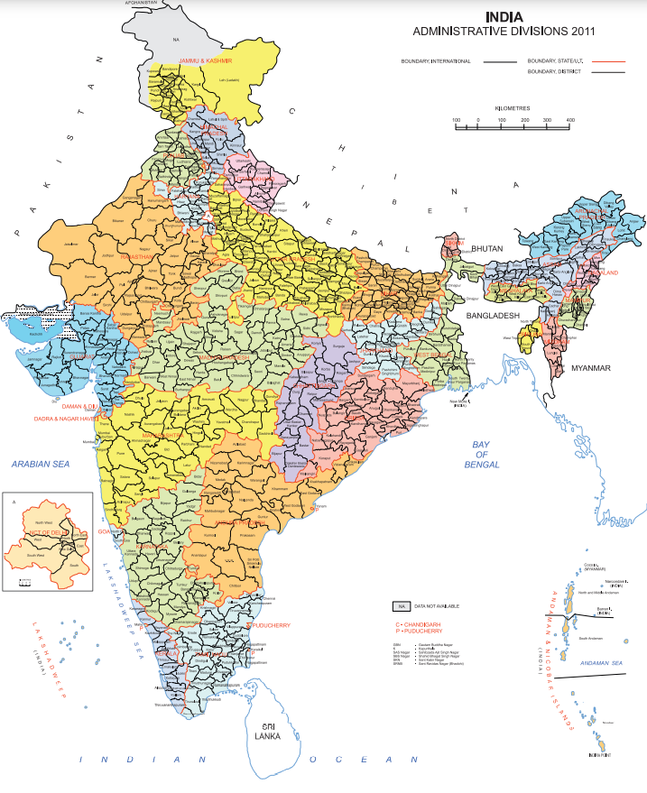

(Chandramoulli, 2011)

Between 1881 to 2011, there were various changes in the boundaries of states as well as renaming of cities. This affected the number of migrants calculated and the source regions of migrants that were recorded. The first change that can be noted was the Partition of Bengal into West Bengal and East Bengal in 1905 (Directorate of Census Operations West Bengal 2015). This could have led to an increase in the value of interstate migrants, if a considerable portion of migrants were coming from East Bengal. The second change that occurred was the shifting of the capital from Kolkata to Delhi in 1911 and the separation of Delhi from the province of Punjab in 1912 (Khan, 1933). Due to the separation, the same phenomenon of an increase in migrants observed due to the changing definitions of the boundaries may have occurred.

In 1947, India gained independence and the partition of India into India and Pakistan occurred (The Partition Museum, 2022). This led to migrants from Pakistan being classified as international migrants from the 1951 Census onwards as opposed to internal migrants in the prior decades.

Post-Independence, many states were created due to linguistic reorganisation, that is, states were formed based on the language spoken. Karnataka and Tamil Nadu, known as Mysore and Madras respectively at the time, were formed in 1956 during the States Reorganisation Act, 1956 (Koshi, 2016). Furthermore, the state of Bombay was split into Maharashtra and Gujarat in 1960 (Chari, 2016). These changes impacted the figures of intrastate and interstate migrants. Moreover, the cities underwent changes such as Bangalore being split into Bangalore and Bangalore Rural between 1981 to 1991. Further Surat was split into Surat and Valsad between 1961 and 1971 and was further split into Surat and Tapi between 2001 to 2011 (Chandramoulli, 2011).

Additionally, certain states were created during the time period taken into account for the study, such as the states Uttarakhand, Jharkhand and Chhattisgarh which were created after 1991. Uttarakhand was previously a part of Uttar Pradesh, Chhattisgarh was part of Madhya Pradesh, and Jharkhand was part of Bihar (Chandramouli, 2011). However, since the specific states where the migrants came from were not looked into, this did not affect the data analysis.

Finally, several cities underwent changes in their names. Bombay was renamed as Mumbai in 1995, Calcutta was renamed as Kolkata in 2001 and Madras was renamed as Chennai in 1996 (Nambiar, 2016; Banerjee-Guha, 2022; The Editors of Encyclopaedia Britannica, n.d.). While this did not have an effect on the migrant numbers, this is important to note to avoid confusion about the cities being analysed.

### *Issues faced*

Table 1

*An overview of the issues faced in the data by decade*

|  |  |
| --- | --- |
| Issues faced by decade | |
| 1881 | There was a mismatch in data for Mumbai, Pune, Surat, Ahmedabad of up to 200 persons. |
| 1891 | There was a mismatch in data for Mumbai of around 600 persons and less than 200 persons for Pune, Surat and Ahmedabad. |
| 1901 | Huge discrepancies found in data for Mumbai, Pune, Surat and Ahmedabad, hence the data for this year was omitted for the four cities. |
| 1921 | There was a mismatch in data for Mumbai, Pune, Surat, Ahmedabad of up to 60 persons.  There was a mismatch in data for Kolkata of up to 30 persons. |
| 1931 | There was a mismatch in data for Mumbai, Pune, Surat, Ahmedabad of up to 80 persons.  The population of the natives in Kolkata was not recorded so calculations of the migrants were not made and this year’s data for Kolkata was omitted. |
| 1941 | Only sample data for migration was provided for all the cities, hence the data on migration for 1941 was not considered. |
| 1981 | For all cities considered, data mismatch of up to 3 persons occurred. |

For all the districts that were studied, the year 1941 was not included. In the year of 1941 since the Second World War was ongoing, only sample data was provided and not actual values of the population (Dracup, 1942; Yeats, 1942). This was not comparable to the other years’ data and hence was not looked into. One more common issue among the districts that were taken into account was that in 1981, there was a mismatch of up to 3 persons between the calculated value of population based on the migrant and native numbers in the table and the total population figure stated by the Census report.

Additionally, there were some issues faced district-wise. Mumbai, Surat, Pune and Ahmedabad were all part of the Bombay Presidency and Bombay state till 1960s, hence all four had similar issues of mismatch in data between the calculated value of population based on the migrant and native numbers in the table and the total population figure till 1960. In 1881, there was a mismatch up to 200 persons, in 1891, there was a mismatch of around 600 persons for Mumbai but less than 200 persons for the other cities, in 1921 there was a mismatch of up to around 60 persons and finally in 1931, there was a mismatch of data of up to 80 persons. In Kolkata a mismatch of 30 persons was observed for 1921. Except for 1981, no such data mismatch was observed for Delhi, Chennai and Bangalore.

Finally, some years had to be omitted for particular cities due to issues in the data. For Mumbai, Pune, Surat and Ahmedabad in 1901, there was a huge discrepancy in the data that was added up and the total population value, for instance, Ahmedabad had the largest discrepancy of around 46,000 people. The data for migrants from Australasia and those born at sea were not mentioned (Enthoven, 1902). Hence this data was not taken into consideration. For Kolkata, in 1931, the population of natives was not provided so the calculation of migrants could not be conducted.

There were a few other issues. One issue with the intraprovince and intrastate values is that it also includes intradistrict migration which is not a significant migration aspect. A second issue was that the countries considered in international migration varied from district to district or even across years. For instance, in 1891, in Bangalore the countries of Brazil, Canada and

West Indies were present in the section for the migrants who were born in the Americas whereas in the Bombay Presidency Canada, Jamaica, US, West Indies and South America were considered as part of the Americas (Narasimmiyengar, 1893; Drew, 1892). Furthermore, in 1901, in Bangalore the countries considered as part of the Americas were British Guiana, Chile, Canada, US and West Indies (Row, 1903). Hence, comparing international migration for specific continents across decades may not be accurate.

# **Chapter 3: Results and Analysis of Migration in 5 cities**

Figure 7  
 Population change for 8 cities

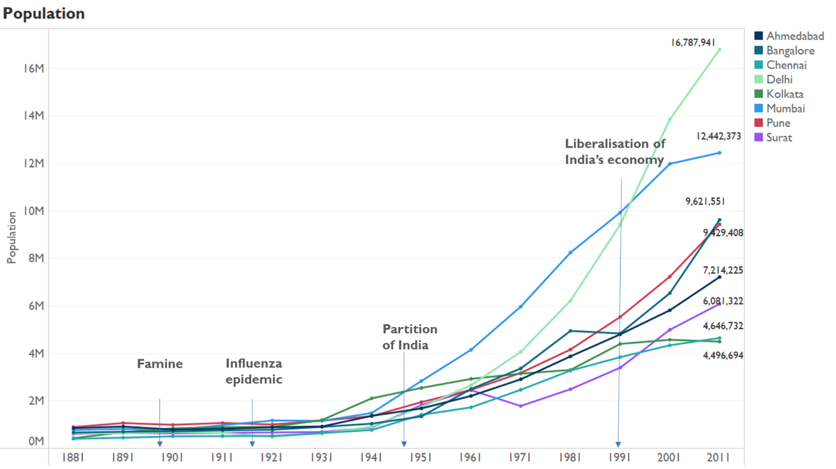

In the graph above, it can be observed that the population in all the eight cities remained more or less stagnant till the 1940s. For most of the cities, the total population was under 2 million. The population has been expanding at a faster rate since the 1940s. Delhi, Mumbai and Bangalore have had the largest increase with around 17 million and 12 million for the two in 2011 respectively whereas Chennai and Kolkata have had the smallest increase with both having population figures between 4 to 5 million in 2011. This large rate of growth is in accordance with the population growth rates of the world, as since the 1920s, higher growth was found across the world due to the industrial revolution (Bowman, 1953a).

Prior to the 1920s, some events that created changes in population growth of India as a whole included the famine in 1877, a second famine in 1899 and the 1918-19 influenza epidemic. There were increases in population in 1891 and 1911 as recovery from the famines occurred, whereas the influenza epidemic had the most intense impact on the population since the 1899 famine (Bowman, 1953a).

## **Mumbai**

Mumbai has long been a destination for migrants. After the East India Company gained possession of Mumbai in 1668, it saw a growth in foreign trade, the textile industry as well as the railway construction (Directorate Of Census Operations, 2011; Raghavan, n.d.). Due to this, it has been the centre of the cotton textile industry since the colonial period (Directorate Of Census Operations, 2011; Raghavan, n,d). Moreover, it serves as the country’s financial hub (Raghavan,

n.d.). Hence many migrants move to Mumbai to seek jobs in several sectors ranging from technical to informal to professional (Zachariah 1996 as cited in Gaikwad & Nellis, 2017).

The city has also gone through changes in its district boundaries. First, the Bombay district only referred to the island city but in 1920, the Bombay Suburban district was carved out.

In 1957, Greater Bombay was established which included the city proper and the suburban district. In 1990, Greater Bombay was divided into Mumbai and Mumbai Suburban (Directorate Of Census Operations, 2011).

Figure 8   
*a) Mumbai boundaries in 1991 b) Mumbai boundaries in 2001*

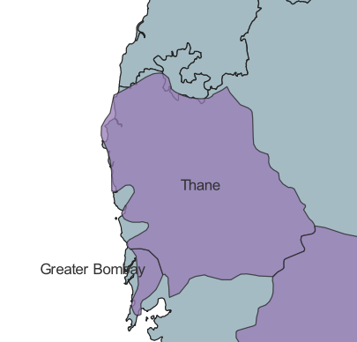 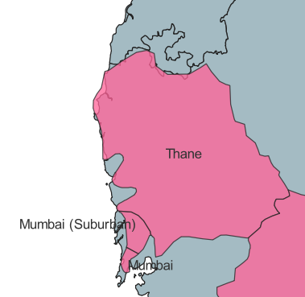

In the analysis, for Mumbai, prior to 1951, the Bombay city region was taken into account. Between 1951 to 1991, the Greater Bombay district data was used. After 1991, both the districts of Mumbai Suburban and Mumbai were used.

The following graphs demonstrate notable trends in population and migration for Mumbai.

Figure 9   
Population of Mumbai from 1881 to 2011

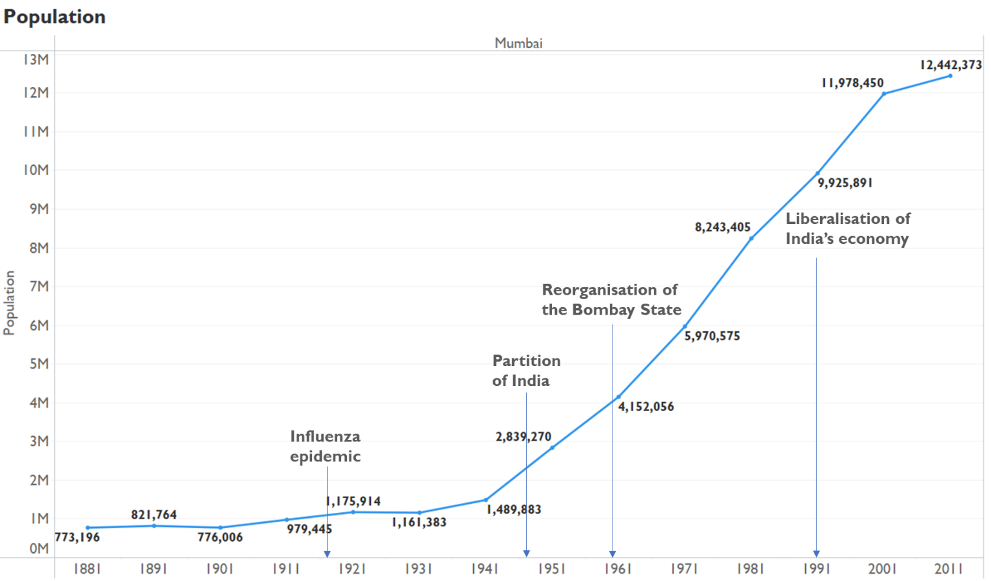

Source: Author’s own

Figure 10  
*Decadal Population Growth of Mumbai from 1881 to 2011*

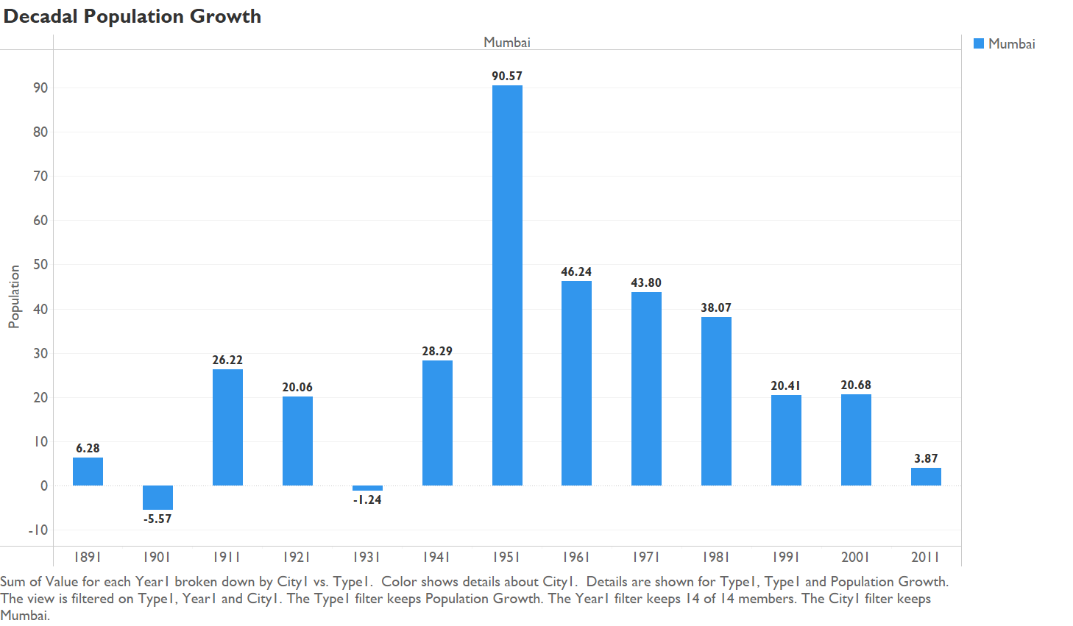

Source: Author’s own

This figure demonstrates that Mumbai’s population has overall risen since 1881. There were declines in population between 1891 to 1901 and 1921 to 1931 by 5.57% and 1.24% respectively. The rate of population growth was higher from 1951 onwards as compared to the growth rate prior to 1951. The decline between 1891 to 1901 can be attributed to the plague and famine that occurred in the decade (Dracu & Sorley, 1932). In fact, the decline in population was observed to be the highest in the Bombay Presidency amongst other regions in India in 1901 (Bowman, 1953a). Although the decade of 1921 to 1931 was relatively prosperous with the negative shock of the decrease in agricultural goods’ prices, Mumbai was still recovering from the effects of the influenza epidemic which is possibly what caused the decline (Bowman, 1953a; Dracu & Sorley, 1932). The migrants shifting to Mumbai were a major cause in growth in population between 1921 to 1951. The slight decrease of 1.24%between 1921 to 1931 was partly due to the reason that some workers left due to the slump in trade and also due to the under-enumeration that occurred because of the political conditions. Moreover, the increase in population in 1951 was in part due to the Partition of 1947 and several migrants coming in from Pakistan (Bowman, 1953a).

Figure 11   
Percentage of total migrants and natives in Mumbai from 1881 to 2011

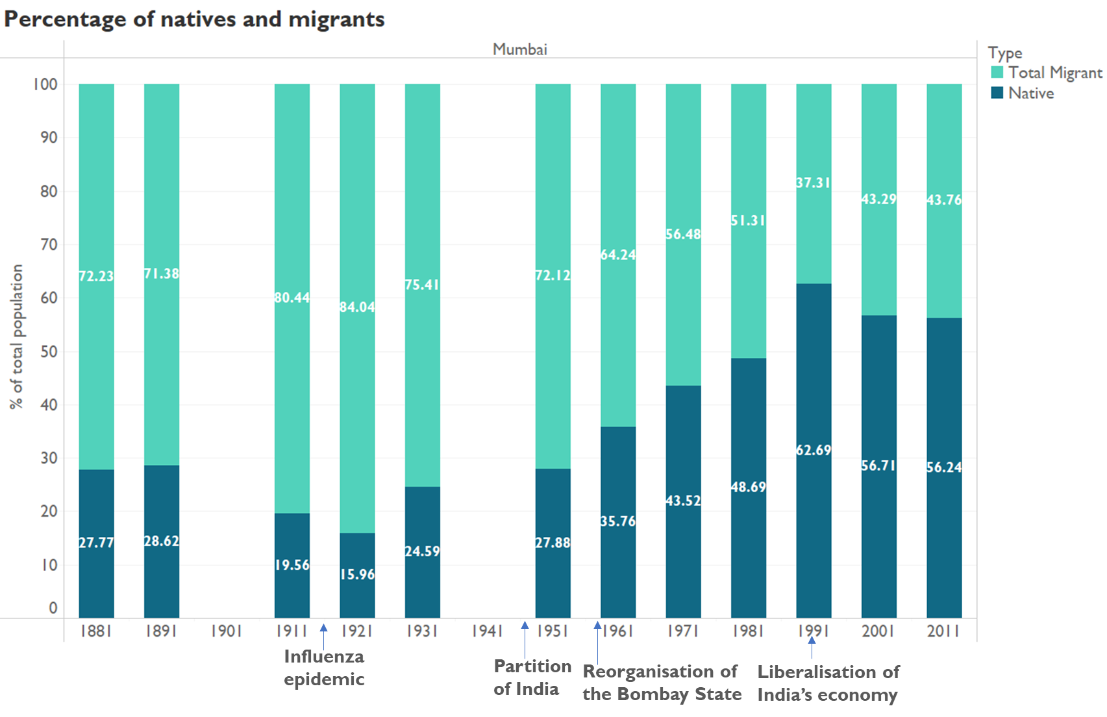

Source: Author’s own

The figure depicts the overview of total natives and migrants in Mumbai. From the figure, it can be concluded that Mumbai’s population is seeing a shift from being predominantly composed of migrants to being composed of a higher proportion of natives.

Between 1881 to 1981, the population of Mumbai was predominantly migrants with the peak in the percentage of migrants occurring in 1921. Moreover, after the largest drop in percentage of migrants (between 1981 to 1991), the percentage of migrants has slowly risen again till 2011.

Since the migrants being depicted in the graph are defined as migrants by birthplace, it may the case that those who came as migrants in the earlier decades continued to reside in Mumbai and the generations after them were born in Mumbai itself, thus not being counted as migrants.

Another reason for reduction in the migrant population is the anti-migrant sentiment that gained prominence in the 1960s after the linguistic reorganisation of the states into Maharashtra and Gujarat and with the formation of the political party Shiv Sena in Maharashtra (Gaikwad & Nellis, 2017; Chari, 2016). This party and other nativist politicians have an agenda that includes but is not limited to reservation of public-sector jobs for those who are speakers of Marathi, not giving voter identification cards and other public services to migrants, and at times, punishing migrants for celebration of non-local festivals ( Hansen 2000 as cited in Gaikwad & Nellis, 2017; Pashlikar 2004 as cited in Gaikwad & Nellis, 2017; India Today 2008 as cited in Gaikwad & Nellis, 2017; Tehelka as cited in as cited in Gaikwad & Nellis, 2017 ). Such goals act as a barrier for migrants and also may discourage individuals considering to shift to Mumbai.

Figure 12   
Percentage of different types of migrants and natives in Mumbai from 1881 to 2011

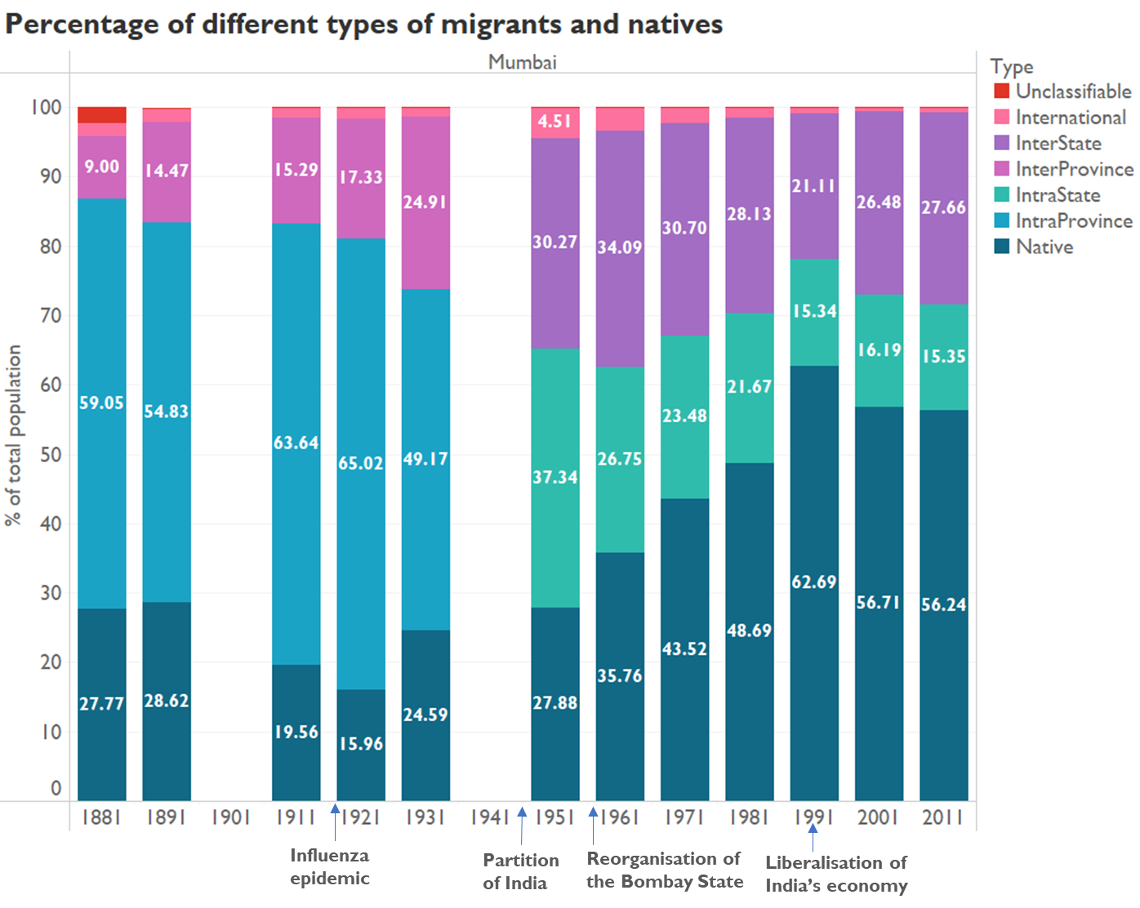

Source: Author’s own

In Figure 12, the composition of the population by natives and the different types of migrants is displayed for Mumbai. As was evident from Figure 3, the percentage of the native population has been on the rise. Other notable observations include the change in the percentages of the intraprovince to the percentages of the intrastate migrants as well the high percentage of international migrants in 1951.

During the colonial period, the population of intraprovince migrants was the highest in each of the decades. For instance, in 1931, several individuals migrated from the United

Provinces, Punjab, Madras, Ajmer-Merwara and Baroda (Dracu & Sorley, 1932).

However, the interstate migrants, which one may assume to be similar to intraprovince migrants since the individuals were migrating within one region, reduced by 1961. At the same time, the highest proportion of the population became the migrants from other states in 1961 and natives in the consequent decades. Moreover, from 1961 onwards, the percentage of migrants from other states outweighed the percentage of migrants from within the state. This can be attributed to the change in the boundaries of the state. Prior to 1960, the states of Maharashtra and Gujarat were one province known as the Bombay Presidency during the British rule and as the state of Bombay after independence (Chandramouli, 2011). In 1960, the state of Bombay was split into Gujarat and Maharashtra due to linguistic reorganization of states (Chari, 2016). Hence, in terms of the present-day boundaries, the intraprovince migration was occurring from two states. Perhaps, a major portion of migrants migrating to Mumbai have been coming from Gujarat, hence explaining the change in the higher percentage composition of the population being of the intraprovince migrants to migrants from other states. The data between 1991 to 2011 shows that the top three source states of migrants were Uttar Pradesh, Gujarat and Karnataka (Government of India, 2014a; Government of India, 2014b; Government of India, n.d.). Additionally, post the Independence, other major source states of migrants include Bihar, Madhya Pradesh, Andhra Pradesh and Rajasthan (The Maharashtra Census Directorate, 1992).

Moving to the observation regarding the high number of international migrants in 1951; the aforementioned can be attributed to the Partition of India which occurred in 1947 (The Partition Museum, 2022). Out of 4.51%, which was the total percentage of international migrants, 4.21% hailed from other countries in Asia. Specifically, 103,713 individuals, which is

3.65% of the total population of Mumbai in 1951, were born in Pakistan (Bowman, 1953b). It is important to note that during 1951, Pakistan included the present-day Bangladesh as well (The Partition Museum, 2022). Thus, this included people who migrated as well as people who had settled decades before but their place of birth became classified as another country.

## **Surat**

In 1772, Surat used to be regarded as one of the most significant emporiums of trade. However, after this time period, it experienced a decline in trade since the trade industry shifted to Mumbai (Trivedi, 1964). In 1901, the diamond industry was established and started growing in the 1970s. Today, Surat is known for its diamond industry as a Diamond hub of the world (Directorate Of Census Operations Gujarat, 2011). It is important to note that the raw materials for this industry come from Africa (Win, 2017). Surat is also well known for its textile industry (Directorate Of Census Operations Gujarat, 2011). Both industries have been attracting migrants (Engelshoven, 1999).

Other popular industries in Surat include art-silk, power looms and the mill industry (Directorate Of Census Operations Gujarat, 2011). Surat is also one of the fastest developing cities in the world (Directorate Of Census Operations Gujarat, 2011). Surat has undergone several changes in its boundaries across the years.

Figure 13  
a) Surat boundaries in 1941 b) Surat boundaries in 1951

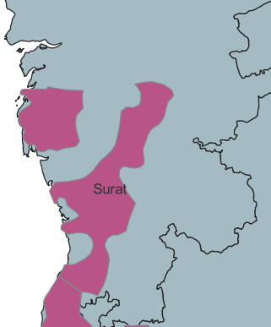 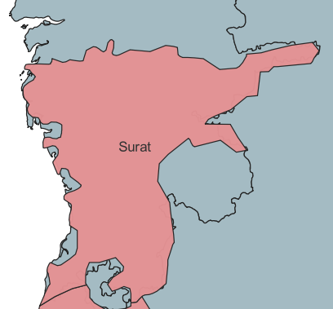

After Independence in 1947, territories in the Dharampur and Bandsa States as well as Navsari Prant which was part of the Baroda state, were combined with the pre-existing Surat area to form the Surat district (Trivedi, 1964).

Figure 14   
a) Surat boundaries in 1961 b) Surat boundaries in 1971

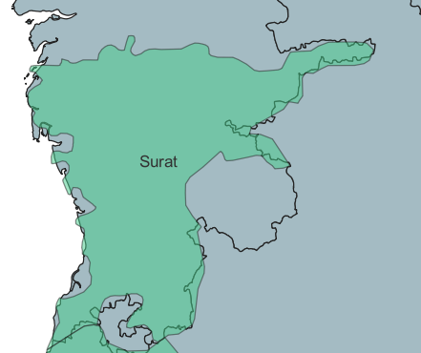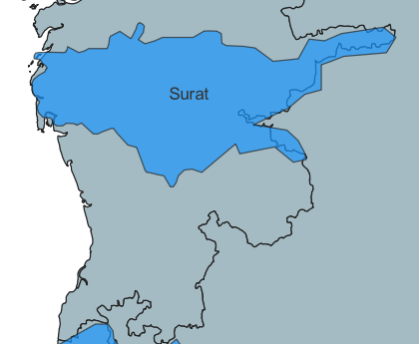

Surat district was bifurcated into Surat and Valsad in 1964 (Doctor, 1972).

Figure 15   
a) Surat boundaries in 2001 b)Surat boundaries in 2011

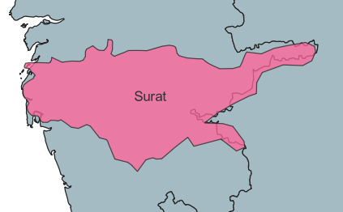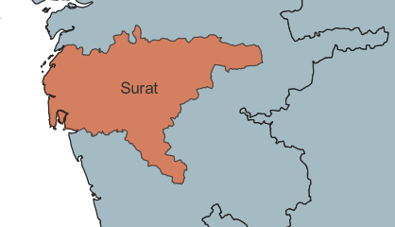

In 2007, the Surat district was split into two, and the Tapi district was formed (Directorate Of Census Operations Gujarat, 2011). For the analysis, the Surat district has been used throughout, hence some of the changes in the numbers would be a result of differences in district boundaries.

Figure 16   
Population of Surat from 1881 to 2011

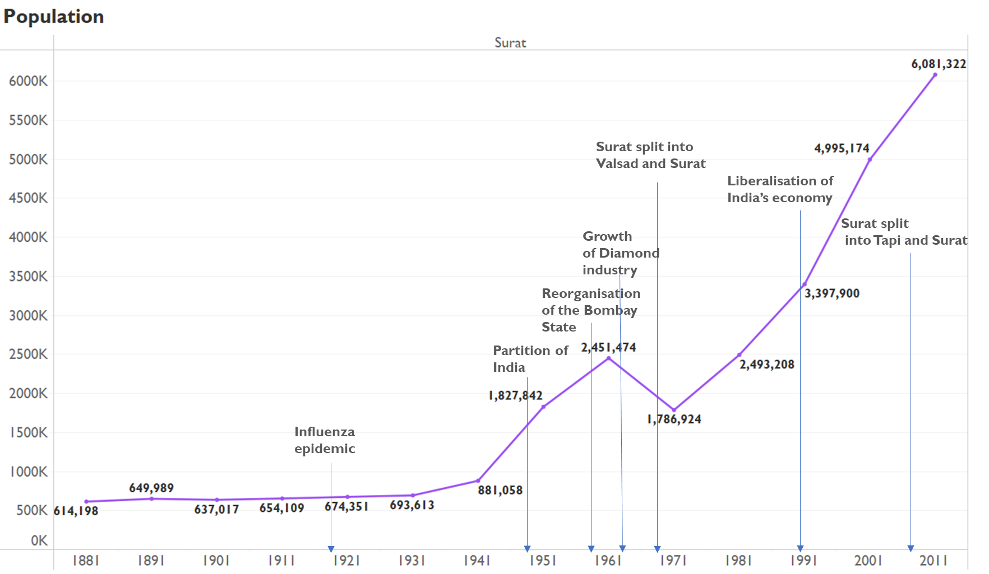

Source: Author’s own

Figure 17   
Decadal Population Growth of Surat from 1881 to 2011

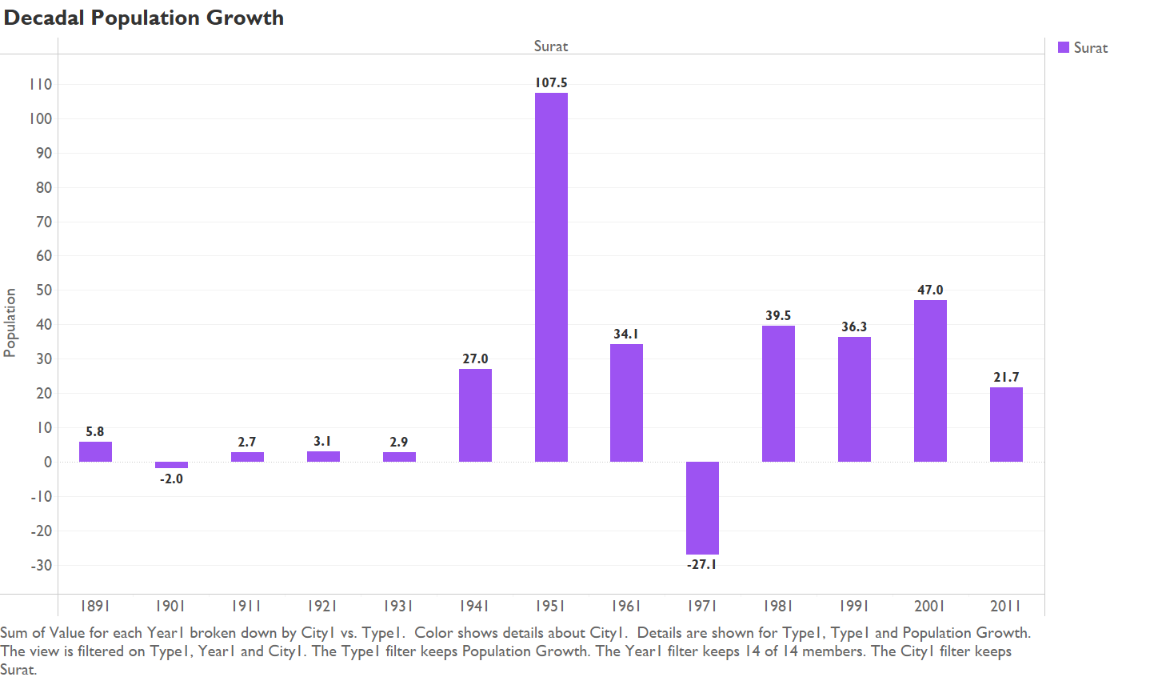

Source: Author’s own

From this figure, it can be observed that Surat’s population has overall risen since 1881. Between 1901 to 1931, the population figures were more or less constant, ranging between negative 2 and positive 3. There were many natural disasters which may have led to the lack of growth in population. There was a severe flood in 1883 and a fire in 1889 in Surat (Trivedi, 1964). Additionally, there were famines in the late 19th century and the epidemic in 1918-19. Finally, there were floods in the Gujarat and Sindh regions between 1921 to 1931 (Bowman, 1953a).

Secondly, Surat was not a hub of migrants between 1881 to 1951 (Bowman, 1953a). An example which demonstrates the same is that in 1931, there was only one province from which interprovince migration was occurring, which was the Ajmer Merwara province. Hence, one more factor that led to growth of population was not present.

A third reason for the especially low increase reported in 1931 could be the underenumeration that occurred due to the disturbed political conditions (Bowman, 1953a).

In 1951, there was an increase in population which can partially be attributed to the migrants entering due to Partition of 1947 (Bowman, 1953a). Another reason for the rise could be the expansion in the boundaries of Surat and regions that Surat was constituted of. The growth in the decade of 1951 to 1961 occurred due to enhancement in public health and medical services and the consequent drop-in death rate (Trivedi, 1964). The drop in population seen from 1961 to 1971 is due to change in district boundaries as Surat was split into Surat and Valsad (Doctor, 1972). After this, there has been a steady rise in population even after Surat was further split into Surat and Tapi in 2007 (Directorate Of Census Operations Gujarat, 2011). The growth of the textile industry and the diamond industry in the 1960s has attracted migrants which also led to the rise in population.

Figure 18   
Percentage of total migrants and natives in Surat from 1881 to 2011

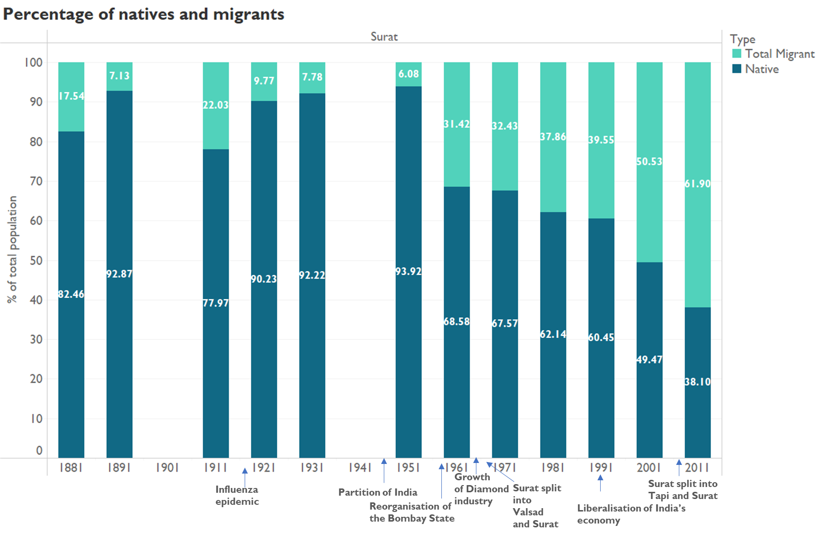

Source: Author’s own

Contrary to the trend seen for Mumbai, Surat has been shifting from having a predominantly native population to harbouring more migrants. Until 1991, majority of the population was composed of natives, in 2001, both kinds of population were around 50% and in 2011, the migrant population overtook the native population.

Although Gujarati emigrants from East Africa set up the diamond industry in the early 20th century, the industry only began to take off in the 1970s (Engelshoven, 1999; Directorate of Census Operations Gujarat, 2011). The rise in migrant population also corresponds to this development as it is evident from the graph, that there was a sharp rise from 1951 to 1961, which has consequently increased over the decades. Simultaneously, several migrants also began to shift to Surat to work in the textile industry (Jayaram & Varma, 2020).

Figure 19  
Percentage of different types of migrants and natives in Surat from 1881 to 2011

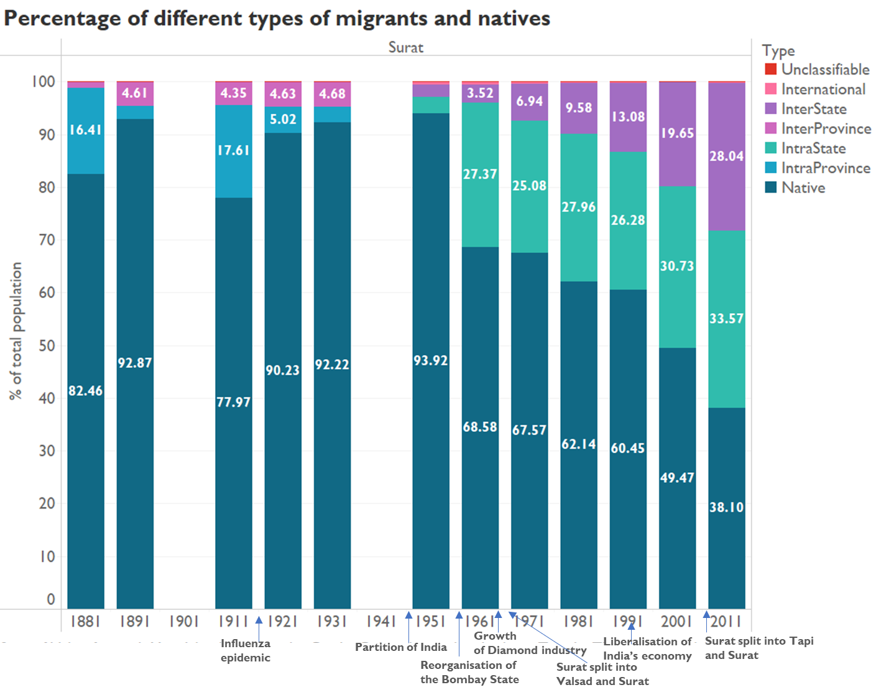

Source: Author’s own

In the figure above, the composition of the population by natives and the different types of migrants is displayed for Surat. As already established from the previous figure, the native population has been decreasing.

Between 1881 to 1921, there was a fluctuation in the percentage of native population and intraprovince population, where the two kept increasing and decreasing. However, since the data for 1901 is not present, there is no clear indication as to whether the native population gradually decreased and intraprovince migration gradually increased from 1891 to 1911.

While the percentage of intrastate migrants has remained within a 5% range since 1961, there has been a notable rise in the percentage of other state migrants since 1951 where it was approximately 7% to 2011 where it is around 28%. Since Surat was part of the Bombay

Presidency during the colonial period and Bombay state till 1960, the intraprovince and intrastate migration represented till 1951 would be from two states in the current time period. Here the sharp rise in intrastate migrants even after the split of the Bombay Presidency, represents that some phenomenon occurred that did result in a change in the trend. Additionally, the slight increase in other state migrants between 1951 to 1961, of around 1%, suggests that a part of the migrants in the previous years were from Maharashtra but majority of the migrants hailed from states other than Maharashtra. Major sending states include Odisha, Uttar Pradesh, Bihar, Jharkhand and Madhya Pradesh (Surat Municipal Corporation, 2022). Specifically, a majority of the interstate migrants are from Ganjam, Odisha and these migrants are employed in the textile industry (Jayaram & Varma, 2020). It is important to note that there is a divide between the industries migrants are employed in based on their place of origin: interstate migrants are usually given jobs in the textile industry and intrastate, that is Gujarati migrants, are usually given jobs in the diamond industry (Chowdhury, 2020; Subramaniam, 2018).

The international migration has been miniscule. Similar to Mumbai, there was a slight increase in the international migration from 0.1 in 1931 to 0.58% in 1951. Once again, the highest value of international migrants hailed from Pakistan (0.46%) in 1951 and 6940 (0.38%) people of the population were born in Pakistan (Bowman, 1953b).

## **Kolkata**

Kolkata is regarded as the primary educational, cultural and commercial capital of East India. It is also the country’s oldest port along with being the only significant riverine port. It is also known for its textile and jute industry which grew rapidly from the 1850s (Directorate of Census Operations West Bengal 2015). Hence, it used to attract several migrants. It was also the capital of British India till 1911. Over the years, the migrant population has reduced which will be discussed further with the help of the figures below.

Figure 20   
a)Kolkata boundaries in 1941 b)Kolkata boundaries in 1951

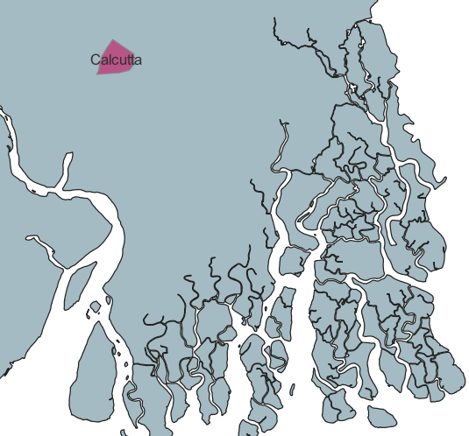 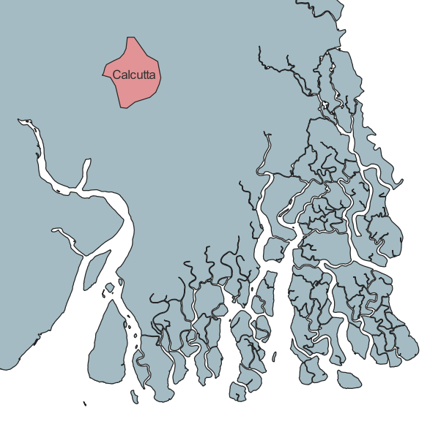

With regards to district boundaries, overall, not many significant changes were observed for Kolkata over the years. However, in the decade of 1941 to 1951, there were changes in the boundaries, resulting in Kolkata becoming larger in area (Chandramouli, 2011).

Figure 21  
*Population of Kolkata from 1881 to 2011*

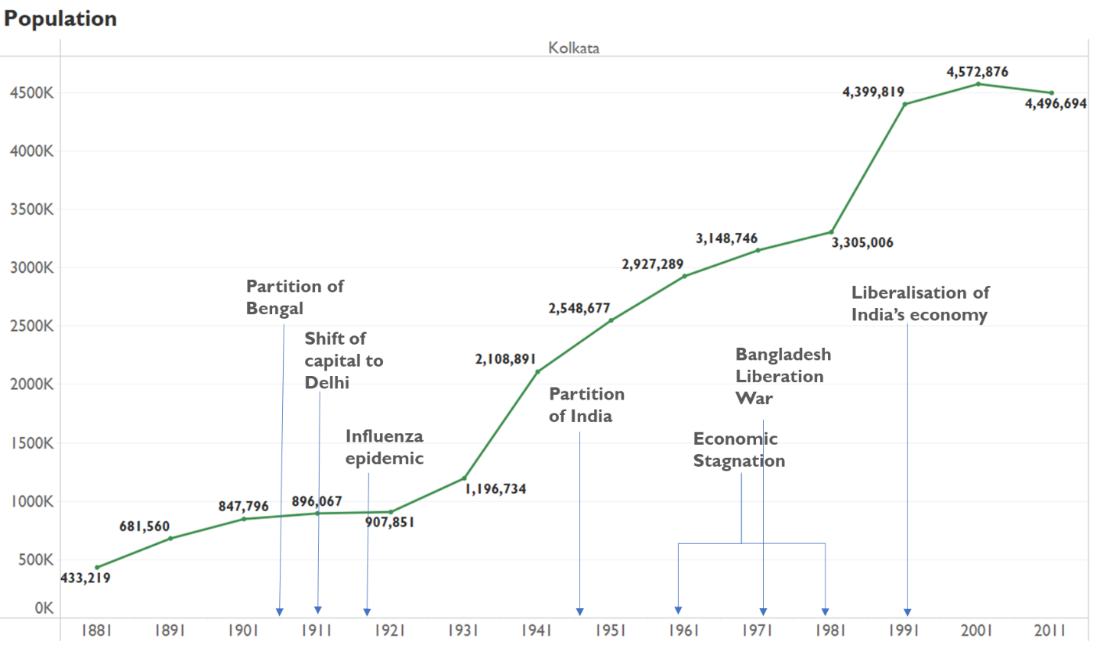

Source: Author’s own

Figure 22  
Decadal Population Growth of Kolkata from 1881 to 2011

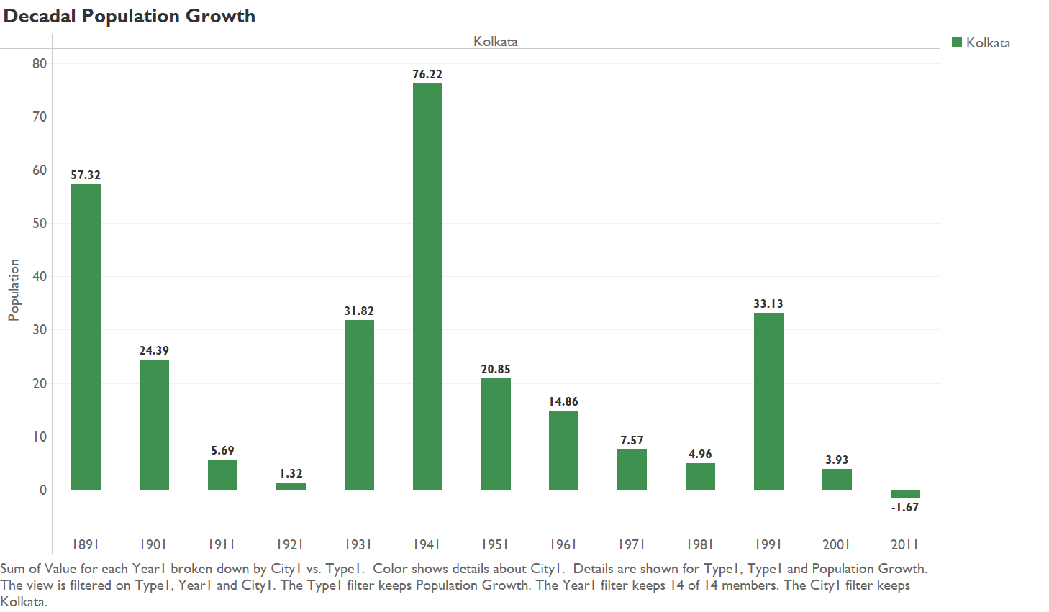

Source: Author’s own

It can be seen that the population in general has had phases of staggered growth. The population grew largely in the decade of 1881 to 1891, which can be attributed to the growth of the textile and jute industries in Kolkata (Directorate of Census Operations West Bengal, 2015).

Between 1901 to 1931, the population grew slowly. The Partition of Bengal occurred in 1905 which led to widespread protest and the Swadeshi movement where British goods were boycotted. The agitation of the people as well as Kolkata’s disadvantageous location prompted the shifting of the capital from Kolkata to Delhi in 1911. This shift could be a cause of reduction in population growth rate (Directorate of Census Operations West Bengal, 2015). Moreover, the influenza epidemic of 1918-19 would have also contributed to the slow growth.

Although, the graph does not depict the change from 1941 to 1951, there were several factors which had impacted the population figures of Kolkata differently. There were bombings by the Japanese in 1942-1944 because of World War II, a famine in 1943-44, communal riots in

1946 (referred to as the Great Killing of August) and 1950, and exodus of Muslims after the Partition (Directorate of Census Operations West Bengal 2011; Mitra, 1954). These factors would have negatively impacted the growth rate. However, during the time of the Partition, over hundred thousand Hindus shifted to Kolkata, which led to increasing the population and can be observed in the 1951 value presented (Directorate of Census Operations West Bengal, 2015).

After this, once again, it can be seen that Kolkata’s population growth rate steadily declined till 1981. In the 1960s and 1970s, drastic power shortages, strikes and Naxalites’ violent attacks led to economic stagnation, which in turn must have affected the population figures. However, some increase in population may have occurred, since in 1971, thousands of refugees came to Kolkata due to the Bangladesh Liberation War. By the mid-1980s, the most populous city shifted from Kolkata to Mumbai (Directorate of Census Operations West Bengal, 2015). The sharp rise from 1981 to 1991 is due to the merging of three municipalities of the 24 Parganas with the Calcutta Municipality (Directorate of Census Operations West Bengal, 1991).

In the 1990s, the recovery of the economy began due to India changing to an open economy. This may be the cause for the minor increase in population between 1991 to 2001. Moreover, from 2000 onwards, the Information Technology sector was set up in Kolkata which helped in bolstering the city’s economy (Directorate of Census Operations West Bengal 2015). However, there is still a decline in population that has been observed between 2001 to 2011, which could be due to several rural migrants leaving the city (Devulapalli, 2019).

Figure 23   
Percentage of total migrants and natives in Kolkata from 1881 to 2011

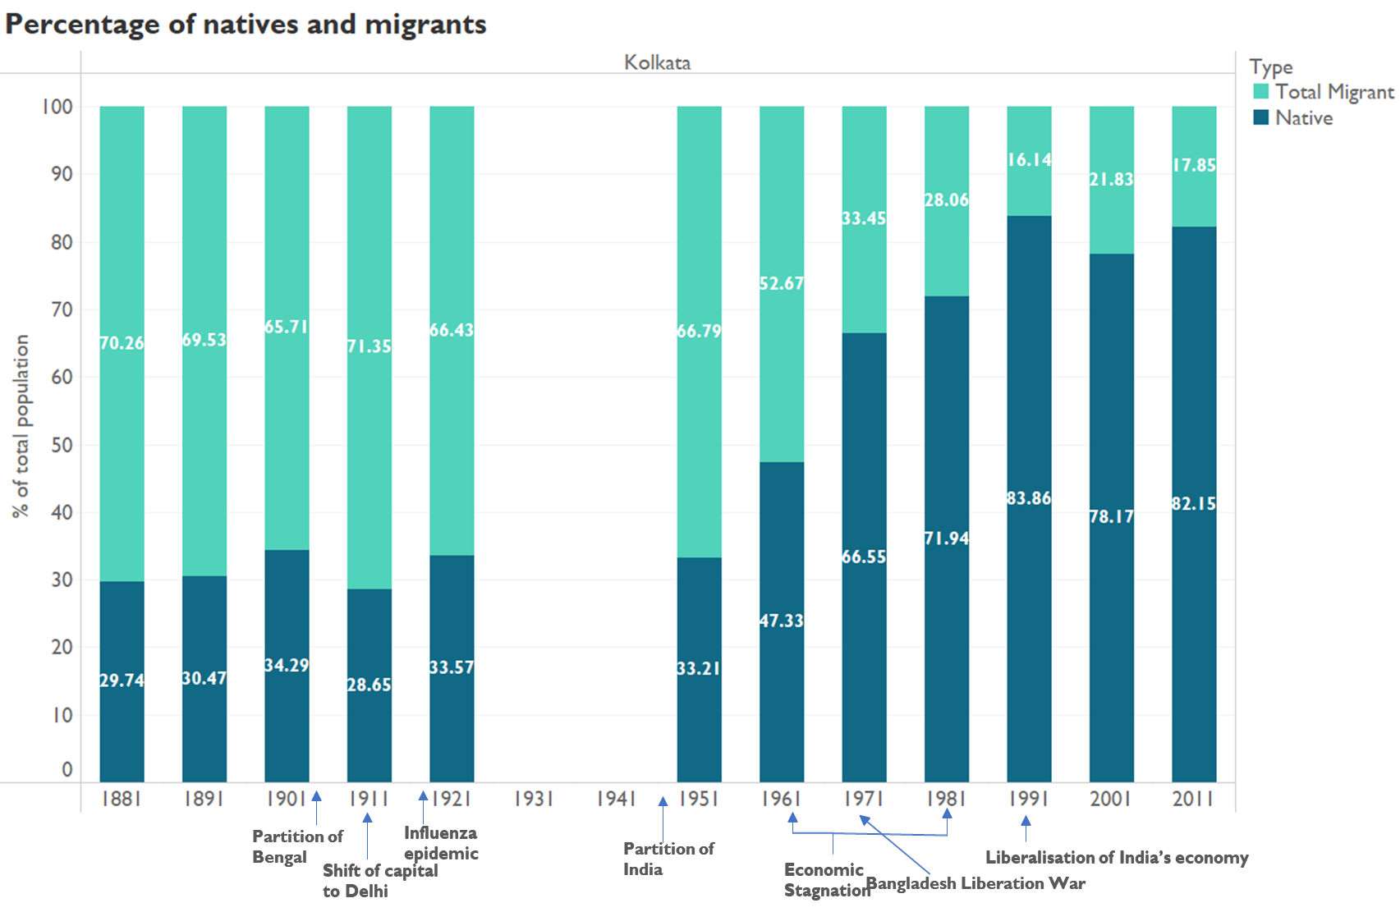

Source: Author’s own

It can be seen that similar to Mumbai, Kolkata went from being composed of predominantly migrants to being composed of majorly natives. However, the change has been far more drastic than what was observed in Mumbai.

Between 1881 to 1951, there were fluctuations in the migrant population percentages.

While the cause for the slight dip between 1891 to 1901 cannot be ascertained, the approximately 5% drop in migrant population between 1911 to 1921 was perhaps due to the epidemic where migrant workers would have returned home (Tumbe, 2022). There was no data present for 1931 and 1941 so the changes could not be observed, but one of the reasons for the migrant population percentage remaining high in 1951 would be the mass movement of people into Kolkata during the Partition of India.

The drop in migrant figures from 1951 to 1991 may have occurred due to the economic stagnation in the 1960s and 1970s. The 5% increase in migrants between 1991 to 2001 may have been due to Kolkata’s economic recovery, which in turn attracted migrants to the city once again.

Figure 24  
 Percentage of different types of migrants and natives in Kolkata from 1881 to 2011

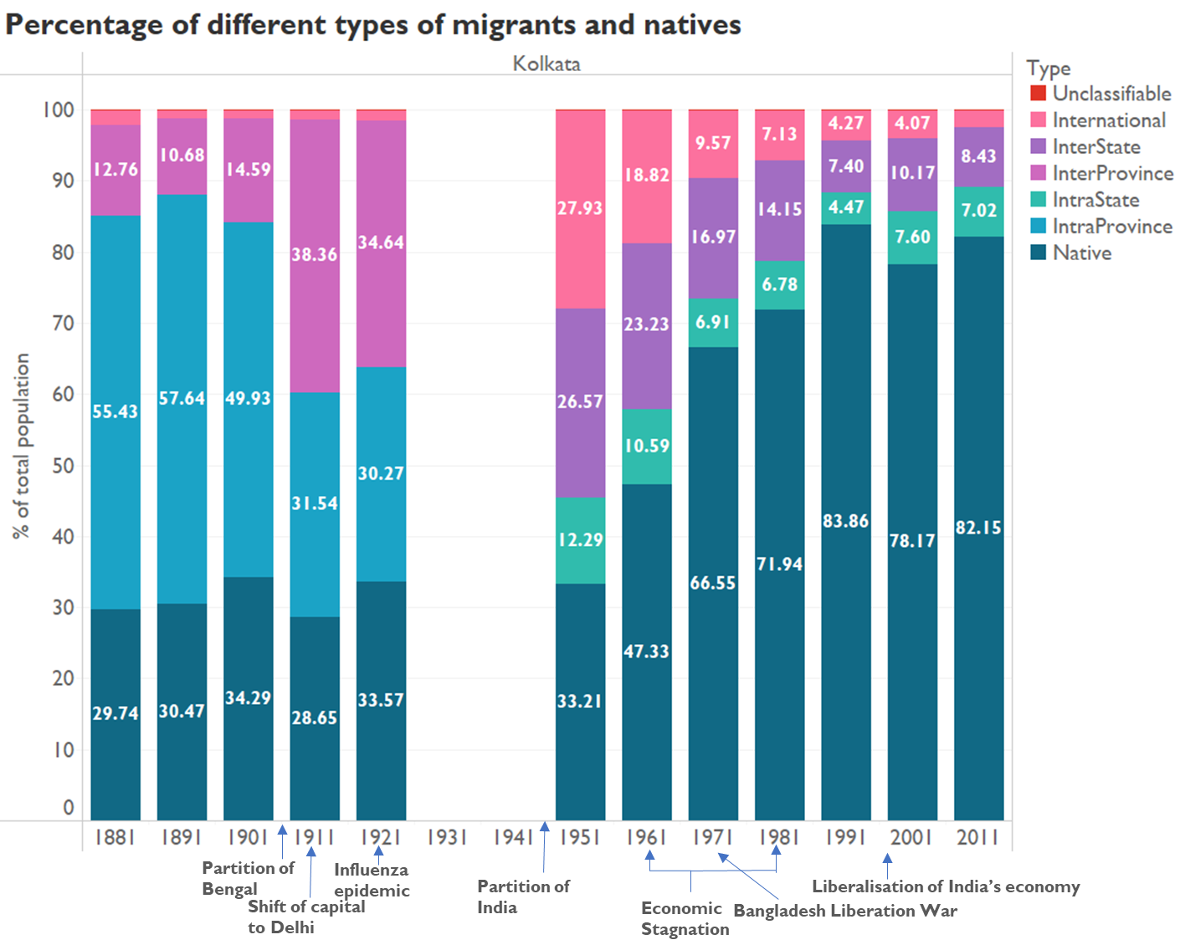

Source: Author’s own

As established previously, the native population of Kolkata used to be smaller in proportion to the migrants but increased over the years.

Between 1881 to 1901, the majority of the population was composed of intraprovince migrants. However, in 1911, the composition changed and there was a higher proportion of interprovince migrants. This change reflects the Partition of Bengal in 1905, as those who were considered as intraprovince migrants in the previous decades, became interprovince migrants as they were coming from East Bengal (Directorate of Census Operations West Bengal, 2015).

While the intraprovince and interprovince percentage of migrants remained similar in 1911 and 1921, after 1951, both interstate and intrastate migrants kept declining. As of the 2011 data, major source states are Jharkhand, Odisha, Bihar and Uttar Pradesh (Sen, 2019).

Finally, a high percentage of international migrants were observed for 1951 and 1961. In general, across the cities being compared in this study, the percentage of international migrants for Kolkata and Delhi is higher. The observations regarding international migration for the city will be explored in the section: *International migration in the four metropolitan cities*.

## **Bangalore**

Bangalore only began to attract a considerable number of migrants post-independence. Today it is known for its Information and Communications technology sector and is regarded as the “Silicon Valley” of India (Dey & Pendharkar, 2019; The Editors of Encyclopaedia Britannica, n.d.). Other significant sectors and industries attracting migrants include the public sector, manufacturing industry and automobile industry (Dey & Pendharkar, 2019).

Over the years, there have not been significant changes in the district boundaries. However, there have been multiple political and administrative changes. Major changes are highlighted below.

Figure 25   
Bangalore boundaries in 1981 Bangalore boundaries in 1991

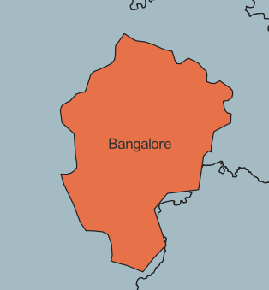 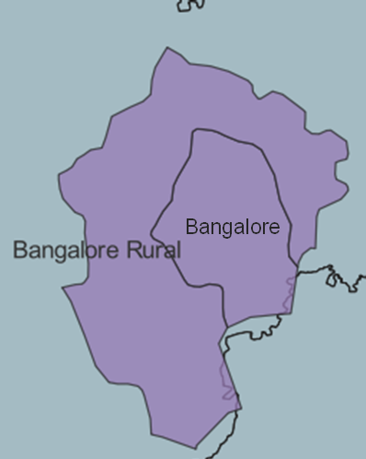

During the decade of 1981 to 1991, the Bangalore district was split into Bangalore and Bangalore Rural. The Bangalore rural region was created by the transfer of certain villages in the taluks Bangalore North, Bangalore South and Anekal (Nambisan, 1992).

Figure 26   
Bangalore boundaries in 2001 Bangalore boundaries in 2011

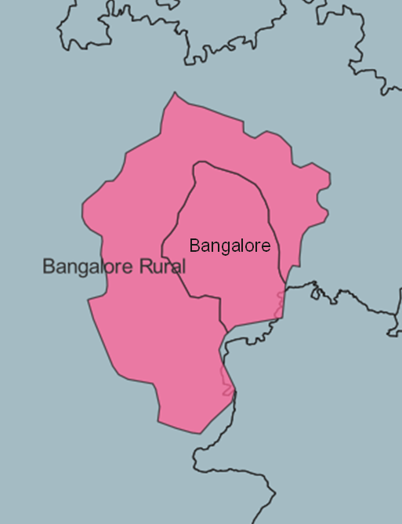 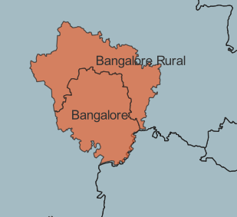

Between 2001 to 2011, a new district was carved out of Bangalore rural which is known as Ramanagara (Chandramouli,2011).

In the analysis, only Bangalore district has been considered. Hence the region being studied post 1981 is smaller than in the previous decades.

Figure 27   
Population of Bangalore from 1881 to 2011

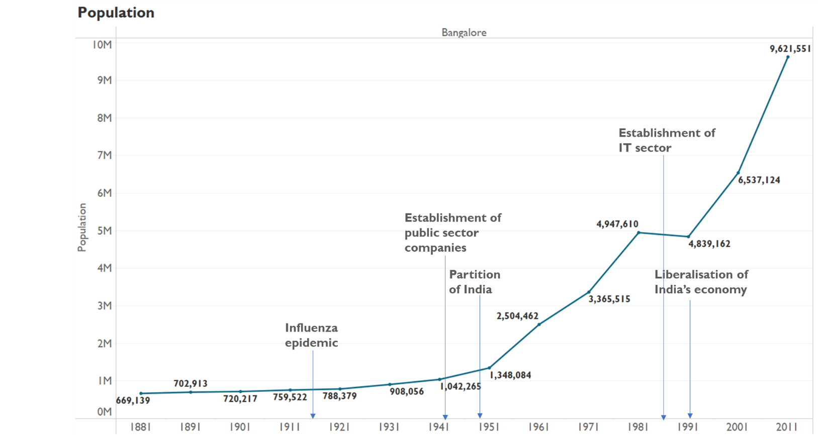

Source: Author’s own

Figure 28  
 Decadal Population Growth of Bangalore from 1881 to 2011

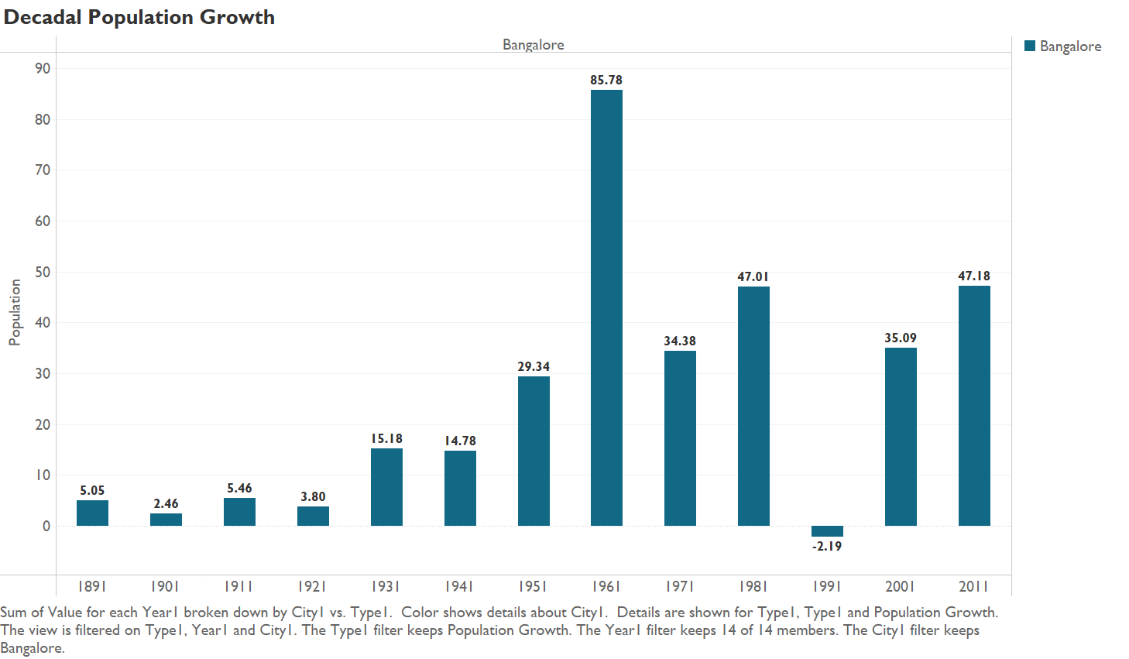

Source: Author’s own

In the figure it can be observed that the population growth was minor till 1921. Between 1921 to 1931, the increase was slightly more than the previous decades. However, it is only after 1951, that a rapid increase in population is seen, especially in the decade of 1951 to 1961.

Since, there were fewer migrants prior to 1951, this is one reason why the population growth was minimal. However, there were other factors which may have affected the population growth. In 1877, there was a famine which led to many deaths by starvation. Although the population did begin to recover, the famine did seem to affect the population till 1901. Moreover, there was a plague in 1899 which may have affected population growth (Iyengar, 1932). Furthermore, the growth of the Mysore state population as a whole between 1911 to 1921 was the lowest recorded (as of 1931) amongst all the Census records for Mysore. The reasons for the same included the influenza epidemic in 1918-19 and the food distress which also occurred in 1918 (Iyengar, 1932).

Industrialisation that began in the decade of 1941 to 1951 led to an increase in migration and hence, population. This industrialisation included the establishment of Hindustan Aircraft Factory and Indian Telephone Industries as well as expansion of the pre-existing iron and steel industries (Mallaradhya, 1954).

Moreover, in the 1980s, the Information and communications technology sector was started with the setting up of Infosys and Wipro (Dey & Pendharkar, 2019). Hence, it would be expected that an increase in population would be seen from 1981 to 1991. However, a drop in population is observed which is actually a result of the change of Bangalore’s district boundaries to Bangalore and Bangalore rural. Post 1991, Bangalore’s population continued to grow due to the expansion of the Information and communications technology sector.

*Figure 29*   
Percentage of total migrants and natives in Bangalore from 1881 to 2011

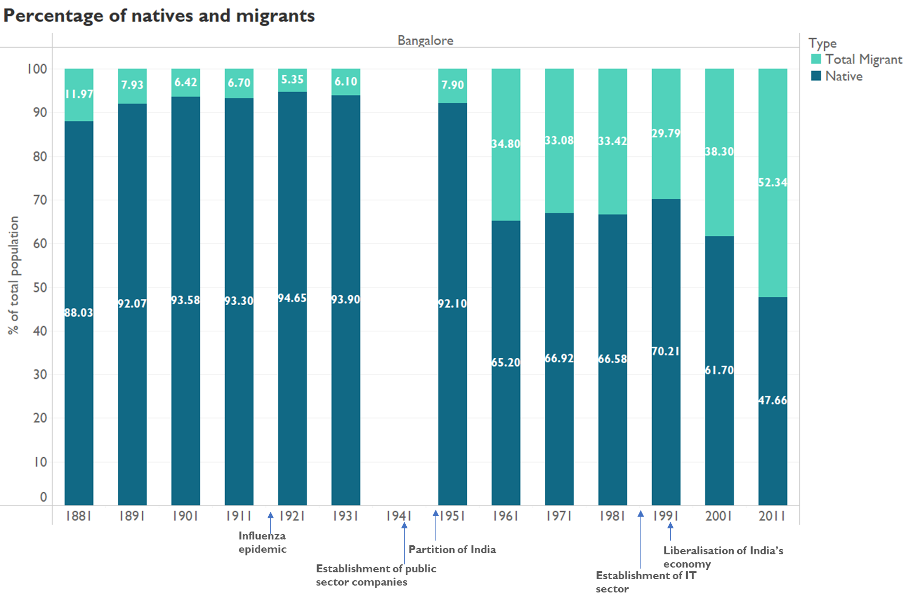

Source: Author’s own

The figure illustrates that initially, Bangalore was majorly composed of native population. The percentage of native population remained similar till 1931. Although, data for the composition in 1941 is not present, the sharp rise in migrant population in 1951 can be attributed to the migrants who came to the city during the industrialisation in the 1940s (Mallaradhya, 1954). Post-independence, the central government also decided to construct strategic industries in Bangalore due to it being comparatively distant from the borders of China and Pakistan (Dey & Pendharkar, 2019). Hence, this along with the other industries led to growth in migrant numbers between 1961 to 1981. A drop in migrant population in 1991 can be attributed to the change in the district boundaries. Finally, the rise in migrants post 1991, is a culmination of India’s liberalisation and the growth of informational technology and multinational companies (Dey & Pendharkar, 2019).

Figure 30   
Percentage of different types of migrants and natives in Bangalore from 1881 to 2011

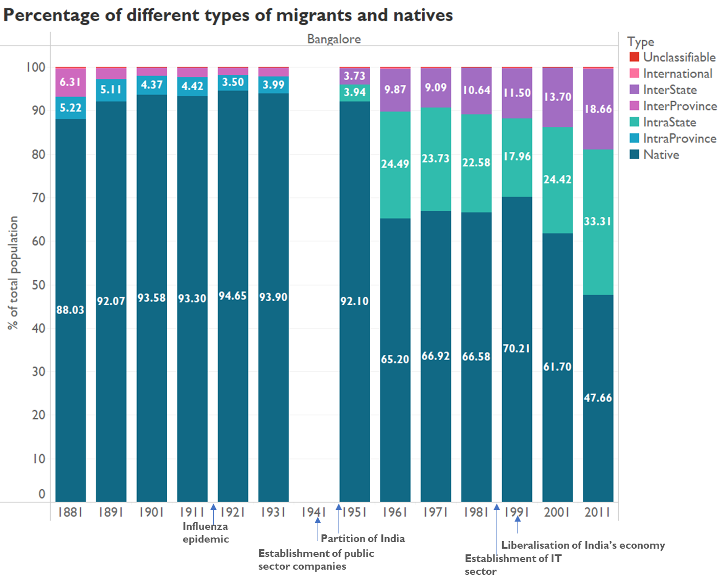

Source: Author’s own

The graph once again establishes the rising intrastate and interstate migrants post 1951. It is important to note that in 1956, linguistic reorganisation of the Mysore state (now known as Karnataka) occurred. During reorganisation, the Mysore State was merged with the Coorg province and certain districts that were in Bombay Presidency, Hyderabad State and Madras

Presidency to form the new Mysore State (Srinivasan, 2021). This may have led to the increase in intrastate migrants observed in 1961, as those born in the new districts that were merged would have been previously classified as interstate migrants.

After 1961, the intrastate migrants declined until 1991 and then began to increase once more. Once again due to the changes in Bangalore in 1991, the value for 1991 may not be accurate. On the other hand, after 1961, the population of interstate migrants has been on the rise. Between 1991 to 2011, the top three migrant source states have been the neighbouring states of Tamil Nadu, Andhra Pradesh and Kerala (Government of India, 2014; Government of India, 2014; Government of India, n.d.).

Finally, it can be seen that the percentage of international migrants has remained low throughout 1881 to 2011. Unlike, Mumbai, Surat and Kolkata where an increase in population of migrants from Pakistan was observed in 1951, there was no significant population of international migrants around the time of the Partition in Bangalore. This was because Bangalore is quite far away from Pakistan. It would be more expensive to travel from Pakistan to Bangalore, so only those who could afford it would have shifted to Bangalore. Moreover, many of the migrants who were from Pakistan at the time of enumeration for the 1951 Census, had migrated to Bangalore long before the Partition. This included a considerable population of people from Sindh and Punjab, particularly Sindhi businesspeople (Mallaradhya, 1954).

## **Delhi**

Delhi is the capital of India. It has deep historical significance and is a transport, commercial as well as cultural hub. Being the capital city, it is also India’s political centre

(Sundaram, n.d.). The migrant population has fluctuated through 1881 to 2011. During major events such as the shifting of the capital to Delhi from Kolkata in 2011 and the Partition of India, it was observed that there was an increase in migrant numbers.

Throughout the years, the district of Delhi has undergone many changes in its boundaries.

Figure 31  
a) Delhi boundaries in 1891 b) Delhi boundaries in 1901

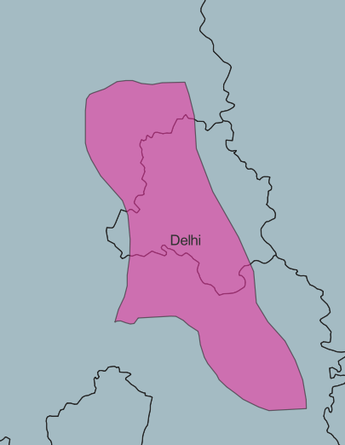 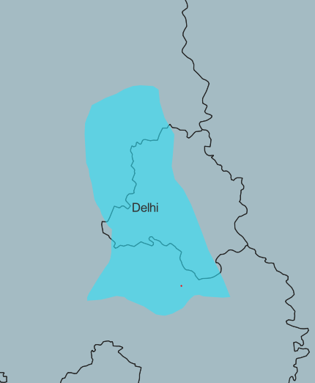

In the decade of 1891 to 1901, the boundaries of Delhi were changed and the area of Delhi was reduced (Chandramouli, 2011).

Figure 32  
 a)Delhi boundaries in 1911 b) Delhi boundaries in 1921

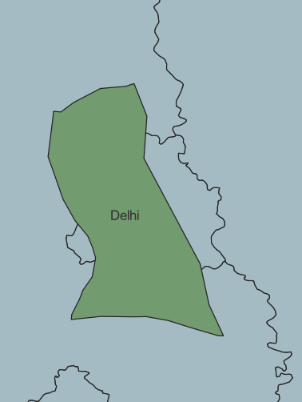 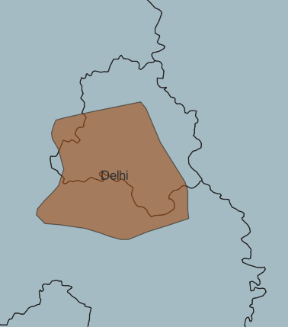

In 1911, Delhi became the capital of British India (Directorate of Census Operations West Bengal 2011). Subsequently in 1912, Delhi was formed as a separate province (prior to this, it was part of Punjab) (Khan, 1933). During these administrative changes, the boundaries were changed as well.

Figure 33  
 a) Delhi boundaries in 1941 b)Delhi boundaries in 1951

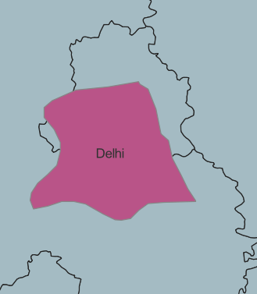 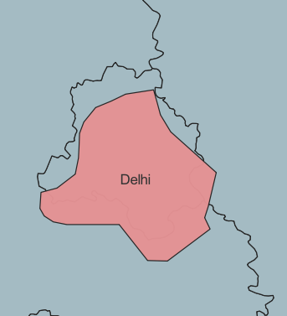

In the decade of 1941 to 1951 (the decade in which the Partition occurred), the district boundaries were once again changed, making the area of Delhi even smaller (Chandramouli, 2011).

Figure 34  
 Population of Delhi from 1881 to 2011

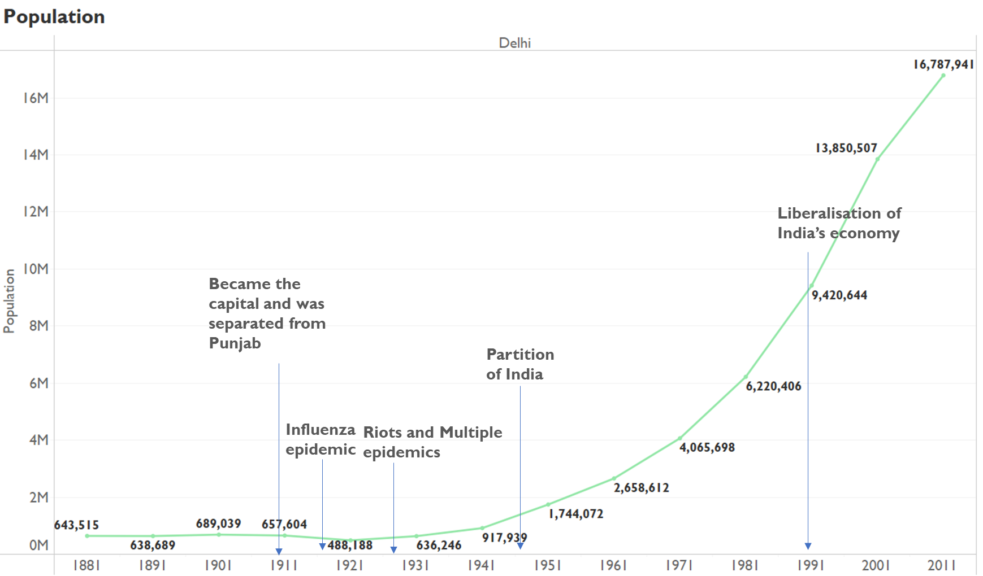

Source: Author’s own

Figure 35   
Decadal Population Growth of Delhi from 1881 to 2011

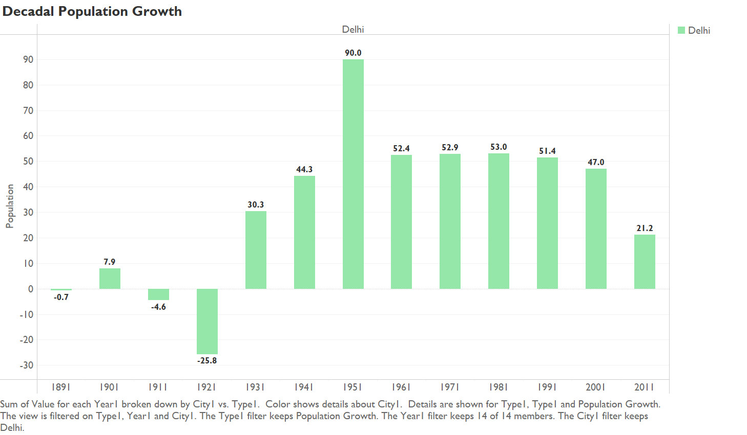

Source: Author’s own

The figure demonstrates that until 1951, not much population growth was observed. Although the process of industrialisation began between 1872 to 1879, there was a decrease in population between 1881 to 1891 (Vashishta, 1951). This may be because the population was still recovering from the famine of 1877. Between 1901 to 1911, there was another decrease in population observed which occurred due to destructive effects of the plague (Khan, 1933).

Although Delhi became the capital in 1911 and it would be expected that there would be a growth in population due to the shifting of authorities, a decline in population by 26% was observed. There were several factors for the same. The district boundary of Delhi became smaller so the area of enumeration itself would have led to a change. Additionally, the influenza epidemic of 1918-19 caused high mortality. Moreover, a large proportion of soldiers from India, majorly from Punjab fought in the First World War; hence their population may not have been accounted for. When many crop failures and high prices took place, and the higher death rates in influenza epidemic occurred, there was political unrest which could have also led to a reduction in population (Khan, 1933).

Between 1921 to 1931, there were multiple riots in the province, a cholera epidemic, spread of malaria, epidemic of plague which would have reduced population. However, there were also years which were free of epidemics where recovery occurred and would have led to an increase in population. Overall, the population increased in the decade (Khan, 1933).

The surge observed in 1951 can be attributed to the mass migration that occurred during the Partition in 1947. Post 1951, the population has been growing more rapidly as in accordance with the world population growth rates.

Figure 36   
Percentage of total migrants and natives in Delhi from 1881 to 2011

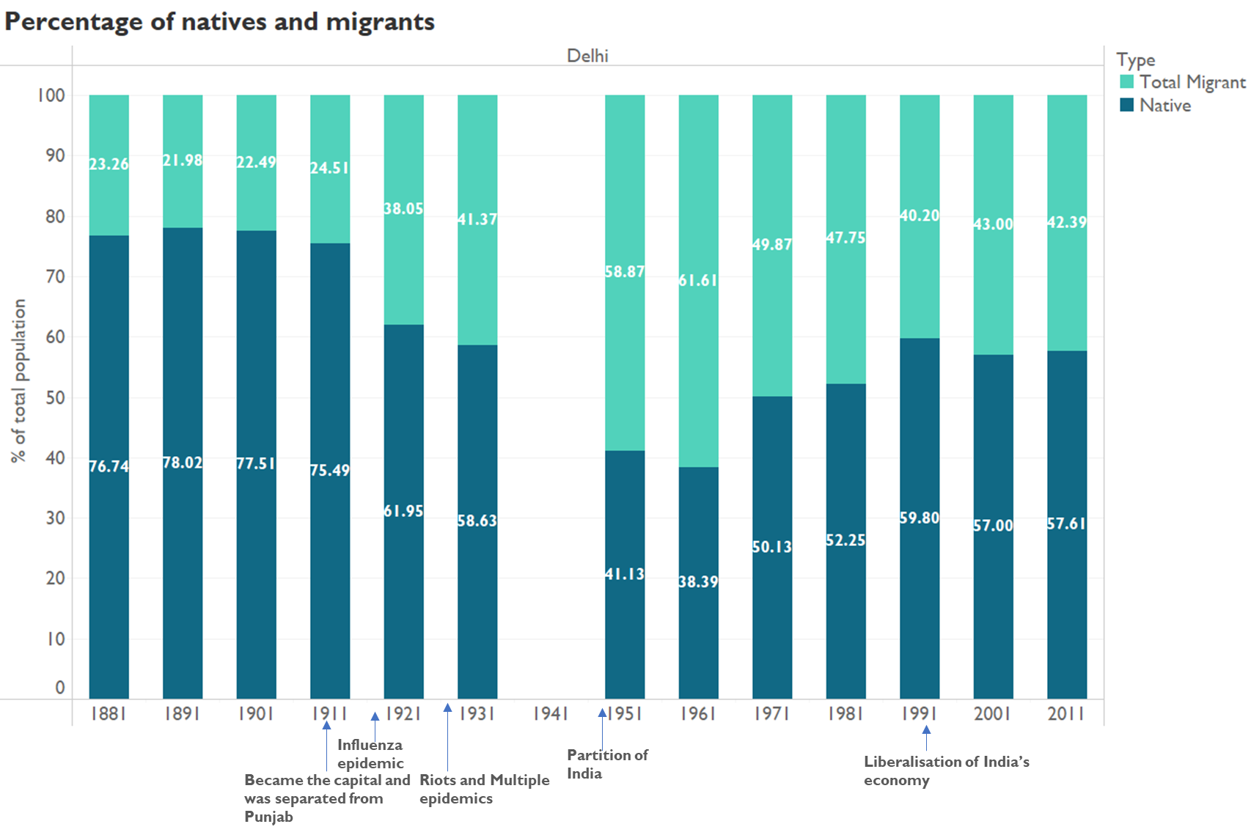

Source: Author’s own

Delhi has gone from being predominantly composed of natives to being composed majorly of migrants to slowly being composed of a majority of natives again. The first surge in migrants corresponds to the decade when Delhi was established as the capital. The second major surge in migrants corresponds to the decade when the Partition occurred. However, here there is no comparison to the 1941 composition so it is not known whether the intensity of the increase of migrants was as big as it seems in the graph.

After 1951, the percentage of migrants has been decreasing. One of the factors may be the traffic congestion that begun in the mid-20th century, which harmed mobility as well as the development of the city. Subsequently, this congestion worsened the level of air pollution in Delhi(Sundaram, n.d.). This may have discouraged migrants from moving to Delhi. There is a minor increase in migrant population between 1991 to 2001 which could be because of India’s liberalization in the 1990s. Finally, one more reason resulting in the declining population of migrants would be the domicile requirements of Delhi. To be considered for domicile, one has to produce documents such as residence and identity proof. Furthermore, an educational certificate of three years is not considered as a qualification (Mitra, Singh & Rawat, 2020). Such policies discourage migrants from considering shifting to Delhi.

Figure 37   
Percentage of different types of migrants and natives in Delhi from 1881 to 2011

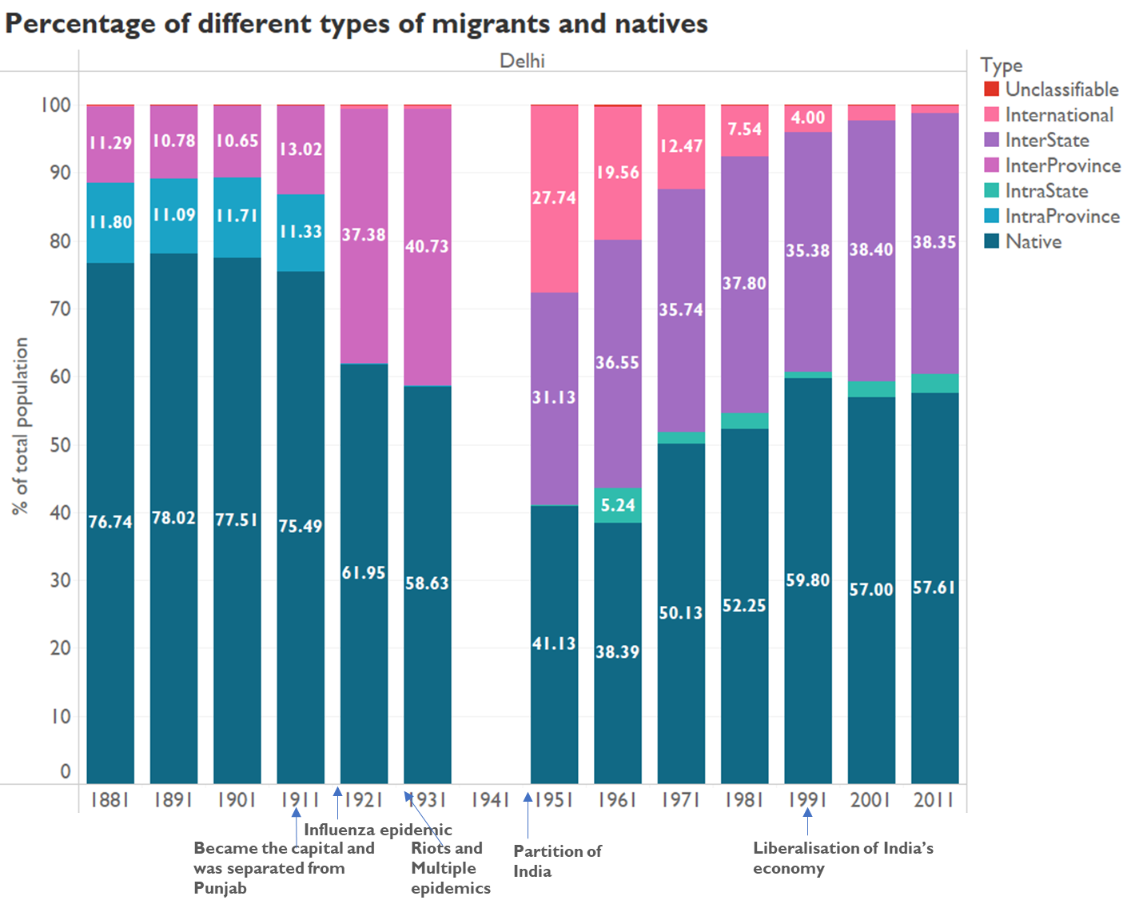

Source: Author’s own

This figure shows the changing patterns in the types of migrants for Delhi. It can be seen that across 1881 to 1911, the percentage of natives, interprovince migrants and intraprovince migrants remained similar.

Since Delhi became a province separate from Punjab in 1912, those who were considered as intraprovince migrants in Punjab till 1911, would thereafter be considered as interprovince migrants. This accounts for the rise in the interprovince migrants in 1921. Moreover, since Delhi is a separate province, there would be no intraprovince migration. This is applicable to Delhi after the Partition as well, as it became a Union Territory in 1956 (Aggarwal, 2019). Hence, the minor intrastate migration seen from 1961 is not actually migration, it is just movement of people within the Union Territory of Delhi. Since 1961, the percentage of interstate migrants has been in the range of 35 to 38%. Popular source regions of migrants since 1991 include Uttar Pradesh, Bihar, Jharkhand and Uttarakhand (Kawoosa, 2019).

Finally, Delhi also had a high percentage of international migrants in 1951 and along with Kolkata more international migrants in general in the subsequent years. This pattern of migration will be discussed further in the section: *International migration in the four metropolitan cities*.

## **International migration in the four metropolitan cities**

Among the eight cities observed, it was clear that international migration was significant only in Kolkata and Delhi. The international migration trends for Mumbai and Chennai are also provided so that the contrasts in the figures can be observed. It is to be noted that in the following two graphs, the international migrants are shown as a percentage of the total population of the city.

A common trend observed across the cities is that pre-Independence, the percentage of migrants from Europe used to be the highest whereas after Independence, the percentage of the migrants from Asia has been the highest. The reasoning for the same is that British residing in India would have contributed to the percentages of Europe born migrants during the colonial period. Furthermore, the high percentage of Asian migrants in 1951 observed is of the migrants who moved during the Partition or who had been born in Pakistan/Bangladesh earlier and settled in these cities but were classified differently due to India’s change in national boundaries.

Figure 38  
 International Migrants (except Asian migrants) as a percentage of total population

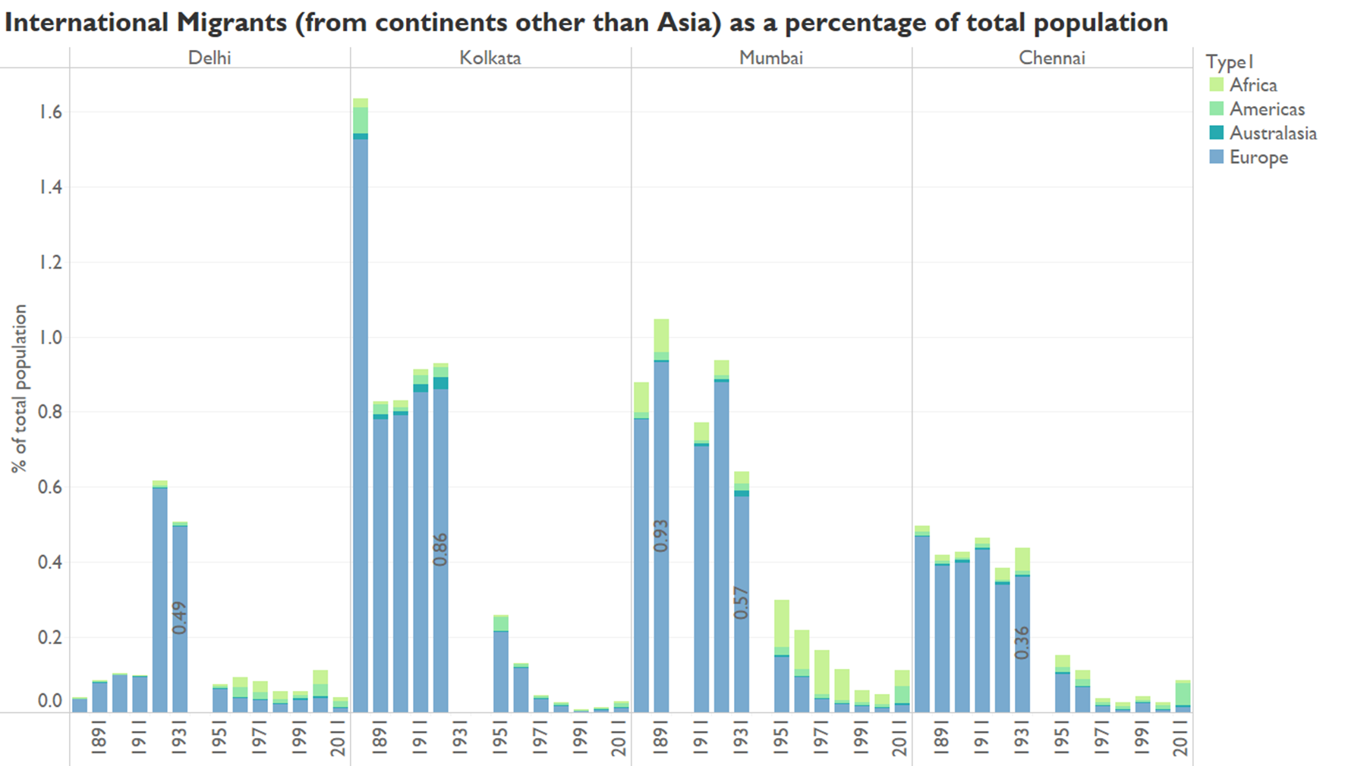

Source: Author’s own

Note: The year 1941 has been excluded from the analysis. Furthermore, the Partition of India occurred in 1947 which drastically affected the international migrant patterns. Americas includes countries in both North America and South America, as this was how it was defined in the Census.

Figure 39  
 Asian Migrants as a percentage of total population

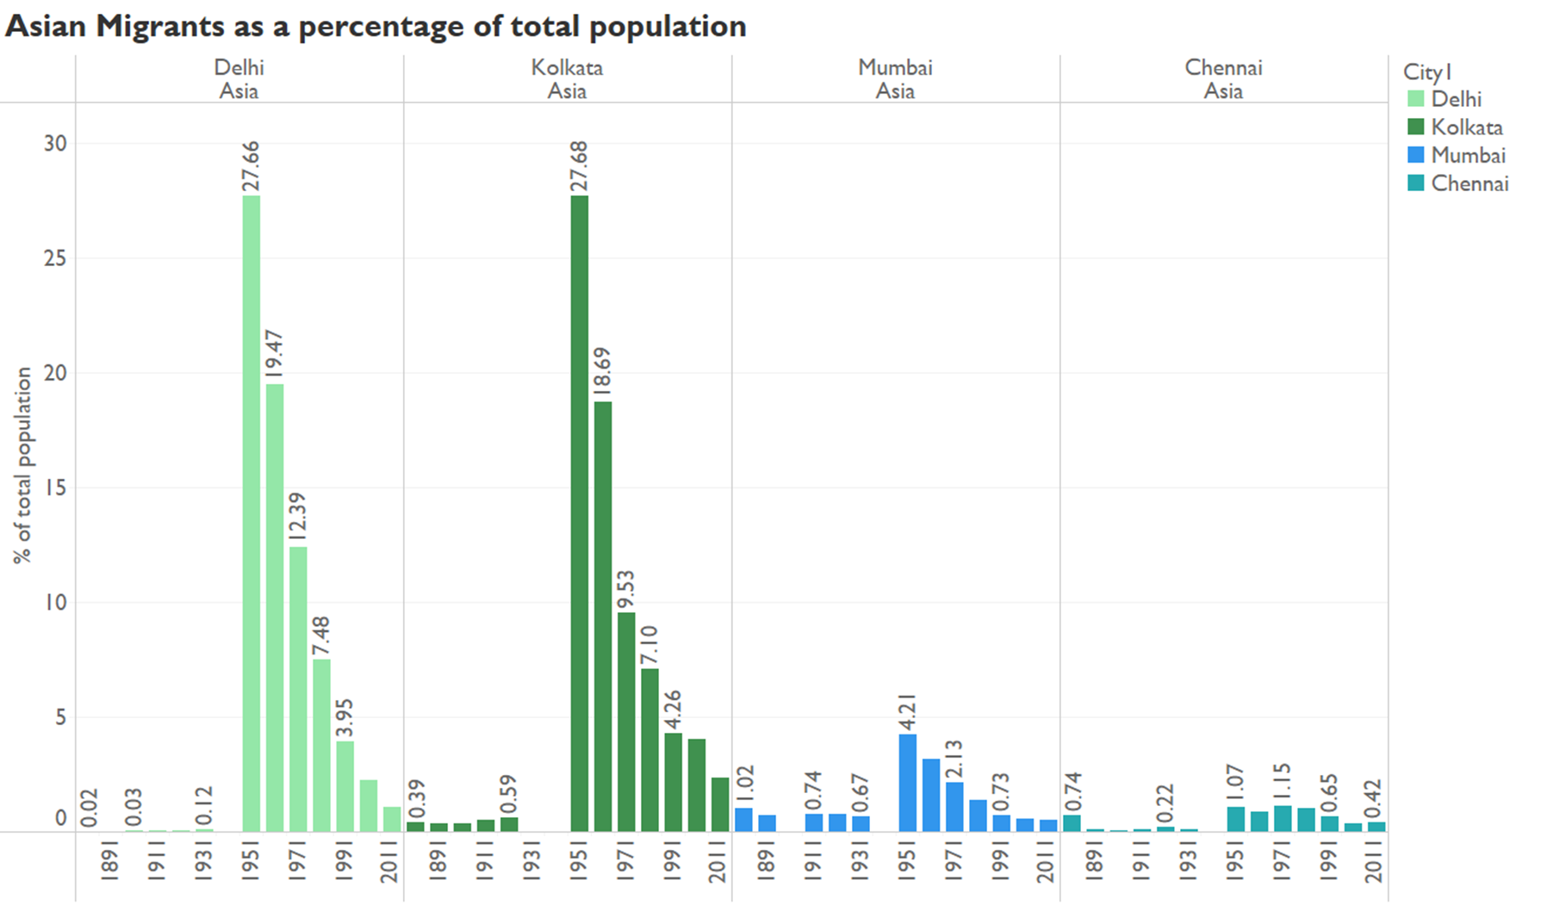

Source: Author’s own

Note: This includes all migrants from countries in Asia other than India. The year 1941 has been excluded from the analysis. Furthermore, the Partition of India occurred in 1947 which drastically affected the international migrant patterns.

***International migration in Kolkata***

In 1951, there were 685,672 migrants born in Pakistan (including East Pakistan), that is 27% of the total population (Mitra, 1953). Whereas in 1961, there were 528,205 migrants (18% of the total population) from Pakistan (Gupta, 1966). The 1971 Bangladesh Liberation war also led to a high percentage of Asian immigrants; the numbers of which are reflected in the 1981 composition, 1,19,587 (3.62%) from Bangladesh (Ghosh, 1986). After Bangladesh was formed, it was also seen that the majority of immigrants from Asia were from Bangladesh instead of Pakistan, indicating that the migrants since 1951 were perhaps majorly from East Pakistan or the numbers prior to 1981 from Pakistan indicated a mix of migrants from Pakistan and Bangladesh. In the remaining decades as well, the highest percentage of migrants from Asia are from Bangladesh (4.06, 3.88 and 2.24 for 1991, 2001 and 2011 respectively) (Government of India, 2014; Government of India 2014; Government of India, n.d.). These percentages represent the irregular migrants and refugees entering from Bangladesh (Das & Ansari, 2017).

***International migration in Delhi***

In 1951, due to the Partition, the highest number of migrants from Asian countries were from Pakistan, totalling around 479,744 individuals (27.5% of the total population). For the remaining decades as well, the highest number of migrants within Asia came from Pakistan (Vashishta, 1951; Raj, 1961; Gandotra, 1971; Bhalla, 1985; Government of India, 2014; Government of India, 2014; Government of India, n.d.). Unlike Kolkata which majorly had migrants from one country, that is, Bangladesh, the migrants in Delhi have been coming from Nepal, Myanmar and Afghanistan in addition to Pakistan and Bangladesh.

In most of the years post 1951, the second highest number of migrants came from Nepal, perhaps due to the open border present between India and Nepal as per the terms of the bilateral treaty the countries signed in 1950. The treaty allows Nepalis to travel through the border and work in India. Moreover, the treaty states that the same treatment that Indians receive is also given to Nepalis (Bhattrai, 2007). It is important to note that these terms are applicable to Indians travelling to and working in Nepal as well; signifying a possible case of out-migration from India (Bhattrai, 2007).

Moreover, with the exception of 2001, there was a considerable number of migrants from Myanmar from 1971 onwards (Gandotra, 1971; Bhalla, 1985; Government of India, 2014 Government of India, 2014; Government of India, n.d.). The high number of migrants from Myanmar observed in the decade of 1981 and subsequent decades can be attributed to the discriminatory policies formed by the Myanmar government in the late 1970s. These policies caused the fleeing of Muslim Rohingyas (Albert & Maizland, 2020).

After the formation of Bangladesh, many migrants have also been coming from Bangladesh except for 2001 or perhaps those migrants who were earlier considered as born in Pakistan, would now be considered as Bangladeshi migrants (Bhalla, 1985; Government of India, 2014 Government of India, 2014; Government of India, n.d.).

Finally, in 1991, the third highest number of migrants came from Afghanistan to Delhi and in 2011, the fourth highest number of migrants came from Afghanistan to Delhi (Government of India, 2014 Government of India, 2014; Government of India, n.d.). The migration of those who came in 1991 can be attributed to the second wave of migration in Afghanistan due to political instability in the country (Agarwal, 2022). Moreover, the war that began in 2001 in Afghanistan against the Taliban (until 2021), post the 9/11 attacks, by the U.S. military, would have also led to many people migrating and hence the rise in numbers of Afghani migrants as seen in 2011 (Council for Foreign Relations, n.d.; Witte, n.d.).

Figure 40   
Major Asian migrant source countries (In Delhi 2011 Census)

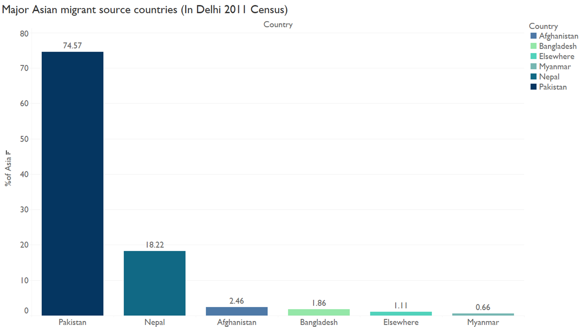

Source: Author’s own’

Note: Migrant percentages have been calculated as a percentage of the total Asian migrants (the number of migrants from Asia other than India) residing in Delhi in 2011 was 1182749.

The figure above depicts the major sending countries of migrants to Delhi in 2011. The migrants classified as “Elsewhere” are the migrants which are from Asia but the specific country of where they came from was not recorded. The percentage values of the migrants from the remaining countries were equal to or lesser than 0.2%. It is clearly seen that the majority of the international migrants remain to be from Pakistan and Nepal.

# **Chapter 4: Conclusion**

## **Discussion**

Among the five cities that have been observed, both Mumbai and Kolkata which used to have a larger migrant population than native population in 1881 have faced a decrease in the migrant numbers to the extent that the native population percentage has overtaken the migrant population percentage. Perhaps one common reason for the trend in both the cities would be saturation of opportunities. Moreover, the migrant population in Delhi was initially lesser than the native population, then overtook it before once again reducing. It is known that the common factor in Delhi and Mumbai for decline in the migrant population is that there have been policies which discourage migrants.

For Surat and Bangalore on the other hand, there was not much migration that occurred prior to the Independence of India but after this there has been an increase in migrants which has led to the migrant population overtaking the native population. This indicates that there has been a rise in opportunities in the two cities.

The different times in rise of population and migrants observed also indicate when industrialisation became prominent for the different cities. Mumbai, Kolkata and Delhi had rapid industrialisation prior to the Independence and Surat and Bangalore had more industrialisation post the Independence.

It is also to be noted that Surat’s fall in trade and shift in the trade industry to Mumbai was depicted by the fewer migrants during the late 19th century to the mid-20th century and parallelly the migrants in Mumbai were observed to be higher during the same time period.

Additionally, it is interesting to note that three out of five cities that were observed were ports namely, Mumbai, Surat and Kolkata.

Moreover, the international migration trends differed in each of the cities. Delhi and Kolkata were the only cities among the eight cities studied that had significant percentages of international migrants. The reasons for these were similar for both the cities in the regard that many individuals migrated to India during the Partition of India and that in the subsequent years, both cities received a significant number of refugees from neighbouring Asian countries.

Lastly, the impact of the common events differed for the cities. While the famines and influenza epidemic bore a negative impact on the population growth for all cities, the migration during the Partition impacted the cities at varying levels. Delhi and Kolkata had a much larger population of migrants from Pakistan and East Pakistan (now Bangladesh) during the Partition. Mumbai and Surat also had a considerable number of migrants. This can be attributed to the fact that a part of Pakistan borders the present-day Gujarat and that Pakistan is close to Delhi in distance as compared to Bangalore. In the case of Kolkata, West Bengal borders Bangladesh and this would have made it easier for the individuals to migrate there. Finally, the globalisation that occurred in the 1990s, led to a growth in migrants in almost all of the five cities observed due to the establishment of multinational companies.

From these observations, it is clear that there are indicators of when large expansions of growth or massive migration waves will occur. The indicators include but are not limited to economic reasons such as the establishment of industries, health related reasons such as epidemics and pandemics and political reasons such as instability in other countries. Therefore, there should be policies created that address the steps to be taken in case of anticipation of higher growth or massive migration. For instance, if a new industry is set up and begins to gain traction, then policies addressing the rights of migrant workers as well as residential planning for the additional number of people in the city should be in place. This will ensure that there is a smoother transition into the expansion of the city and the welfare of the migrants will also not be compromised.

## **Limitations**

Since the Census data was used, only long-term migration could be studied. The changes occurring due to circular migration were not captured.

Additionally, since certain time periods were removed in analysis such as 1941 for all the cities and specific years for other cities, the shifts in the migration trends seemed abrupt and there was no way to accurately determine the migration patterns that occurred in those years.

Moreover, while looking at migrants by their place of birth, it may show inaccurate changes. For instance, as was seen in the figures, one who may have been classified as an intrastate migrant in one decade would be classified as an interstate migrant in the next decade due to the changes in the boundaries of the state. The changes in the boundaries of the districts and states also caused issues since the same area for one region would change and it made it difficult to ascertain if the rise or fall in growth occurred solely due to changing boundaries or other factors as well.

The paper does not look into the reasons for migration. Thus, it is unknown whether majority of the migrants moved for work or for other reasons such as due to marriage. Unfortunately, such data was only available from the 1981 Census data (Government of India,

n.d.). Moreover, the demographics of age and gender were not included in the paper. Observing age of the migrants could indicate age-specific migration patterns for instance, younger migrants may be moving to a particular city for work whereas older migrants may be returning to their home cities or residing in certain cities where people migrate to after retirement. Looking into the gender of the migrants may have demonstrated whether the trend of male-dominated migration was present in the major cities as well.

Finally, the research did not take into account the out-migration figures. For instance, during the Partition of India, several Muslim individuals migrated from India to Pakistan and Bangladesh. This could have helped in determining the net migration rates and the changes in population as a whole.

## **Future Directions**

The future research can include looking into the migration patterns in other cities of India and reasons why the individuals are migrating. The migration patterns may vary depending on whether the city has employment opportunities or not. Additionally, some cities or towns which attract several migrants could be migrant hubs for reasons other than economic factors such as places of religious worship or places where people tend to shift to after retirement. Essentially, the reasons why individuals migrated can be observed in order to ascertain why the growth or fall of cities occurs.

## **Conclusion**

The historical research has shown that the major factors impacting population growth and migration since 1881 to 2011 in Mumbai, Surat, Bangalore, Kolkata and Delhi, include the influenza epidemic, famines, Partition of India and globalisation. Furthermore, across the cities that were observed, only Delhi and Kolkata had a substantial amount of international migration; the majority of which were migrants during the Partition of India or post-Independence, migrants from regions where there was political instability. The remaining cities mostly witnessed internal migration.

In all of these cities, it was found that the migration increased during times of industrialisation, indicating that perhaps, many of the migrants moved due to the employment opportunities present. Specifically, the industries and sectors responsible for the rise in migrants were the textile and financial industries in Mumbai, the jute industry in Kolkata, the textile and diamond industries in Surat, public sector industries and the Information technology sector in Bangalore and the informal sector and government sector in Delhi. However, this industrialisation did not occur simultaneously for all the cities. One of the possible indications for the same is that the change in migration across the decades is not similar across the cities. There has been a decline in migration in Mumbai, Delhi and Kolkata, cities where industrialisation took place at a much earlier stage compared to Surat and Bangalore, where industrialisation occurred later and the percentage of migrants has been on the rise post-Independence.

In conclusion, the historical trends have helped in identifying the major periods of population growth and migration, and can serve as a basis in understanding when a rise or fall in migration can be expected and how the government and people can be prepared for the changes in the same.

# **References**

Agarwal, T. (2022). Afghan refugees in the higher education system in Delhi*. In The*

*Routledge Handbook of Refugees in India* (pp. 790-804). Routledge India.

Aggarwal, A. (2019, August 6). *J&K not the first, Delhi too, was stripped of statehood once.*

India Today. Retrieved April 1, 2022, from https://www.indiatoday.in/india/story/article-

370-statehood-delhi-jammu-and-kashmir-1577629-2019-08-06

Aiyar, V.R.T. (1912). *Vol. XXI: Mysore. Part II: Tables.* Census Operations.

https://dspace.gipe.ac.in/xmlui/handle/10973/19002

Albert, E., & Maizland, L. (2020, January 23). *The Rohingya Crisis. Council on Foreign*

*Relations.* Retrieved April 1, 2022, from https://www.cfr.org/backgrounder/rohingya-

crisis

Arputhanathan, J.I. (1953). *1951 Census Handbook Madras District.*

Government of India.

http://lsi.gov.in:8081/jspui/bitstream/123456789/6431/1/45602_1951_MAD.pdf

Baines, J.A. (1882). *Imperial Census of 1881: Operations and Results in the Presidency of*

*Bombay including Sind. Part II: Tables.* Census Operations.

https://dspace.gipe.ac.in/xmlui/handle/10973/18900

Balasubramanyam. (1967). *Mysore Part II-C(ii) Migration Tables.* Government of India. <https://new.census.gov.in/nada/index.php/catalog/31363>

Banerjee-Guha, S. (2022, April 8). *Kolkata*. Encyclopædia Britannica. https://www.britannica.com/place/Kolkata

British Broadcasting Corporation. (2022). *Migration. Push and pull factors* . BBC News. https://www.bbc.co.uk/bitesize/guides/z3p4b82/revision/1

Bhalla, V.K. (1985). *Series-28 Delhi Part V A & B Migration Tables.* Government of India. http://lsi.gov.in:8081/jspui/bitstream/123456789/3547/1/45692_1981_MIG.pdf

Boag, G.T. (1922). *Madras Part II Imperial and Provincial Tables*. Census Operations.

https://ia802905.us.archive.org/22/items/in.ernet.dli.2015.56002/2015.56002.Census-Of-

India-1921-Vol13-Madras-Pt2-imperial-And-Provincial-Tables.pdf

Bourdillon, J.A. (1883). *Census of Bengal, 1881 Vol. II*. Census Operations.

https://ia902909.us.archive.org/19/items/in.ernet.dli.2015.47395/2015.47395.Census-

Report-Of-Bengal-1881-Vol-2_text.pdf

Bowman, J.B. (1953). *Vol. IV: Bombay, Saurashtra and Kutch. Part II-A: General population tables, social and cultural tables and summary figures*. Government of India.

https://dspace.gipe.ac.in/xmlui/handle/10973/37884

Bowman, J.B. (1953). *Vol. IV: Bombay, Saurashtra and Kutch. Part I*.Government of India. http://lsi.gov.in:8081/jspui/bitstream/123456789/3641/1/B639-1951.pdf

Britannica, T. Editors of Encyclopaedia (2018, December 28). Bengaluru. Encyclopedia

Britannica. <https://www.britannica.com/place/Bangalore-India>

Butsch, C.; Kumar, S.; Wagner, P.D.; Kroll, M.; Kantakumar, L.N.; Bharucha, E.; Schneider,

K.; Kraas, F. (2017). Growing ‘Smart’? Urbanization Processes in the Pune Urban Agglomeration. *Sustainability*, *9*(2335). https://doi.org/10.3390/su9122335

Census Bureau. (2022, March 24). *Urban Area Criteria for the 2020 Census-Final Criteria*. Federal Register. Retrieved April 10, 2022, from https://www.federalregister.gov/documents/2022/03/24/2022-06180/urban-area-criteria-for-the-2020-census-final-criteria

Census Operations.(1902). *Imperial tables, I-VIII, X-XV, XVII and XVIII for the Punjab, with the native states under the political control of the Punjab Government, and for the Northwest Frontier Province*. (1902). https://jstor.org/stable/saoa.crl.25363739

Čirjak, A. (2020, June 10). *What are push and pull factors?* WorldAtlas. Retrieved April 8, 2022, from https://www.worldatlas.com/articles/what-are-push-and-pull-factors.html

Chandramouli, C. (2011). Administrative Atlas of India. Government of India.

Chari, M. (2016, November 1). *How the map of India was redrawn on the lines of language.*

Scroll.in. Retrieved April 2, 2022, from https://scroll.in/article/820359/how-the-mapindia-was-redrawn-on-the-lines-of-language

Chari,R.B. (1978). *Series 11- Maharashtra Part II-D(i) Migration Tables (D-I to D-IV).*

Government of India. http://lsi.gov.in:8081/jspui/handle/123456789/4130

Chhaya,R.S. (1986). *Gujarat Part V A & B Migration Tables.* Government of India. http://lsi.gov.in:8081/jspui/bitstream/123456789/3840/1/27327_1981_MIG.pdf Chockalingam, K. (1978). Series 19- Tamil Nadu Part II-D Migration Tables DI-DIV. Government of India. <http://lsi.gov.in:8081/jspui/bitstream/123456789/3536/1/52825_1971_MIG.pdf>

Chowdhury, S. R. (2020). Migration and city competitiveness: A comparative analysis with Surat as a special case. *Vision: The Journal of Business Perspective*, *25*(4), 460–470. https://doi.org/10.1177/0972262919900448

Council on Foreign Relations. (n.d.). *Timeline: U.S. War in Afghanistan*. Council on Foreign

Relations. Retrieved April 1, 2022, from https://www.cfr.org/timeline/us-warafghanistan

Das, B.K. (1986). Karnataka Part V A & B Migration Tables. Government of India. http://lsi.gov.in:8081/jspui/bitstream/123456789/6185/1/27600_1981_MIG.pdf

Das, B& Ansary, R. (2018). Bangladeshi and Inter-state Migrants: Differential

Adaptation and Acceptance by the Locals in West Bengal, India. *Spatial Demography. 6*.

10.1007/s40980-017-0040-1.

De, S. (2019, December 18). *Internal migration in India grows, but inter-state movements remain*

*low.* World Bank Blogs. Retrieved April 9, 2022, from https://blogs.worldbank.org/peoplemove/internal-migration-india-grows-inter-state-movements-remain-low

Delhi has highest share of inter-state migrants. Hindustan Times. (2019, July 28). Retrieved

April 1, 2022, from https://www.hindustantimes.com/delhi-news/delhi-has-highestshare-of-inter-state-migrants/story-QCYXSWlnSYAJbNb25ljcPL.html

Deshingkar, P. & Akter, S. (2013). *Migration and Human Development in India.* Human Development Reports, 2009/13. http://hdr.undp.org/en/content/migration-and-human- development-india

Dev, A. (2021, March 15). *3 waves of migrations that shaped Bengaluru*. Hindustan Times. https://www.hindustantimes.com/cities/others/3-waves-of-migrations-that-shaped-bengaluru-101615660544003.html

Devulapalli, S. (2019). *Migrant flows to Delhi, Mumbai ebbing.* Livemint.

https://www.livemint.com/news/india/migrant-flows-to-delhi-mumbai-ebbing-

1568981492505.html

Dey, A., & Pendharkar, A. (2019, October 12). *Map: How Bangalore's it sector flowered from a*

*princely state Diwan's industrial dream in 1911.* Scroll.in. Retrieved April 1, 2022, from <https://scroll.in/article/938388/map-how-bangalores-it-sector-flowered-from-a-princelystate-diwans-industrial-dream-in-1911>

Directorate of Census Operations (2014). *District Census Handbook Chennai.* Government

of India.

https://censusindia.gov.in/2011census/dchb/3302_PART_B_DCHB_CHENNAI.pdf

Directorate of Census Operations Gujarat. (2011). *District Census Handbook Surat*. Government

of India.

https://censusindia.gov.in/2011census/dchb/DCHB_A/24/2425_PART_A_DCHB_SURA

T.pdf

Directorate of Census Operations West Bengal. (1991). *District Census Handbook Calcutta*

*District.* Government of India.

http://lsi.gov.in:8081/jspui/bitstream/123456789/5357/1/35307_1991_CAL.pdf

Directorate of Census Operations West Bengal. (2015). *District Census Handbook Kolkata.*

Government of India.

https://censusindia.gov.in/2011census/dchb/1916_PART_B_DCHB_KOLKATA.pdf

Directorate of Census Operations Maharashtra. (2014). *District Census Handbook Mumbai.*

Government of India.

https://censusindia.gov.in/2011census/dchb/2723_PART_B_DCHB_%20MUMBAI.pdf

Doctor, C.C. (1978). *Series 5- Gujarat Part II-D(i) Migration Tables (D-I to D-IV).* Government of India. http://lsi.gov.in:8081/jspui/bitstream/123456789/3774/1/43305_1971_MIG.pdf

Doctor, C.C. (1972). District Census Handbook Surat. Government of India.

http://lsi.gov.in:8081/jspui/bitstream/123456789/3805/1/44449_1971_SUR.pdf

Dracup, A. H., & Sorley, H. T. (1932). *Bombay Presidency General Report.* Census Operations. http://lsi.gov.in:8081/jspui/bitstream/123456789/3995/1/30678_1931_GEN.pdf

Dracup, A.H. & Sorley, H.T. (1933*). Bombay Presidency. Part II: Statistical Tables.* Census

Operations. https://dspace.gipe.ac.in/xmlui/handle/10973/18972

Dracup, A.H. (1942). *Vol. III: Bombay Tables.* Census

Operations. https://dspace.gipe.ac.in/xmlui/handle/10973/37364

Drew, W.W. (1892). *Bombay and its Feudatories Part II-Imperial Tables.* Census Operations.

Dupont, V.D.N. (2000). Spatial and demographic growth of Delhi since 1947 and the main migration flows. In V. Dupont, E. Tarlo & D. Vidal (Eds.), *Delhi: Urban Space and Human Destinies.* (229-239). Manohar. https://www.researchgate.net/publication/282170328_Spatial_and_demographic_growth_of_Delhi_since_1947_and_the_main_migration_flows

Eldridge, A. (n.d.). What’s the Difference Between a Migrant and a Refugee? Britannica. https://www.britannica.com/story/whats-the-difference-between-a-migrant-and-arefugee

Engelshoven, M. (1999). Diamonds and Patels: A report on the diamond industry of Surat.

*Contributions to Indian Sociology, 33*(1–2), 353–

377. https://doi.org/10.1177/006996679903300115

Enthoven, R.E. (1902). Bombay Part II Imperial Tables. Census Operations. https://dspace.gipe.ac.in/xmlui/handle/10973/18874

Francis, W. (1902). Madras Part II Imperial Tables. Census Operations.

https://ia601805.us.archive.org/26/items/in.gov.ignca.31014/31014.pdf

Gaikwad, N., & Nellis, G. (2017). The Majority-Minority Divide in Attitudes toward Internal

Migration: Evidence from Mumbai. *American Journal of Political Science, 61*(2), 456–

472. http://www.jstor.org/stable/26384743

Gait, E.A. (1902). *Bengal Part II Tables.* Census Operations. https://ia800205.us.archive.org/19/items/cu31924071145589/cu31924071145589.pdf

Gandotra, S.R. (1979). *Series 27- Delhi Part II-D Migration Tables.*

Government of India.

http://lsi.gov.in:8081/jspui/bitstream/123456789/3536/1/52825_1971_MIG.pdf

Ghose, B. (1978). *Series-22 West Bengal Part II-D(i) Migration Tables.*

Government of India.

http://lsi.gov.in:8081/jspui/bitstream/123456789/5221/1/26545_1971_MIG.pdf

Ghosh, S.N. (1986). *Series-23 West Bengal Part V A & B Migration Tables.* Government of India.

http://lsi.gov.in:8081/jspui/bitstream/123456789/5284/1/27910_1981_%20IQ.pdf

Government of India. (2011). *History of Census in India.*

https://censusindia.gov.in/Ad_Campaign/drop_in_articles/05-

History_of_Census_in_India.pdf

Government of India. (2014). D-1 (S) : Population Classified By Place Of Birth (1991).

[Ahmadabad]. https://censusindia.gov.in/DigitalLibrary/TVDirectory.aspx

Government of India. (2014). D-1 (S) : Population Classified By Place Of Birth (1991).

[Bangalore]. https://censusindia.gov.in/DigitalLibrary/TVDirectory.aspx

Government of India. (2014). D-1 (S) : Population Classified By Place Of Birth (1991).

[Bangalore Rural]. https://censusindia.gov.in/DigitalLibrary/TVDirectory.aspx

Government of India. (2014). D-1 (S) : Population Classified By Place Of Birth (1991). [Greater

Bombay]. https://censusindia.gov.in/DigitalLibrary/TVDirectory.aspx

Government of India. (2014). D-1 (S) : Population Classified By Place Of Birth (1991).

[Chennai]. https://censusindia.gov.in/DigitalLibrary/TVDirectory.aspx

Government of India. (2014). D-1 (S) : Population Classified By Place Of Birth (1991). [Delhi].

https://censusindia.gov.in/DigitalLibrary/TVDirectory.aspx

Government of India. (2014). D-1 (S) : Population Classified By Place Of Birth (1991)

[Kolkata].https://censusindia.gov.in/DigitalLibrary/TVDirectory.aspx

Government of India. (2014). D-1 (S) : Population Classified By Place Of Birth (1991). [Pune]. https://censusindia.gov.in/DigitalLibrary/TVDirectory.aspx

Government of India. (2014). D-1 (S) : Population Classified By Place Of Birth (1991). [Surat].

https://censusindia.gov.in/DigitalLibrary/TVDirectory.aspx

Government of India. (2014). D-1: Population Classified By Place of Birth, Age and Sex

(2001). [Delhi]. https://censusindia.gov.in/DigitalLibrary/MFTableSeries.aspx

Government of India. (2014). D-1: Population Classified By Place of Birth, Age and Sex

(2001). [Gujarat]. https://censusindia.gov.in/DigitalLibrary/MFTableSeries.aspx

Government of India. (2014). D-1: Population Classified By Place of Birth, Age and Sex

(2001). [Karnataka]. https://censusindia.gov.in/DigitalLibrary/MFTableSeries.aspx

Government of India. (2014). D-1: Population Classified By Place of Birth, Age and Sex

(2001). [Maharashtra]. https://censusindia.gov.in/DigitalLibrary/MFTableSeries.aspx

Government of India. (2014). D-1: Population Classified By Place of Birth, Age and Sex

(2001). [Tamil Nadu]. https://censusindia.gov.in/DigitalLibrary/MFTableSeries.aspx

Government of India. (2014). D-1: Population Classified By Place of Birth, Age and Sex (2001). [West Bengal]. https://censusindia.gov.in/DigitalLibrary/MFTableSeries.aspx

Government of India. (n,d,). D-1: Population classified by place of birth and Sex - 2011 (2011). [Gujarat]. https://censusindia.gov.in/2011census/d-series/d-1.html

Government of India. (n,d,). D-1: Population classified by place of birth and Sex - 2011 (2011).

[Karnataka]. https://censusindia.gov.in/2011census/d-series/d-1.html

Government of India. (n,d,). D-1: Population classified by place of birth and Sex - 2011 (2011).

[Maharashtra]. https://censusindia.gov.in/2011census/d-series/d-1.html

Government of India. (n,d,). D-1: Population classified by place of birth and Sex - 2011 (2011).

[NCT of Delhi]. https://censusindia.gov.in/2011census/d-series/d-1.html

Government of India. (n,d,). D-1: Population classified by place of birth and Sex - 2011 (2011).

[Tamil Nadu]. https://censusindia.gov.in/2011census/d-series/d-1.html

Government of India. (n,d,). D-1: Population classified by place of birth and Sex - 2011 (2011).

[West Bengal]. https://censusindia.gov.in/2011census/d-series/d-1.html

Government of India. (2011). *Urban Agglomerations and Cities.*

https://censusindia.gov.in/2011-prov-results/paper2/data_files/india2/1.%20data%20highlight.pdf

Government of India. (2017, January 31). *India on the move and churning: New evidence.*

https://www.indiabudget.gov.in/budget2017-2018/es2016-17/echap12.pdf.

Gupta, J.D. (1964). West Bengal & Sikkim. Government of India.

http://lsi.gov.in:8081/jspui/bitstream/123456789/5136/1/23073_1961_MIG.pdf

Harold A Stuart. (1893). Madras: tables I to XVII-C, British territory. Census Operations.

https://jstor.org/stable/saoa.crl.25352817

Ibbetson, D.C.J. (1883). *Report on the census of the Panjáb taken on the 17th of February 1881.*

*Census Operations.* https://jstor.org/stable/saoa.crl.25057657http://lsi.gov.in:8081/jspui/bitstream/123456789

/6185/1/27600_1981_MIG.pdf

Indian Statistical Institute. (n.d.). *NSSO*. https://www.isical.ac.in/~repro/history/public/notepage/NSSO-F.html#:~:text=Multipurpose%20National%20Sample%20Survey%20started,of%20Politics%20and%20Economics%2C%20Poona.

International Organization for Migration. (2021). *Who is a migrant? Who is a Migrant?*

https://www.iom.int/node/102743.

Iyengar, M.V. (1932). *Mysore Part-II Tables.* Census Operations.

https://ia803205.us.archive.org/33/items/in.ernet.dli.2015.56052/2015.56052.Census-Of-

India-1931-Vol25-mysore-Pt2-tables.pdf

Iyengar, M.V. (1932). *Mysore Part 1-Report*. Government of India. https://dspace.gipe.ac.in/xmlui/handle/10973/18995

Iyer, M. (2020, June 10). *Migration in India and the impact of the lockdown on migrants*. PRS Legislative Research. https://prsindia.org/theprsblog/migration-in-india-and-the-impact-of-the-lockdown-on-migrants

Jayaram, N., Varma, D. (2020). Examining the ‘Labour’ in Labour Migration: Migrant Workers’ Informal Work Arrangements and Access to Labour Rights in Urban Sectors. *Indian Journal of Labour Economics.* 63, 999–1019. https://doi.org/10.1007/s41027-020-00288-5

Kaul, P. H. (1912). *Punjab Part II Tables.* Census Operations.

https://ia801303.us.archive.org/34/items/in.ernet.dli.2015.62718/2015.62718.Census-Of-

India-1911-Punjab-Vol-Xiv-Part-Ii.pdf

Kawoosa, V. M. (2019, July 28). *Delhi has highest share of inter-state migrants*. Hindustan Times. Retrieved April 13, 2022, from https://www.hindustantimes.com/delhi-news/delhi-has-highest-share-of-inter-state-migrants/story-QCYXSWlnSYAJbNb25ljcPL.html

Khan, K.A.H. (1933). *Delhi Report and Tables.* Census Operations. http://lsi.gov.in:8081/jspui/bitstream/123456789/3511/1/3334_1931_RAP.pdf

Khan, K.A.H. (1933). *Delhi Report and Tables*. Census Operations.

https://dspace.gipe.ac.in/xmlui/handle/10973/37326

Koshi, L. (2016, November 2). *Explainer: The reorganization of States in India and why it happened*. The News Minute. https://www.thenewsminute.com/article/explainer-reorganization-states-india-and-why-it-happened-52273

Kulkarni, B.A. (1966). *Maharashtra Part II-C(ii) Migration Tables.* Government of India.

http://lsi.gov.in:8081/jspui/bitstream/123456789/4100/1/21563_1961_MIG.pdf

Maclagan, E.D. (1892). The Punjab And Its Feudatories, Volume xx, Part 2. Census Operations.

http://www.panjabdigilib.org/webuser/searches/displayPage.jsp?ID=1933&page=1&Cate goryID=1&Searched=

Lewis McIver, Sir. (1883). *Imperial census of 1881: operations and results in the Presidency of*

*Madras*. Census Operations. https://jstor.org/stable/saoa.crl.25057665

Mahana, P.P. (1986). *Maharashtra Part V A & B Migration Tables*. Government of India

Mallaradhya, J.B. (1954). *Mysore Part 1-Report.* Government of India.

http://lsi.gov.in:8081/jspui/bitstream/123456789/6019/1/49290_1941_REP.pdf

Maxwald, R. (2019, May 21). *Six essential elements to make migration safe, orderly and*

*regular*. International Organization for Migration. Retrieved April 16, 2022, from https://rosanjose.iom.int/en/blogs/six-essential-elements-make-migration-safe-orderly-and-regular

Mead, P.J. & MacGregor, G.L. (1912). Bombay. Part II: Imperial Tables. Census Operations. https://dspace.gipe.ac.in/xmlui/handle/10973/18951

Misra, U. (2021, February 18). *Explained: What 2020 taught us about India's internal migration.* The Indian Express. https://indianexpress.com/article/explained/what-2020-taughtus about-indias-internal-migration-explainspeaking-7189053/.

Mitra, A. (1953). *West Bengal, Sikkim & Chandernagore Part II- Tables*. Government of India. http://lsi.gov.in:8081/jspui/bitstream/123456789/5117/1/41900_1951_TAB.pdf

Mitra, A. (1953). *West Bengal, Sikkim & Chandernagore Part IA- Report.* Government of India.

https://dspace.gipe.ac.in/xmlui/handle/10973/37914

Mitra, A. (1954). *Volume VI-Part III Calcutta City.* Government of India.

https://dspace.gipe.ac.in/xmlui/handle/10973/37906

Mitra, R., Singh, P., & Rawat, C. (2020, November 9). *Kerala on top, Delhi near bottom in new*

*migrant policy index.* Indiaspend. Retrieved April 1, 2022, from https://www.indiaspend.com/kerala-on-top-delhi-near-bottom-in-new-migrantpolicyindex/#:~:text=In%20Delhi%2C%20while%20the%20minimum,to%20qualify%20for%2 0domicile%20requirements

Middleton, L. & Jacob, S.M. (1922). *Punjab and Delhi Part II Tables*. Census Operations.

https://ia801608.us.archive.org/2/items/in.ernet.dli.2015.56000/2015.56000.Census-Of-

India-1921-Vol15-Punjab-And-Delhi-Pt2--tables.pdf

Ministry of Home Affairs, India. (n.d.). *Census of India, 1941.* Office of the Registrar General &

Census Commissioner, India. Retrieved April 1, 2022, from https://censusindia.gov.in/census_and_you/old_report/census_1941.aspx

Ministry of Housing and Urban Poverty Alleviation. (2017). Report of the Working Group on

Migration. https://mohua.gov.in/upload/uploadfiles/files/1566.pdf

Molony, J.C. (1912). Madras Part II Imperial and Provincial Tables. Census Operations. http://lsi.gov.in:8081/jspui/bitstream/123456789/6363/1/26726_1911_LMP.pdf

Muthuswami, A.P. (1986). *Series-20 Tamil Nadu Part V A & B Migration Tables.* Government of India. http://lsi.gov.in:8081/jspui/bitstream/123456789/3547/1/45692_1981_MIG.pdf

Nambiar, P.K. (1964). *Madras Part II-C (II)-i. Migration Tables.* Government of India.

https://new.census.gov.in/nada/index.php/catalog/31239/download/34420/40873_1961_

MIG.pdf

Nambiar, S. (2016, September 19). *A brief history of how Bombay became Mumbai*. Culture Trip. https://theculturetrip.com/asia/india/articles/the-history-of-how-bombay-became-mumbai-in-1-minute/

Nambisan, S. (1992). *District Census Handbook Bangalore District.* Government of India. http://lsi.gov.in:8081/jspui/bitstream/123456789/6238/1/43146_1991_BAN.pdf

Nanjundiah, G. (1956*). 1951 Census Handbook Bangalore District.* Government of India. http://lsi.gov.in:8081/jspui/bitstream/123456789/6028/1/20616_1951_BAN.pdf

Narasimmiyengar,V.N. (1893). Mysore Part II Imperial Tables I to XVI with Index of Castes.

Census Operations. https://jstor.org/stable/saoa.crl.25352798

O’Donnell, C.J. (1893). *The lower provinces of Bengal and their feudatories. The Administrative*

*Tables.* Census Operations. https://jstor.org/stable/saoa.crl.25318680

Office of the Registrar General & Census Commissioner. (n.d.). *Brief history of census*. Census of India. https://censusindia.gov.in/census_and_you/brief_history_of_census.aspx#:~:text=A%20systematic%20and%20modern%20population,India%20was%20held%20in%201881.\

O’Malley, L.S.S. (1913). *City of Calcutta. Part 2, Tables.* Census Operations.

https://jstor.org/stable/saoa.crl.25393782

Padmanabha, P. (1979). *Series 14- Mysore Census Handbook Bangalore District Volume I*.

Government of India. <http://lsi.gov.in:8081/jspui/bitstream/123456789/6158/1/44184_1971_BAN.pdf>

Patel, D. V., & Behera, K. C. (2020, May 21). *Lockdown and its impact on inward migrant workers of Chennai*. Indian Institute of Management Bangalore. https://www.iimb.ac.in/turn_turn/lockdown-impact-inward-migrant-workers-chennai.php

Ram, V. , Rao, . Vaddiparti Lova Surya Prakasa and Sundaram, . K.V. (2021, November 24).

*Delhi.* Encyclopedia Britannica. https://www.britannica.com/place/Delhi

Raghavan, C. (2021, October 22). Mumbai. Encyclopedia

Britannica. https://www.britannica.com/place/Mumbai

Raj, B. (1967). *Delhi Part II-C Cultural and Migration Tables*. Government of India. http://lsi.gov.in:8081/jspui/bitstream/123456789/3492/1/52859_1961_CUL.pdf

Rajan, S. I., & Bhagat, R. B. (2021, February). *Internal Migration in India: Integrating Migration with Development and Urbanization Policies*. The Global Knowledge Partnership on Migration and Development (KNOMAD). https://www.knomad.livebox10.com/sites/default/files/2017-04/KNOMAD%20WP%2012%20Lit%20Review%20Remittances%20tofrom%20Refugees%20and%20IDPs.pdf

Rajan, S.I. & Zachariah, K.C. (2019). Emigration And Remittances: New Evidences from the

Kerala Migration Survey, 2018. Working Paper 483. Centre for Development Studies.

Rice,L. (1884). *Report on the Mysore census of 1881.* Census Operations. https://jstor.org/stable/saoa.crl.25057671

Row, T.A. (1903). Mysore Part II. Tables, Part A, I to XI. Census Operations.

https://ia801600.us.archive.org/12/items/in.ernet.dli.2015.55969/2015.55969.Census-OfIndia-1901-Vol24-a--mysore-Pt2-tables.pdf

Roy, S & Samanta, G. (2020). Informal Labours in Kolkata City: Migration from Undivided Bihar

and Uttar Pradesh. *Space and Culture India. 8*(1)*.* 143-153. 10.20896/saci.v8i1.431.

Sen, S. (2019, July 24). *More migrants to Kolkata from other states than districts*. The Times of India. https://timesofindia.indiatimes.com/city/kolkata/more-migrants-to-city-from-other-states-than-districts/articleshow/70354414.cms#:~:text=Kolkata's%20migrant%20population%20is%208.3,to%20Kolkata%20from%20Asian%20countries.

Sedgwick, L.J. (1922). *Bombay presidency. Part II: Tables (Imperial and Provincial).* Census

Operations. https://dspace.gipe.ac.in/xmlui/handle/10973/18868

Sen, S. (2019, July 24). *More migrants to Kolkata from other states than districts.* The Times of

India. Retrieved April 1, 2022, from https://timesofindia.indiatimes.com/city/kolkata/more-migrants-to-city-from-otherstates-thandistricts/articleshow/70354414.cms#:~:text=Around%20a%20lakh%20migrants%20have

,Uttar%20Pradesh%2C%20Jharkhand%20and%20Odisha

Sharma, S. (2018, July 20). *India's water crisis: Errant rainfall, dearth of employment opportunities cause migration from Bundelkhand's farmlands*. FirstPost India. https://www.firstpost.com/india/indias-water-crisis-errant-rainfall-dearth-of-employmentopportunities-cause-migration-from-bundelkhands-farmlands-4783411.html

Singh, D.P.. (2007). Migration in Mumbai: Trends in Fifty Years. *Demography India. 36*(2)*.* 315-327. [(PDF) Migration in Mumbai: Trends in Fifty Years (researchgate.net)](https://www.researchgate.net/publication/346438710_Migration_in_Mumbai_Trends_in_Fifty_Years)

Singh, S. & Magazine, A. (2020, April 6). *Explained: Indian migrants, across India.* Indian

Express. https://indianexpress.com/article/explained/coronavirus-india-lockdown-migran-

workers-mass-exodus-6348834/

Sreevatsan, A. (2017, September 16). *How much of India is actually urban?* livemint. https://www.livemint.com/Politics/4UjtdRPRikhpo8vAE0V4hK/How-much-of-India-is-actually-urban.html

Srinivasan, V.S. (2021). *The Origin Story of India’s States.* Penguin.

Subramaniam, Reetika. (2018, June 12). *Synthetic Fabric, Authentic Despair. People’s Archive*

*of Rural India.* https://ruralindiaonline.org/articles/synthetic-fabric-authentic-despair/.

Superintendent of Census Operations. (1933). *Vol5 Bengal and Sikkim Part 2 Report.*

https://ia601608.us.archive.org/16/items/in.ernet.dli.2015.56024/2015.56024.Census-OfIndia-1931-Vol5-Bengal-And-Sikkim-Pt2-Report.pdf

Superintendent of Census Operations. (1956). *1951 Census Handbook Bangalore District.*

Government of India.

http://lsi.gov.in:8081/jspui/bitstream/123456789/3513/1/48858_1951_DEL.pdf

Surat Municipal. (n.d.). Migration patterns. http://office.suratmunicipal.org/Migrant/Dashboard/MigrationPatterns

The Editors of Encyclopaedia Britannica. (n.d.). *Chennai*. Encyclopædia Britannica. https://www.britannica.com/place/Chennai

The Partition Museum. (2018, November 6). *The Partition.* Retrieved April 1, 2022,

from https://www.partitionmuseum.org/partition-of-india/ https://dspace.gipe.ac.in/xmlui/handle/10973/18874

Thompson, W.H. (1923). *City of Calcutta. Part II Tables.* Census Operations. http://lsi.gov.in:8081/jspui/bitstream/123456789/5081/1/20812_1921_CAL.pdf

Thyagarajaiyar, V. R. (1922). *Part II Tables Vol. XXIII: Mysore.* Census Operations. https://indianculture.gov.in/rarebooks/census-india-1921-part-ii-tables-vol-xxiii-mysore

The Maharashtra Census Directorate. (1992). *District Census Handbook, Greater Bombay.*

Government of India.

<http://lsi.gov.in:8081/jspui/bitstream/123456789/4223/1/50661_1991_GRE.pdf>

TOI. (2019, August 9). *Half of the people in Gujarat's big cities are migrants*. The Times of India. https://timesofindia.indiatimes.com/city/ahmedabad/half-of-the-people-in-gujarats-big-cities-are-migrants/articleshow/70595991.cms

Trivedi, R.K. (1964). *District Census Handbook Surat District.* Government of India.

http://lsi.gov.in:8081/jspui/bitstream/123456789/3674/1/42207_1961_SUR.pdf

Trivedi, R.K. (1966). Gujarat Part II-C Cultural and Migration Tables. Government of India. http://lsi.gov.in:8081/jspui/bitstream/123456789/3687/1/43362_1961_CUL.pdf

Tumbe, C. (2015). Missing Men, Migration and Labour Markets: Evidence from India. Indian

*Journal of Labour Economics, 58*(2), 245–267. https://doi.org/10.1007/s41027-016-

00174

Tumbe, C. (2016). Urbanisation, demographic transition, and the growth of cities in India, 1870- 2020. C-35205-INC-1. International Growth Centre. https://www.theigc.org/wpcontent/uploads/2016/11/Tumbe-2016-Working-paper.pdf

Tumbe, C. (2018). *India Moving: A history of migration*. Viking.

Tumbe, C. (2022, February 9). Pandemics and Mass Mortality (1918 and 2020-21). Ahmedabad.

Vashishta, L.C. (1951). *Delhi State District Census Handbook Volume 27.* Government of India.

http://lsi.gov.in:8081/jspui/handle/123456789/3513

Win, T. L. (2017, May 1). *Surat: India's 'Diamond City' finds ways to keep its sparkle*. mint.

Retrieved April 1, 2022, from https://www.livemint.com/Industry/sBteoEWWKwSDmzuRgovmaJ/Surat-Indias-

Diamond-City-finds-ways-to-keep-its-sparkle.html

Witte, G. (2021, August 16). *Afghanistan War.* Encyclopedia

Britannica. https://www.britannica.com/event/Afghanistan-War

Yeats, M.W.M. (1932). *Madras Part II Imperial and Provincial Tables.* Census Operations. <http://lsi.gov.in:8081/jspui/bitstream/123456789/6381/1/24238_1931_IMP.pdf>

Yeatts, M.W.M. (1943). *Volume I India Part I Tables.* Census Operations.

http://piketty.pse.ens.fr/files/ideologie/data/CensusIndia/CensusIndia1941/Census%20of%20India%201941.pdf

Yeatts, M.W.M. (1943). *Volume I India Part I Tables.* Census Operations.

http://piketty.pse.ens.fr/files/ideologie/data/CensusIndia/CensusIndia1941/Census%20of%20India%201941.pdf

Zachariah, K.C., Mathew, E.T., & Rajan, S.I. (1999). Impact of Migration on Kerala's economy and society. Working Paper 297. Centre for Development Studies.

Zachariah, K.C. & Rajan, S.I. (2007). Economic and Social Dynamics of Migration in Kerala, 1999-2004 Analysis of Panel Data. Working Paper 384. Centre for Development Studies.

# **Appendix**

## **Ahmedabad**

Figure 41   
Population of Ahmedabad from 1881 to 2011

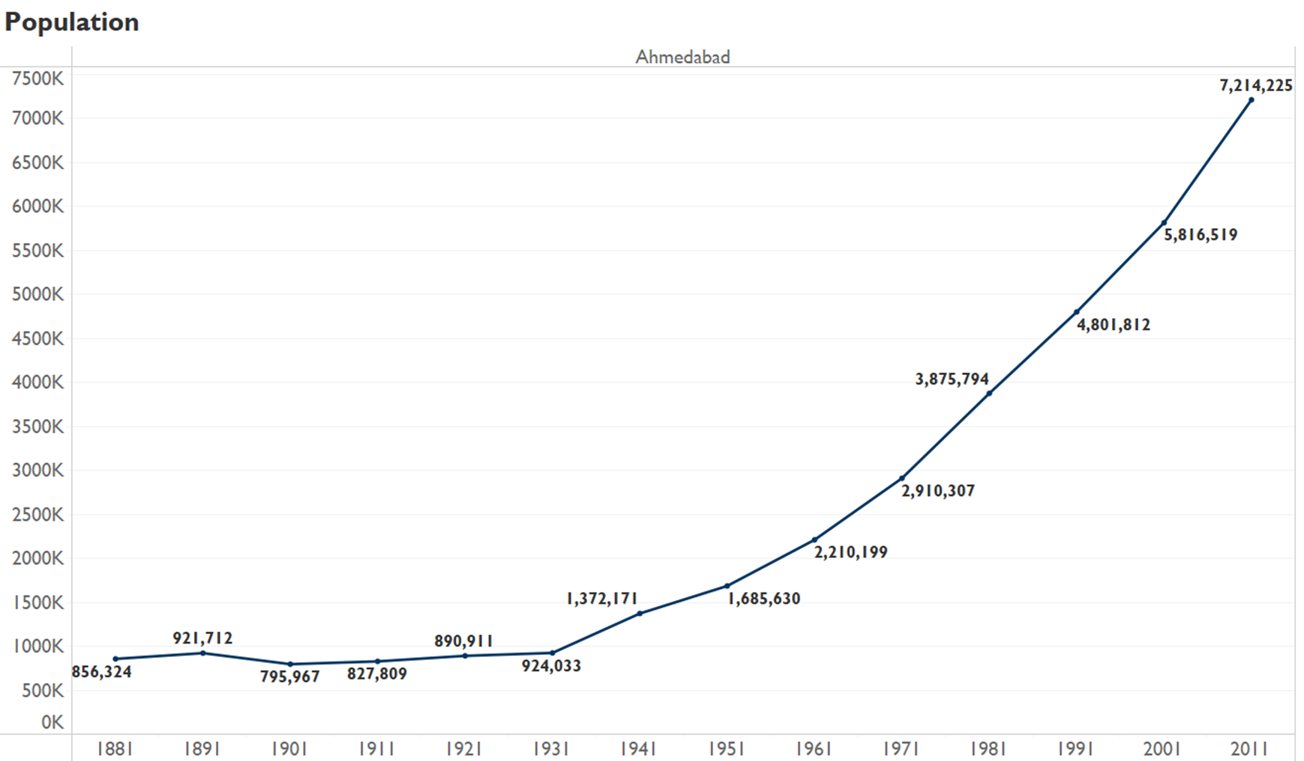

Source: Author’s own

Figure 42  
 Decadal Population Growth of Ahmedabad from 1881 to 2011

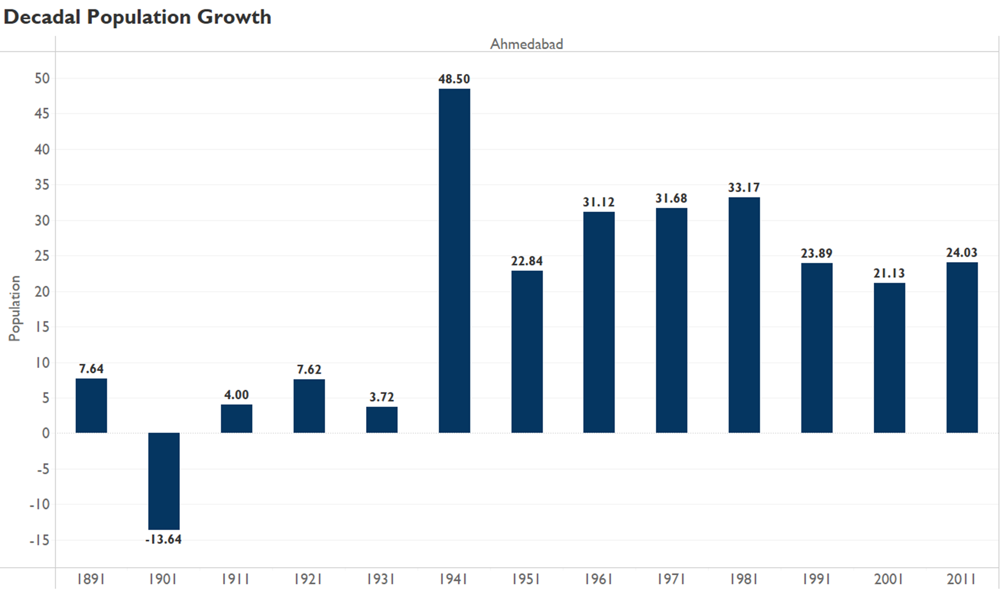

Source: Author’s own

Figure 43   
Percentage of total migrants and natives in Ahmedabad from 1881 to 2011

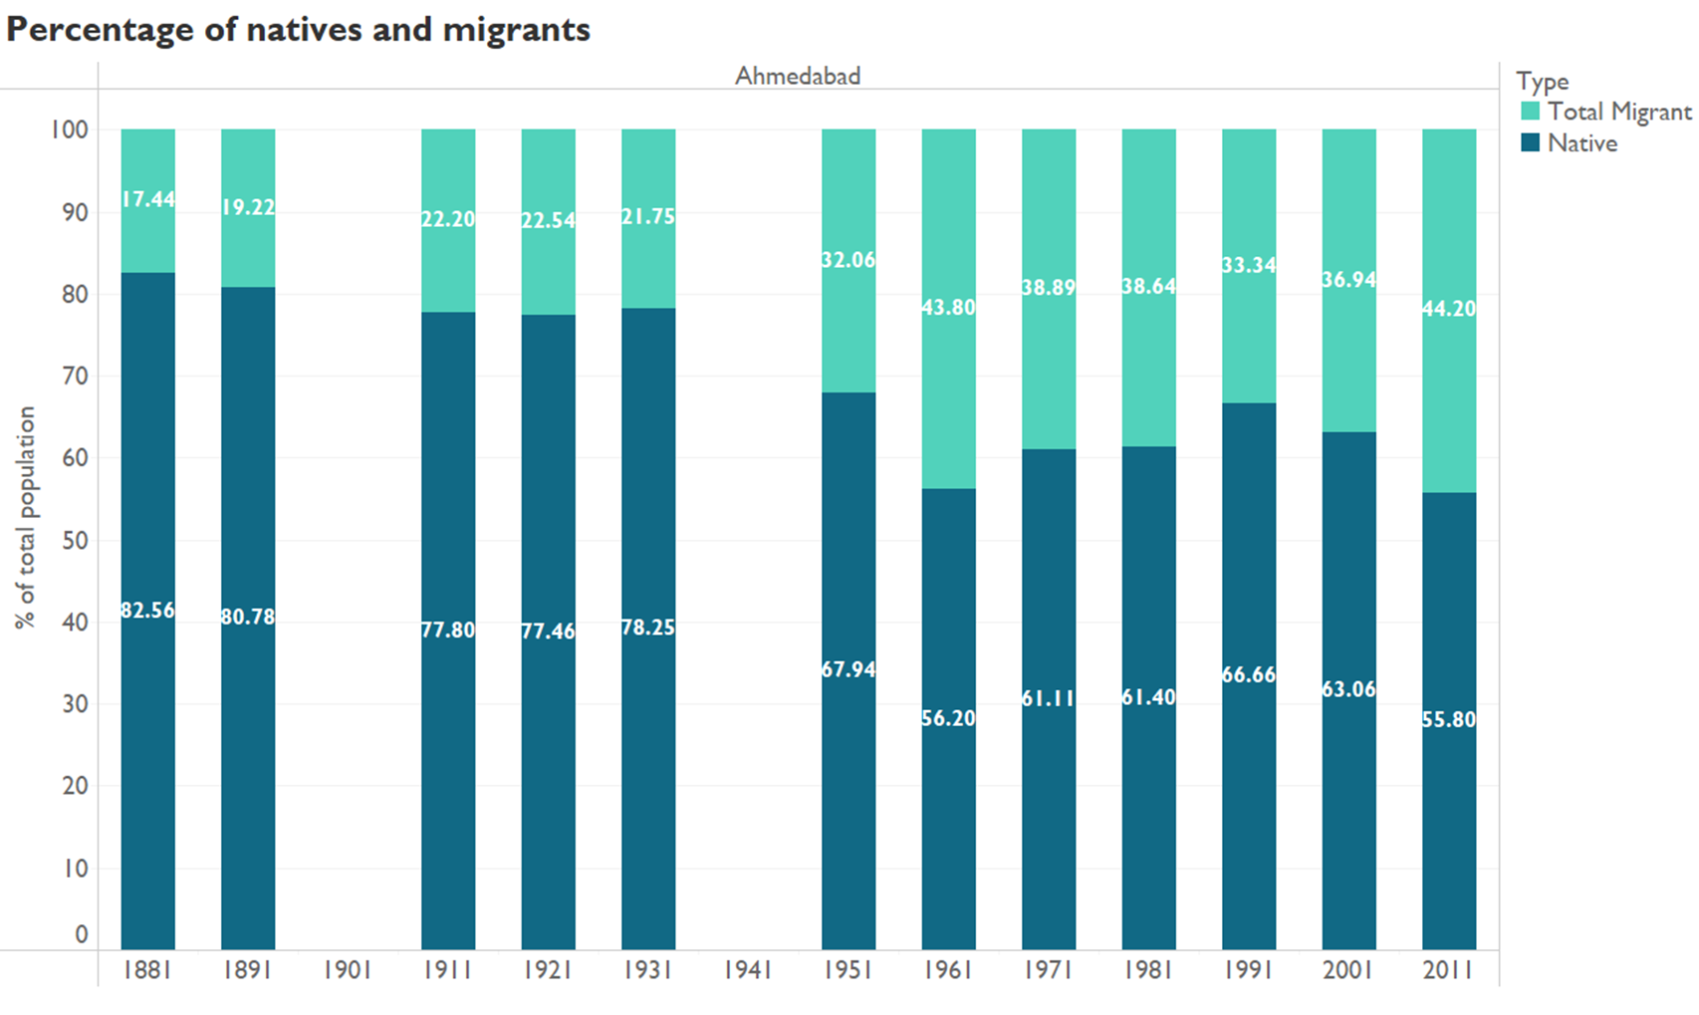

Source: Author’s own

Figure 44  
 Percentage of different types of migrants and natives in Ahmedabad from 1881 to 2011

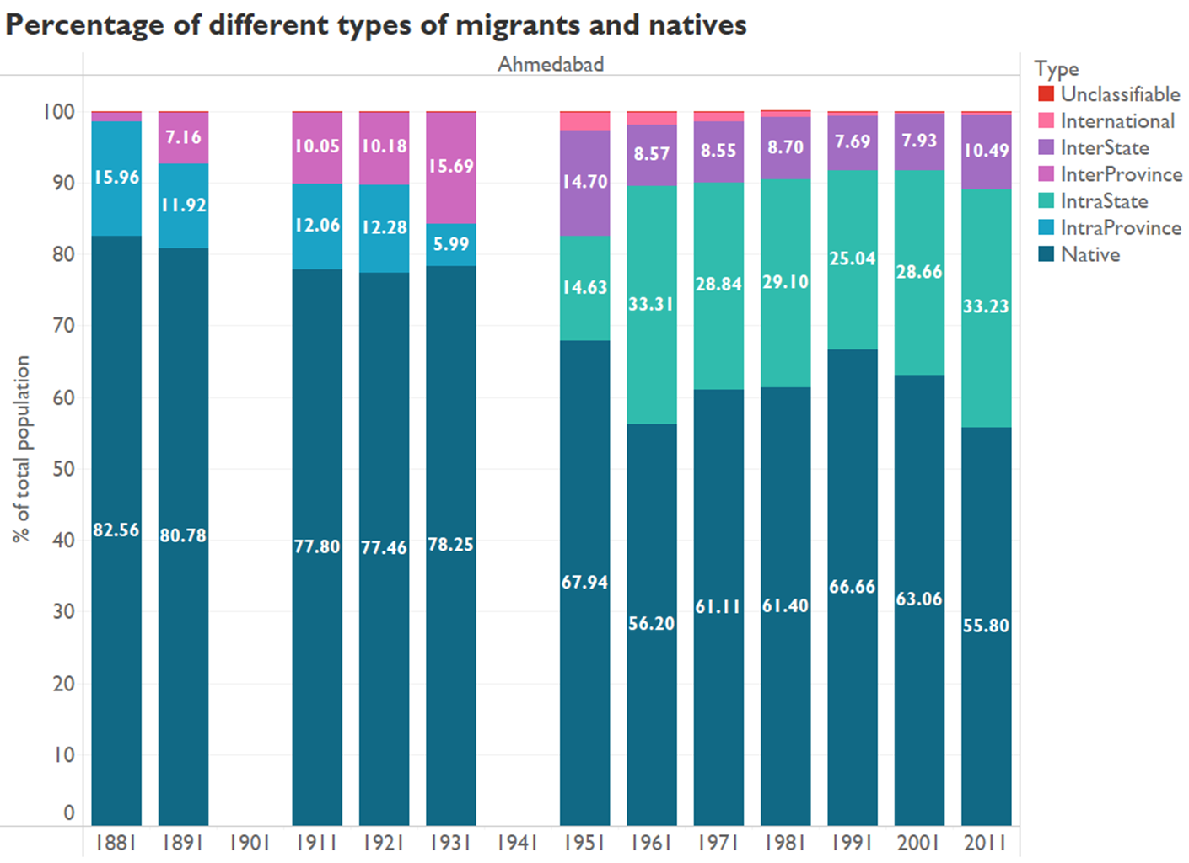

Source: Author’s own

## **Chennai**

Figure 45   
Population of Chennai from 1881 to 2011

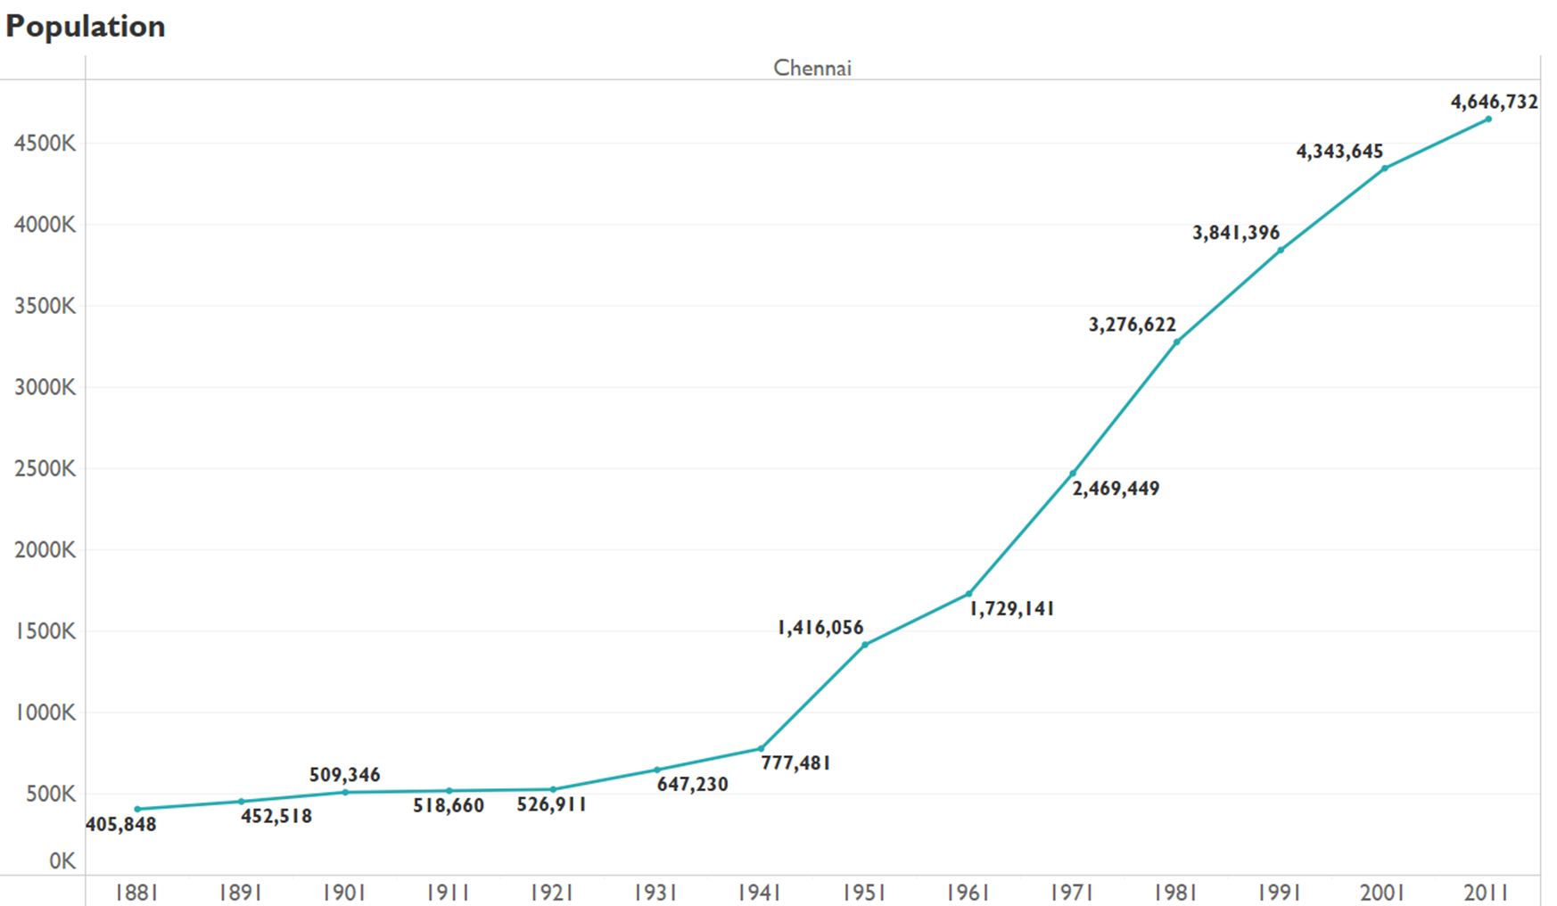

Source: Author’s own

Figure 46   
*Decadal Population Growth of Chennai from 1881 to 2011*

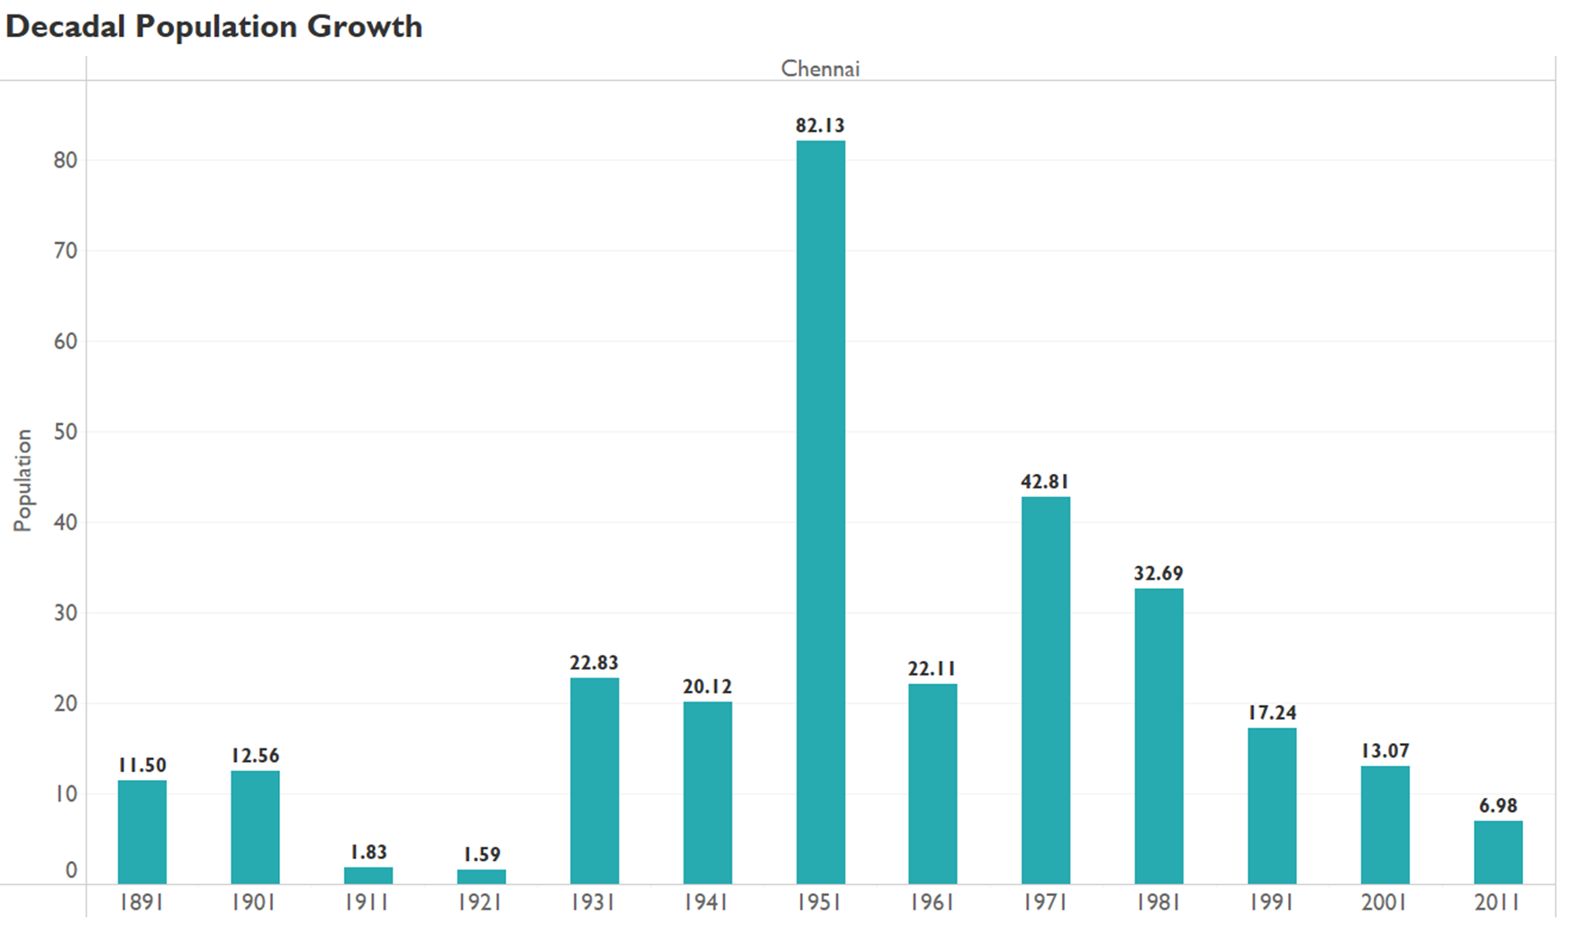

Source: Author’s own

Figure 47   
Percentage of total migrants and natives in Chennai from 1881 to 2011

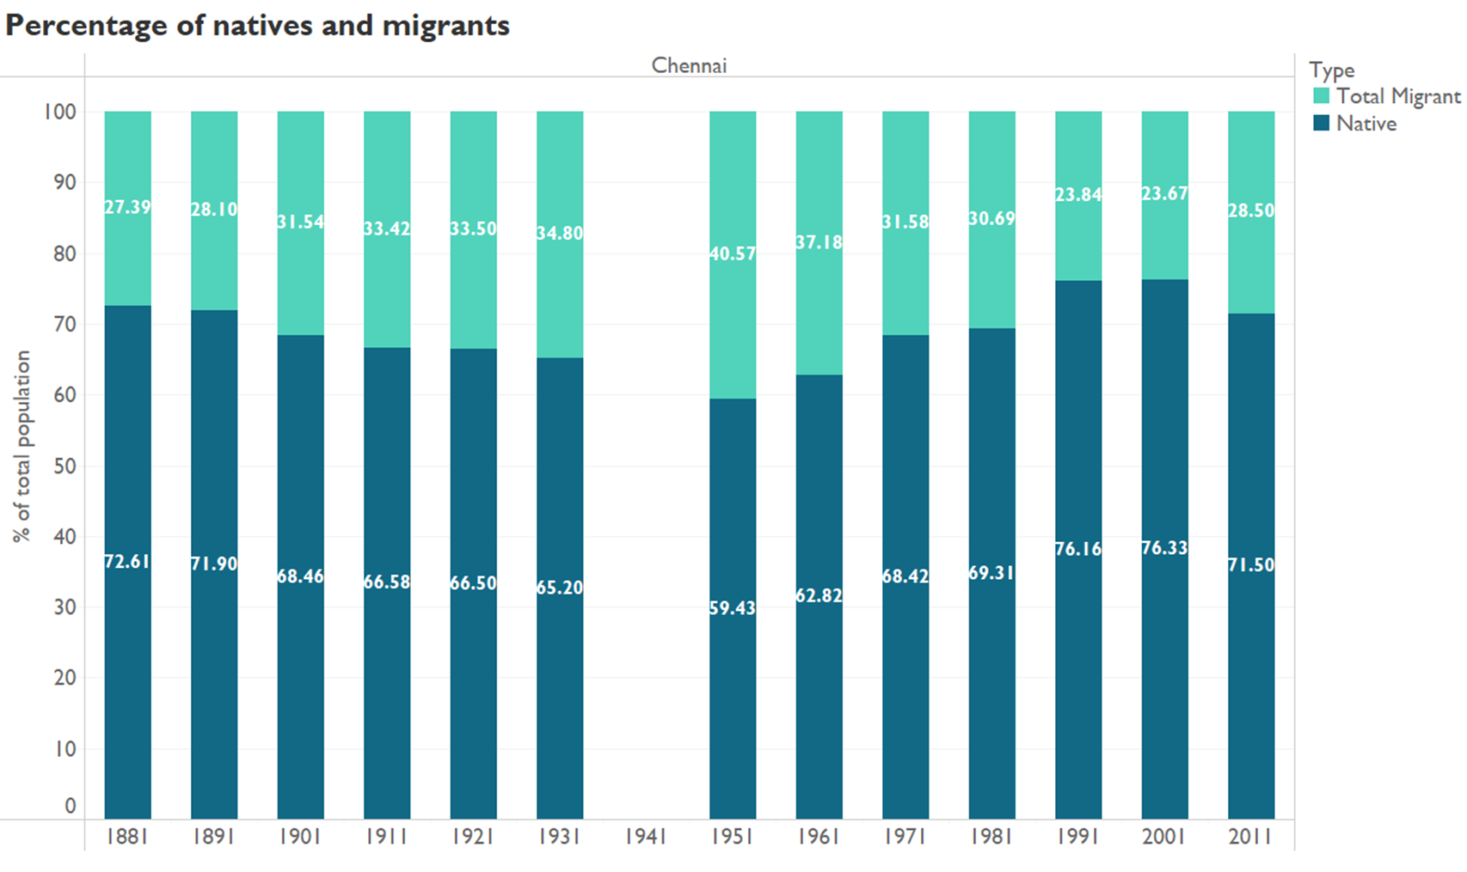

Source: Author’s own

Figure 48   
Percentage of different types of migrants and natives in Chennai from 1881 to 2011

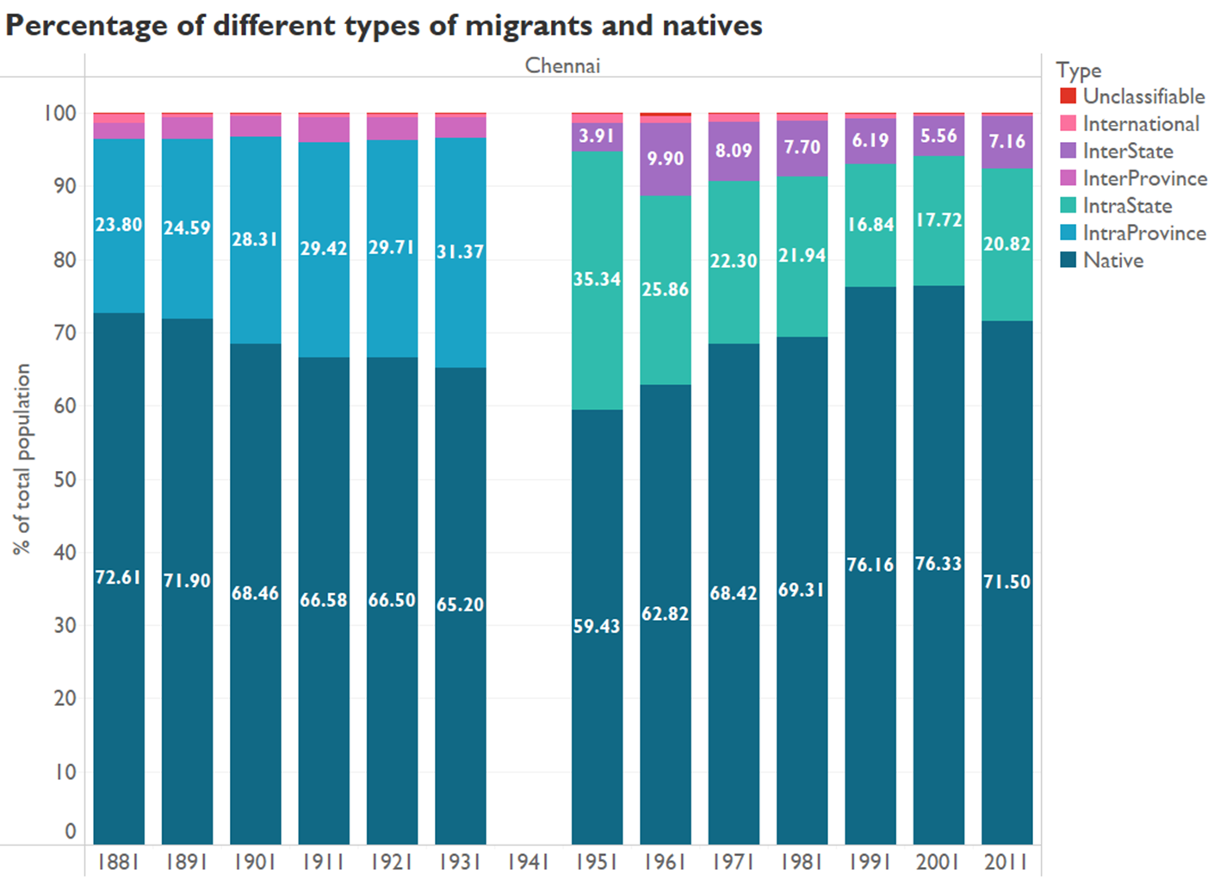

Source: Author’s own

## **Pune**

*Figure 49*   
Population of Pune from 1881 to 2011

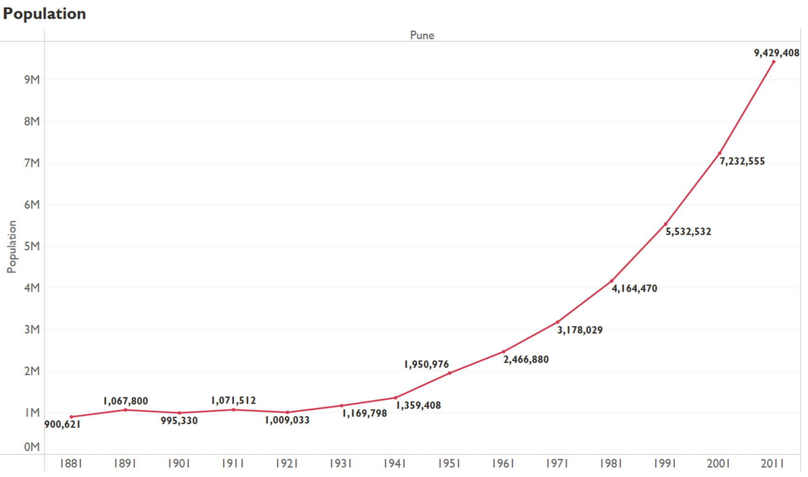

Source: Author’s own

Figure 50  
 Decadal Population Growth of Pune from 1881 to 2011

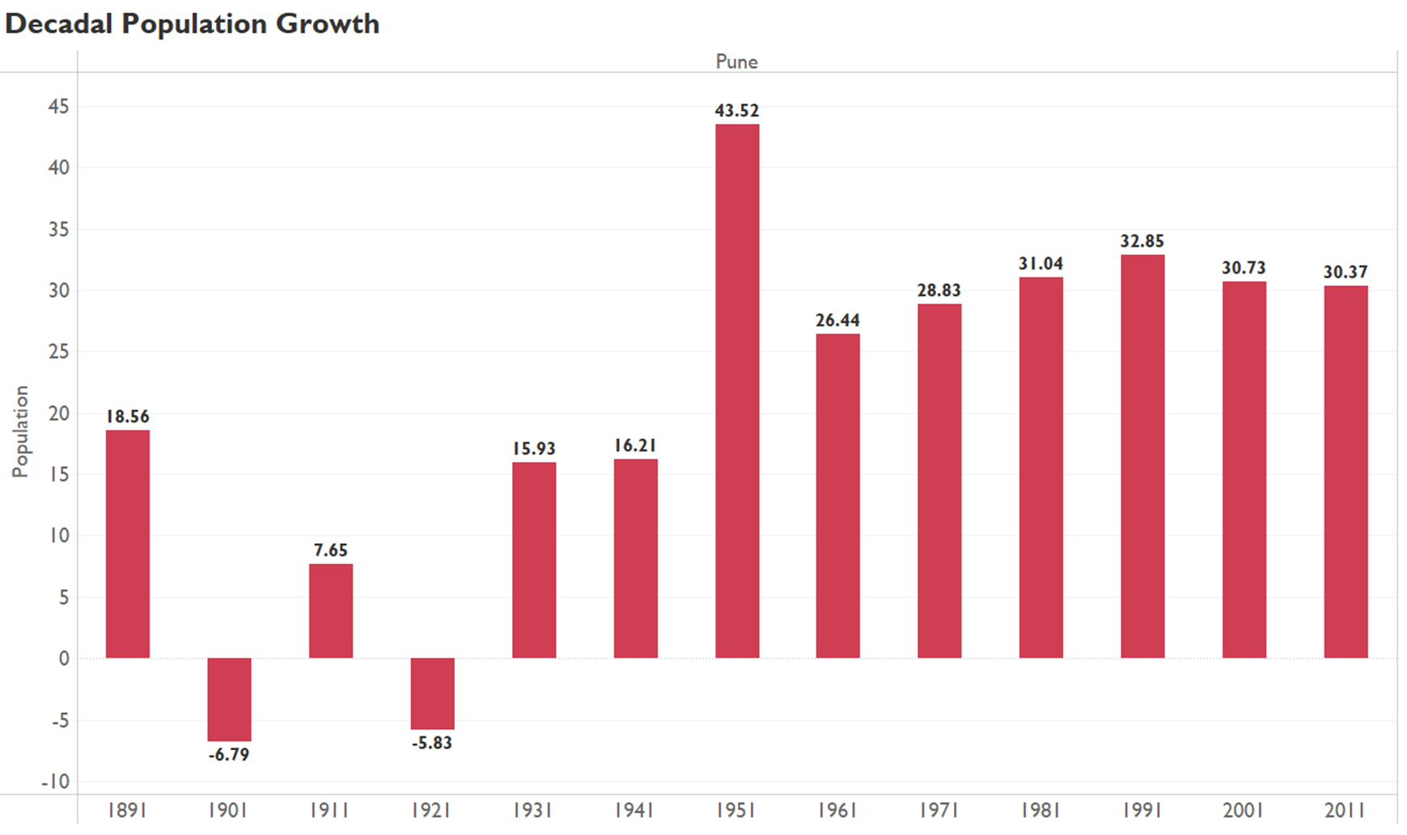

Source: Author’s own

Figure 51  
Percentage of total migrants and natives in Pune from 1881 to 2011

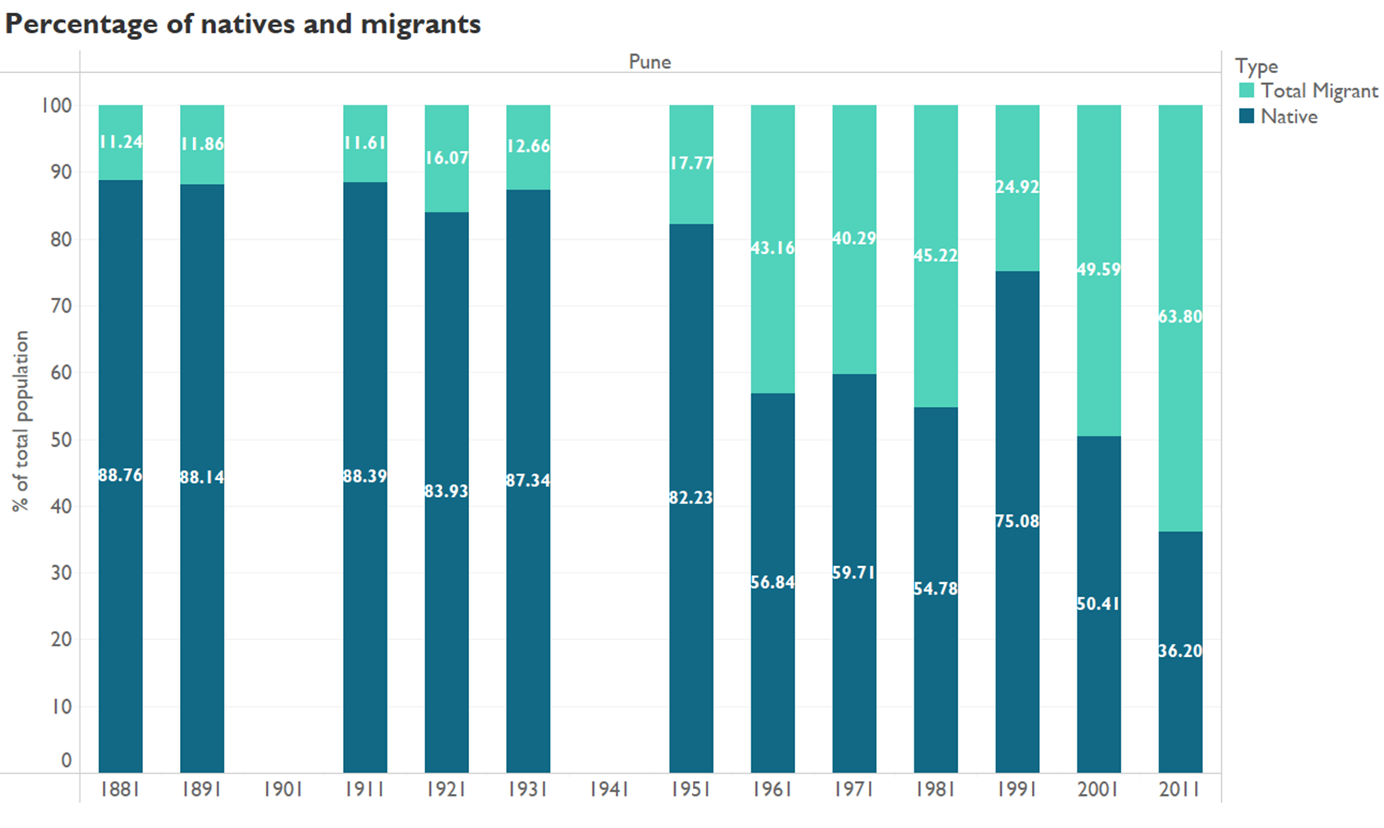

Source: Author’s own

Figure 52  
 Percentage of different types of migrants and natives in Pune from 1881 to 2011

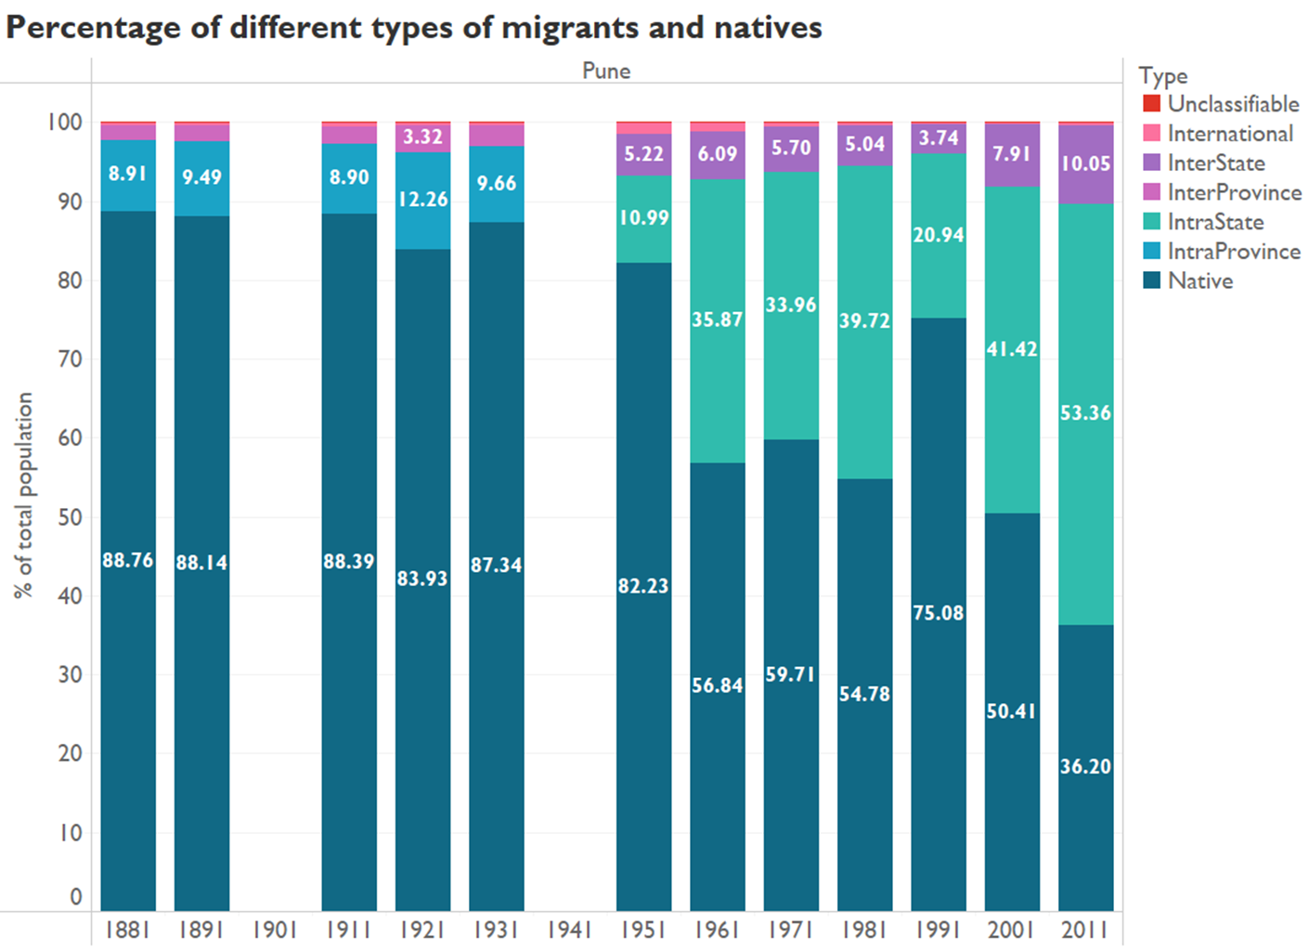

Source: Author’s own